

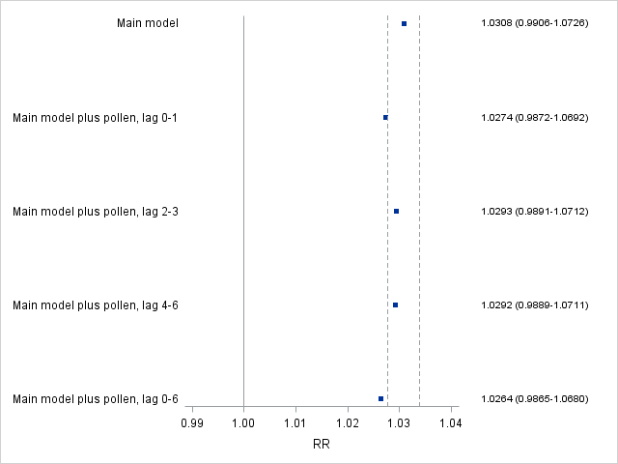

**S3 Fig. Confounding Effects of Outdoor Pollen on the Associations Between Asthma Hospital Admissions in School-age Children and Ozone (top) and PM2.5 (bottom).** Squares are point estimates for relative risks of asthma hospital admissions associated with increases in air pollutants. The dashed lines represent ±10% changes in the point estimates from the main model. Outdoor pollen is defined as daily counts of > 5th percentile.