**S13 Fig. a and b**Chromosome 26 was the most affected chromosome by SVs.

1. Representative CNA (top panel), somatic LOH (middle panel) and germline LOH (bottom panel) plots from the primary lesion in the Labrador.

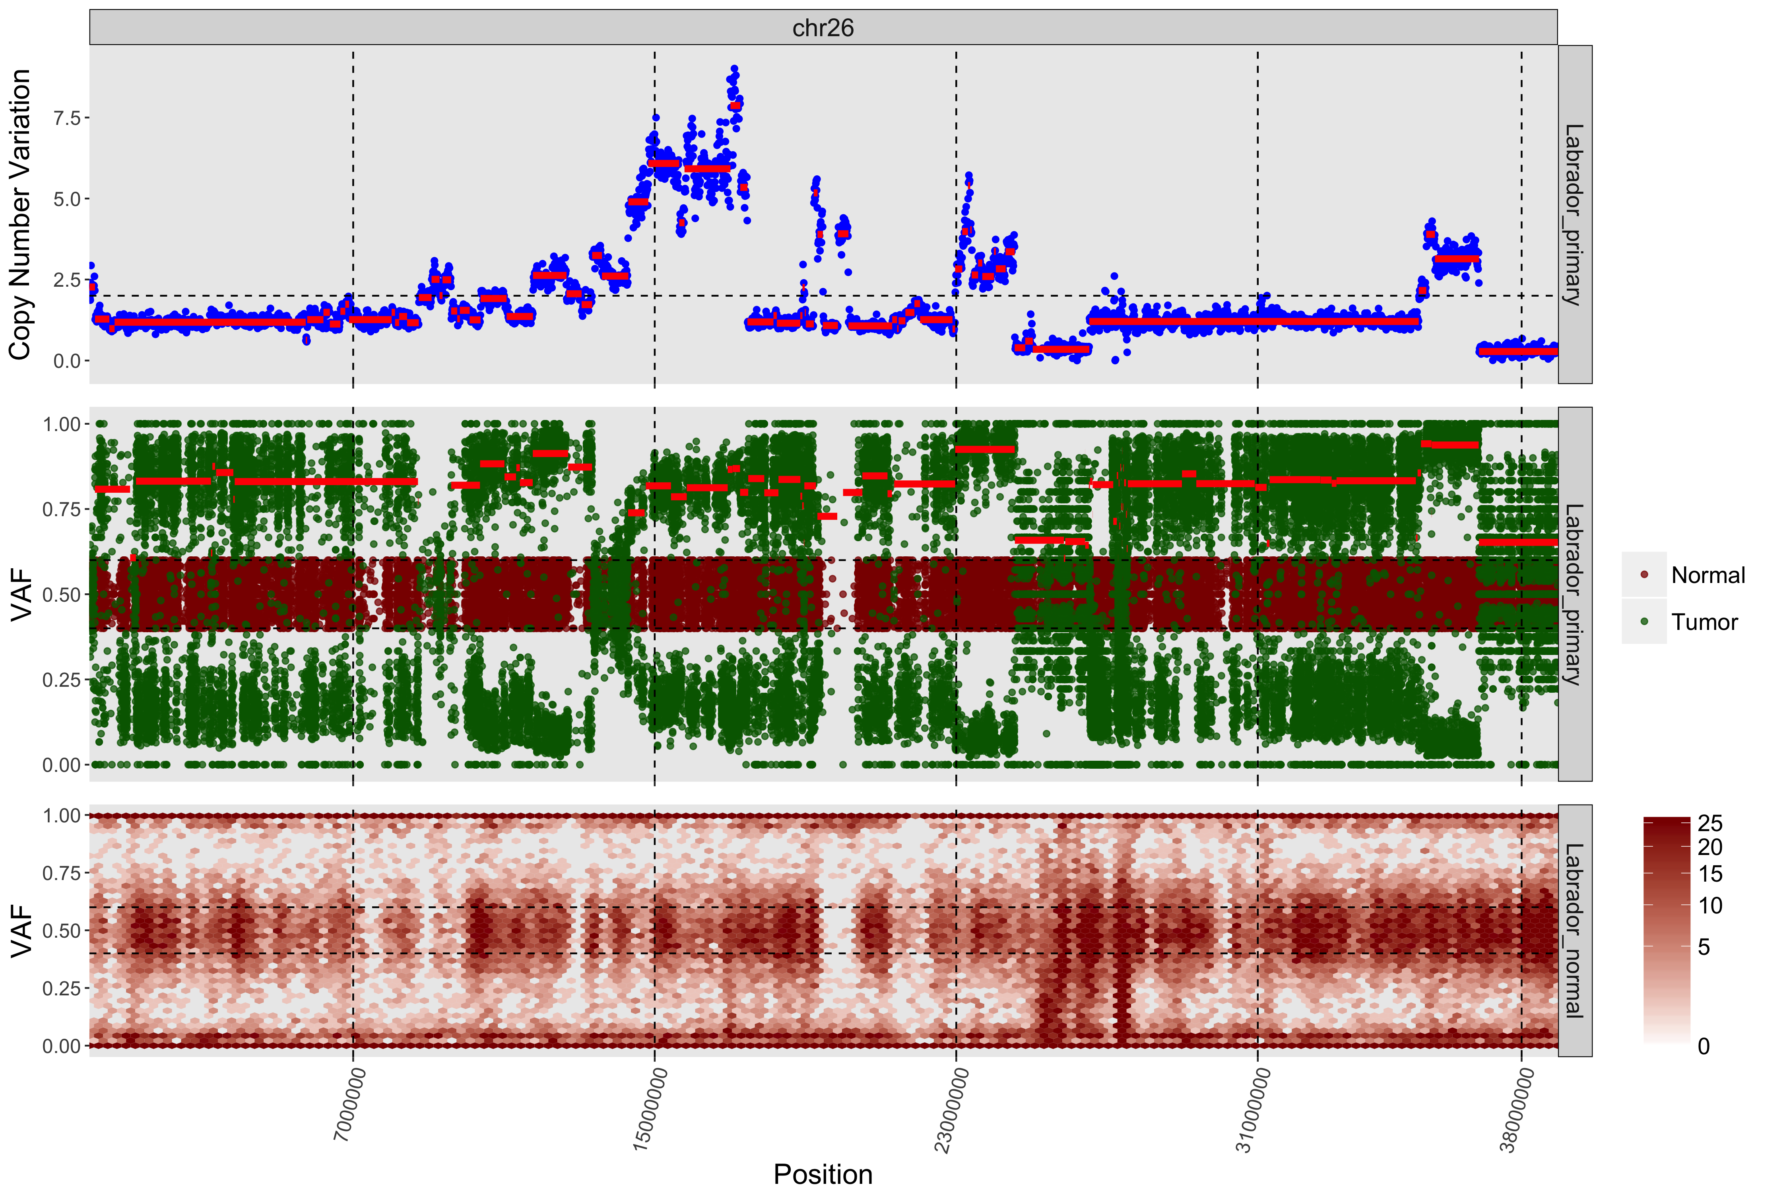

1. Close up view of CNAs for *PTEN* in the Sheepdog primary lesion (top panel), Sheepdog metastatic lesion (middle panel) and Labrador primary lesion (bottom panel)*.*

Macintosh HD:Users:shirleychu:Dropbox:CanineOsteosarcoma:cnv_loh_genes:PTEN:1032_tumor_PTEN.pdf



