Figure S1: Map, plot schematic and preliminary site characterisation of the DIRECT field site.
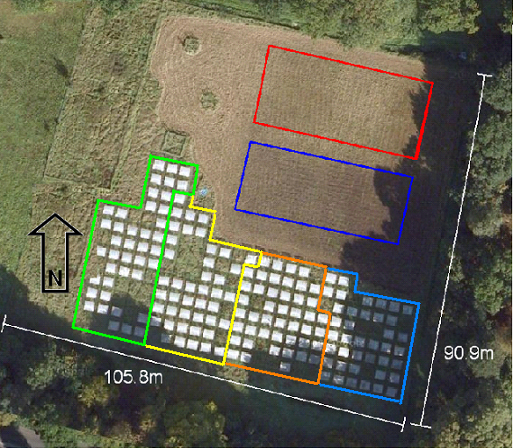
Image of the field site of the DIRECT experiment in June 2009, accessed from Google maps 11/11/10, co-ordinates 51.4091ºN, 0.6378ºW. The dark blue and red rectangles delimit ongoing experiments in 2006 and 2007. The road runs parallel to the 105.8m long periphery of the field, ~20m away. The shelters slope into the prevailing wind. Block 1 is surrounded by light blue, through to block 4 in green. Plots without roofs belong to a related experiment.

