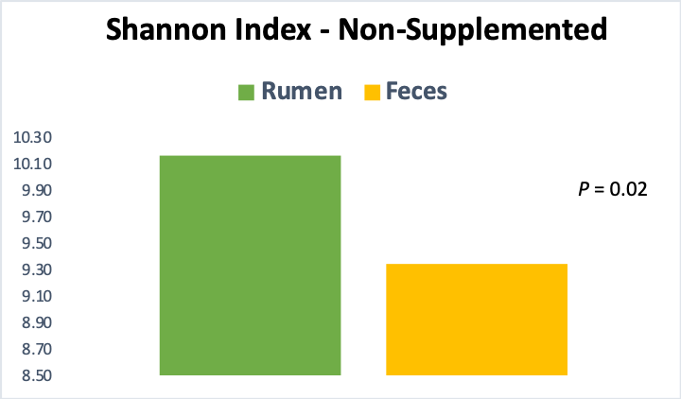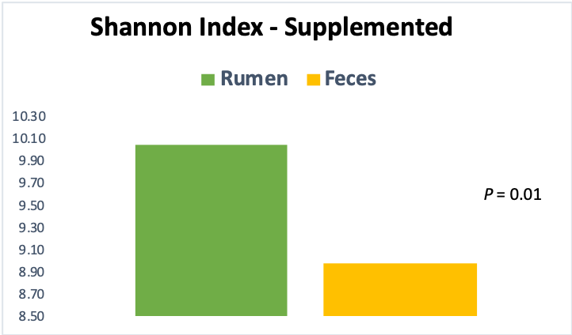

**S2 Fig. Shannon Diversity Index for the ruminal and fecal environments in supplemented and non-supplemented calves.**