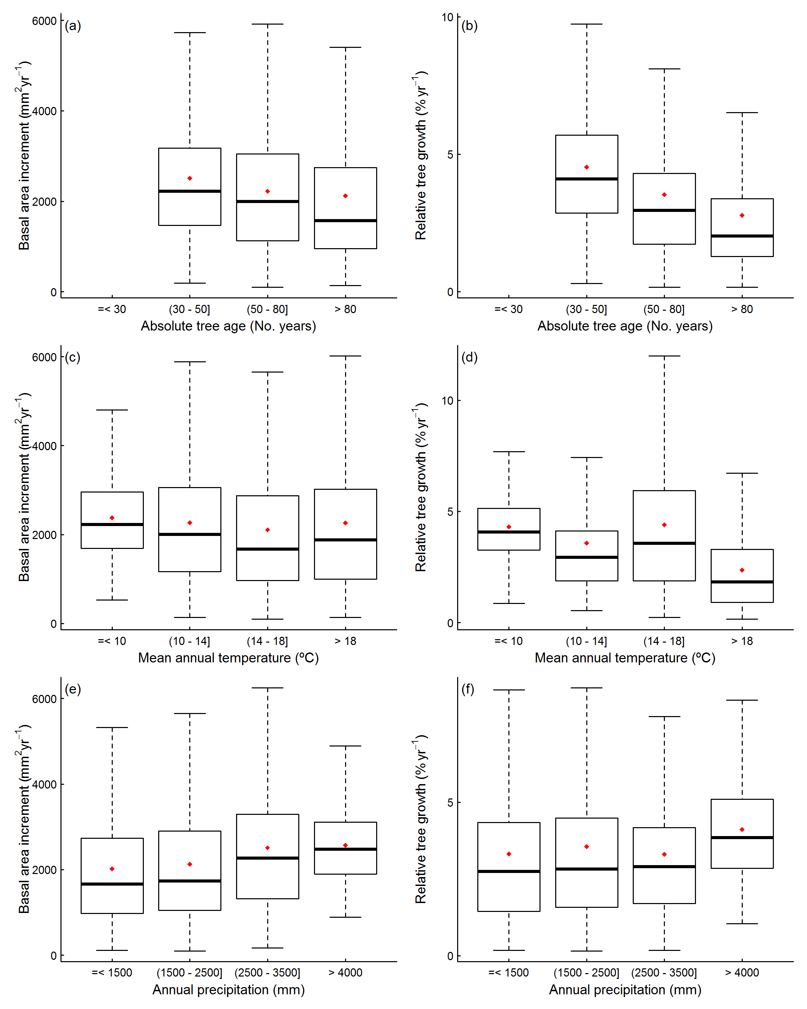
S2 Figure. Box-whisker plots of stand basal area increment and relative tree growth with predictor variables in mature stages. ((a) and (b), respectively) tree age (No. years), ((c) and (d), respectively) mean annual temperature (ºC) and ((e) and (f), respectively) annual precipitation (mm).

