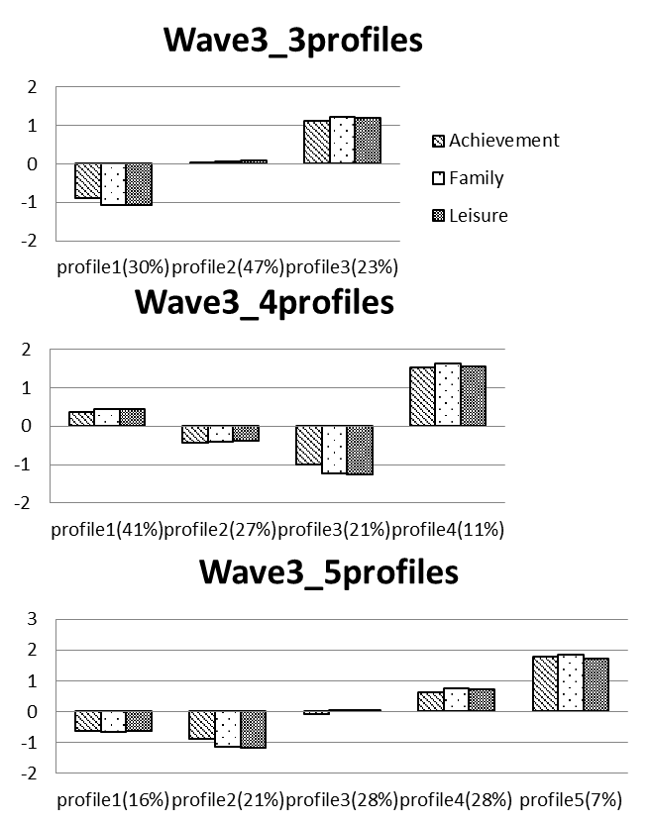

**S9 Fig. latent profile analysis solution for Cohort 1995 at wave 3.**