The importance of stock herding and dairying in the Neolithic Balkans and the subsistence diversity
Supplement Information 2: Graphic representation of pottery samples

Darko Stojanovski, Ivana Živaljević, Vesna Dimitrijević, Julie Dunne, Richard P. Evershed, Marie Balasse, Adam Dowle, Jessica Hendy, Krista McGrath, Roman Fischer, Camilla Speller, Jelena Jovanović, Emmanuelle Casanova, Timothy Knowles, Lidija Balj, Goce Naumov, Anđelka Putica, Andrej Starović, Sofija Stefanović

Morpho-typology:

T210 = hemispherical dishes
T220 = conical dishes
T230 = dishes with everting rim

T310 = spherical bowls
T320 = necked bowls
T330 = bowls with everting rim
T410 = spherical jars (hole-mouth)
T420 = spherical jars with slightly protruding neck (pear-shaped)
T430 = necked jars
T440 = jars with everting rim (S-shaped)

T500 = altars

Assignment of detected lipids:

Yellow = dairy fats
Red = ruminant adipose fats
Pink = ruminant / non-ruminant adipose fat mixture
Blue = fats from aquatic resources (fish)
Green = plant fats and oils
Brown = beeswax / honey

The sample codes under graphics correspond with the codes in the tabular representation in Supplement 1.

Vrbjanska Čuka, Pelagonia, Macedonia, South-central Balkan
6000-5700 calBC

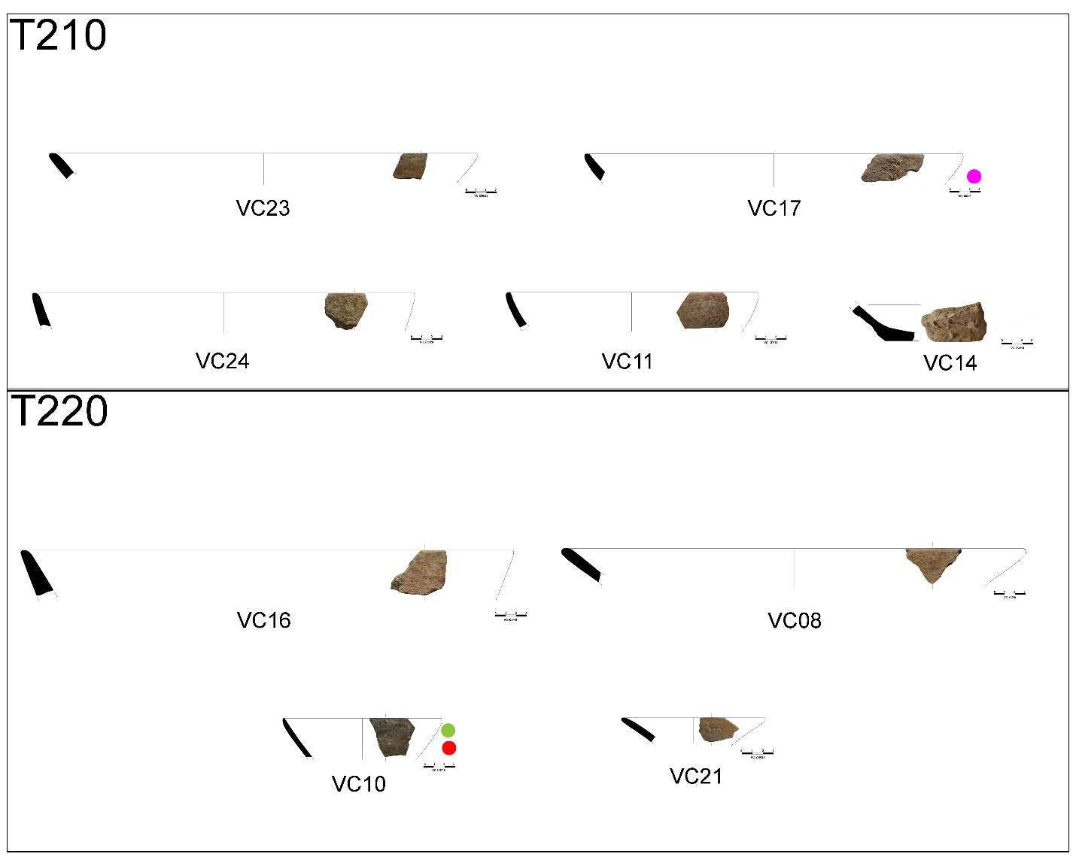
Fig. S2.1 Dish samples from Vrbjanska Čuka

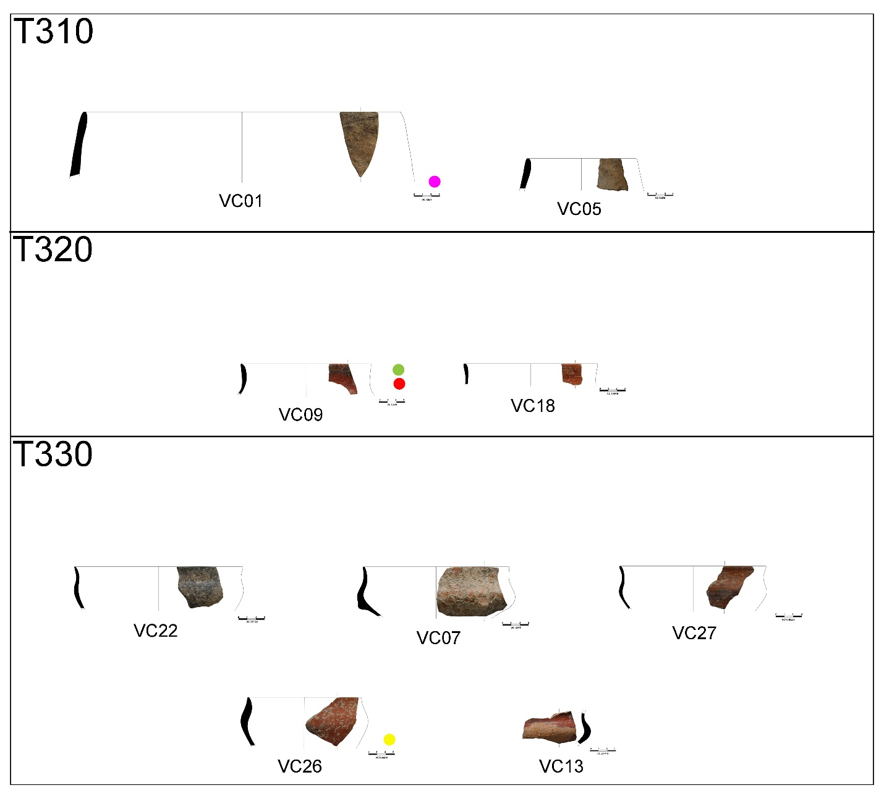
Fig. S2.2 Bowl samples from Vrbjanska Čuka

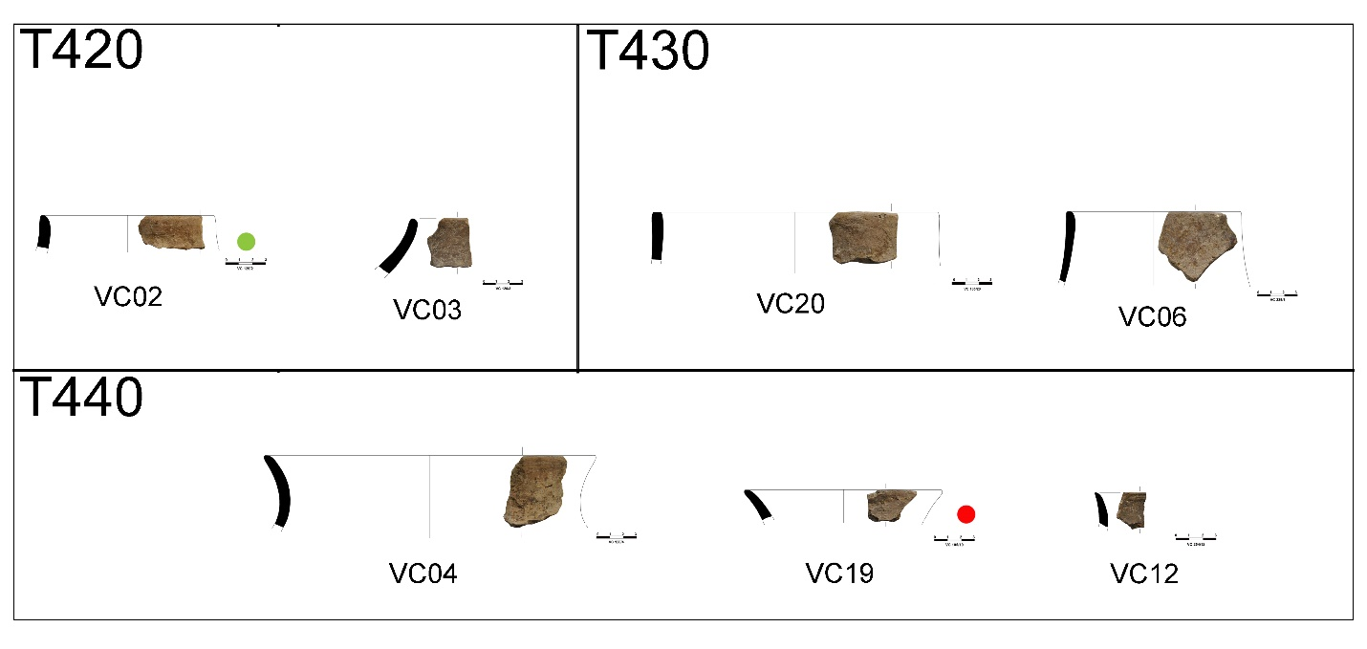
Fig. S2.3 Jar samples from Vrbjanska Čuka

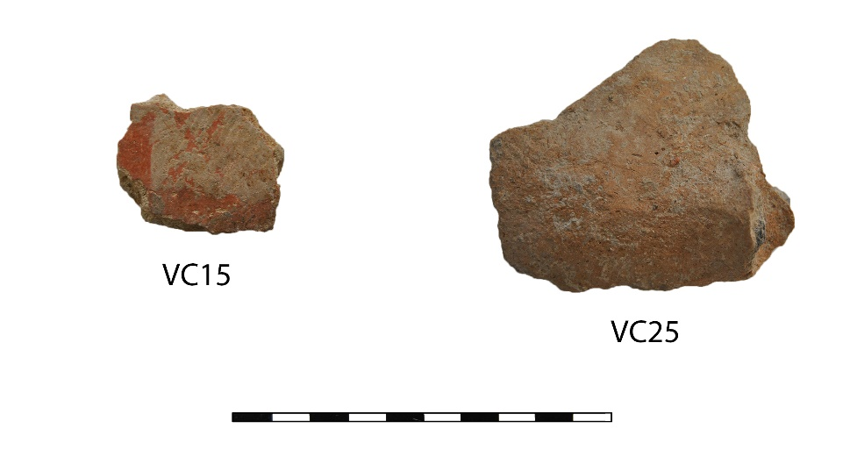
Fig. S2.4 Samples from Vrbjanska Čuka from vessels with uncertain morphology

Starčevo-Grad, South-eastern Vojvodina, Serbia, northern Balkan
first half of the 6th millennium calBC

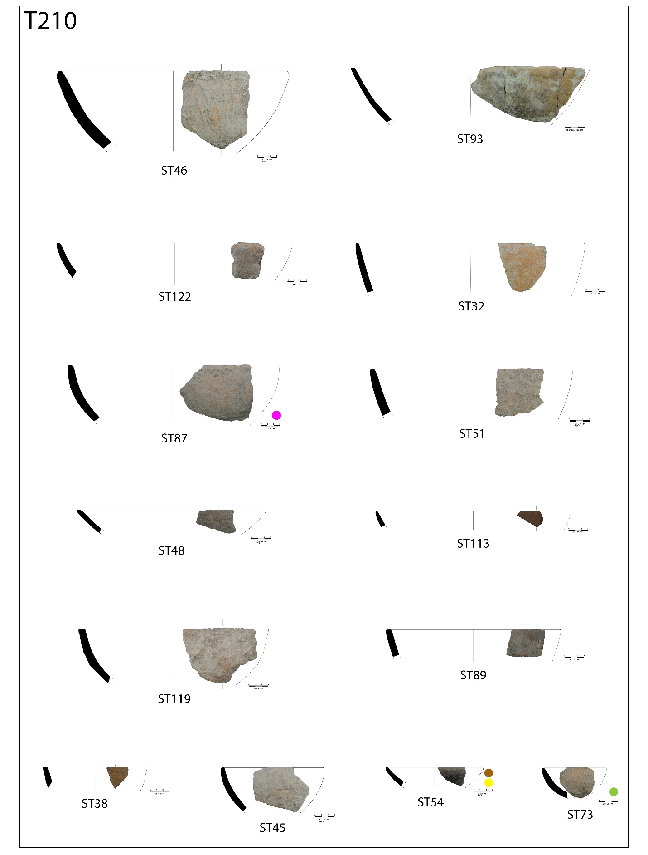
Fig. S2.5 Spherical shaped dish samples from Starčevo-Grad

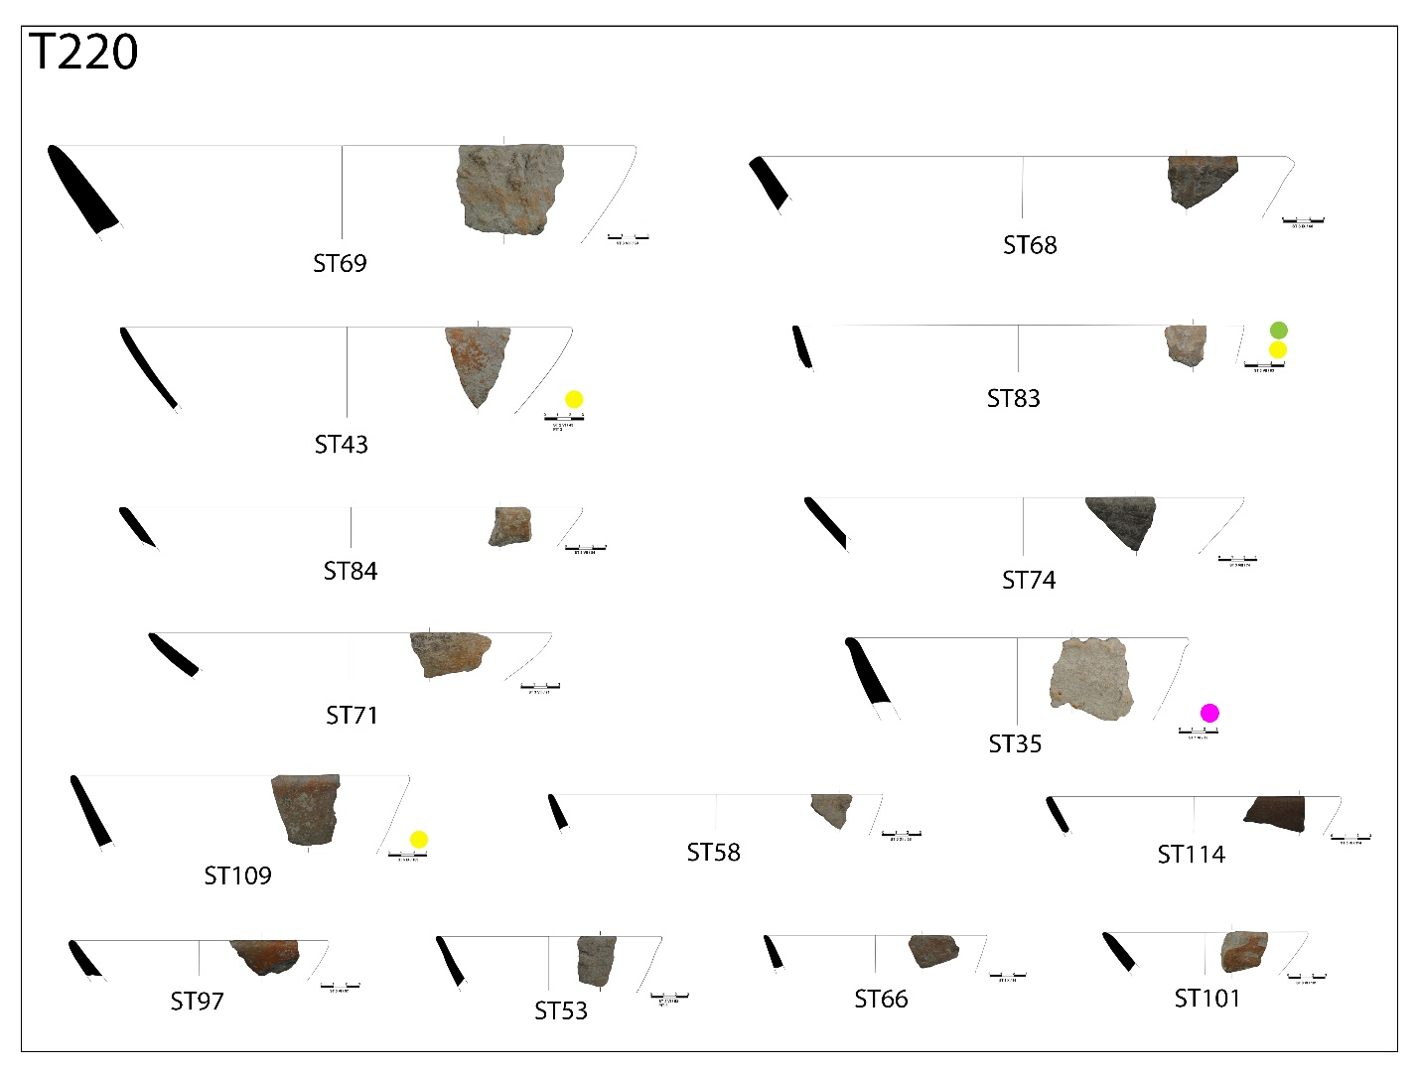
Fig. S2.6 Conical shaped dish samples from Starčevo-Grad

Fig. S2.7 Sample from dish with everted rim from Starčevo-Grad

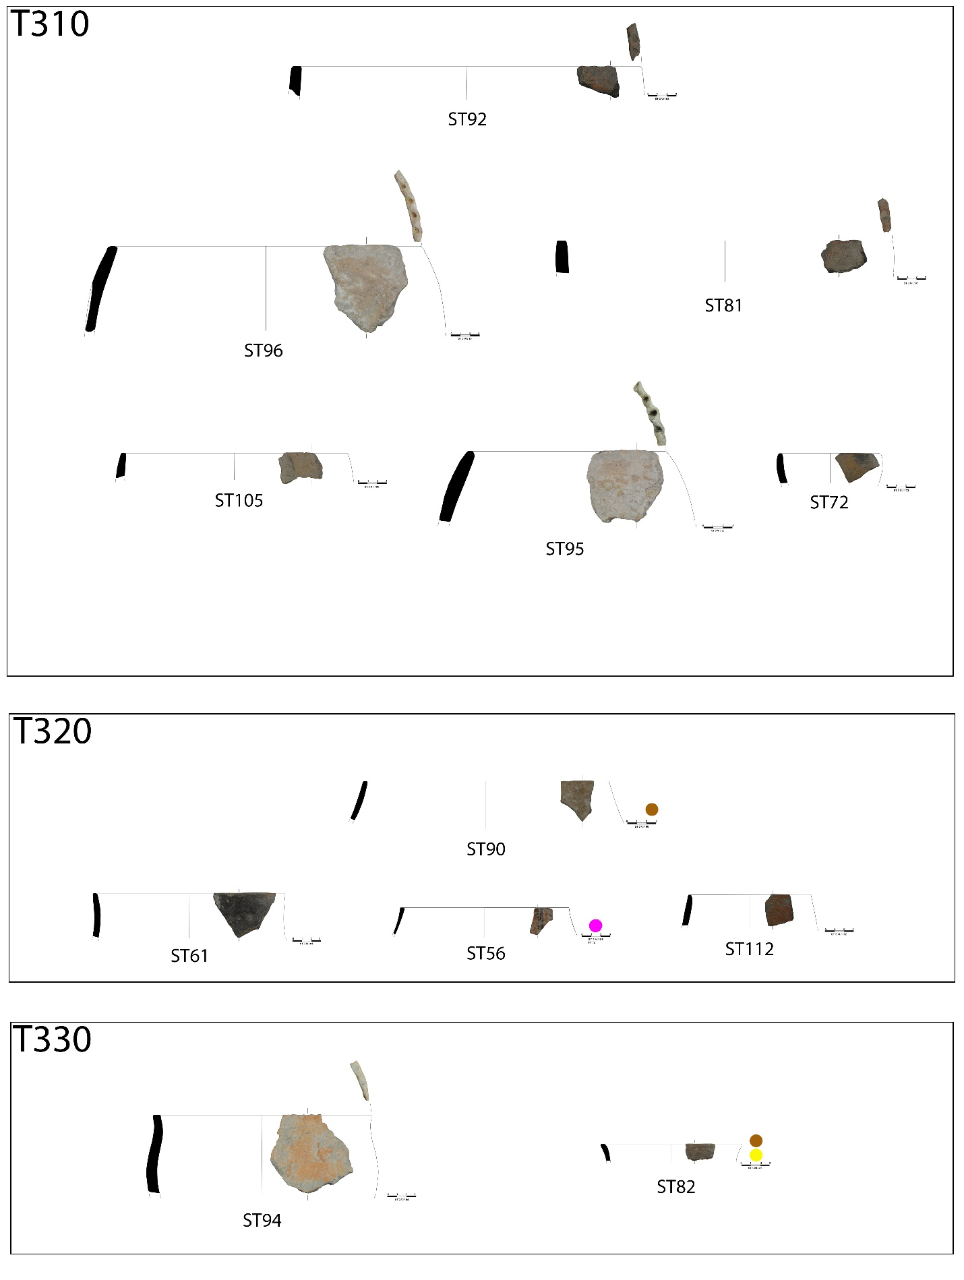
Fig. S2.8 Bowl samples from Starčevo-Grad

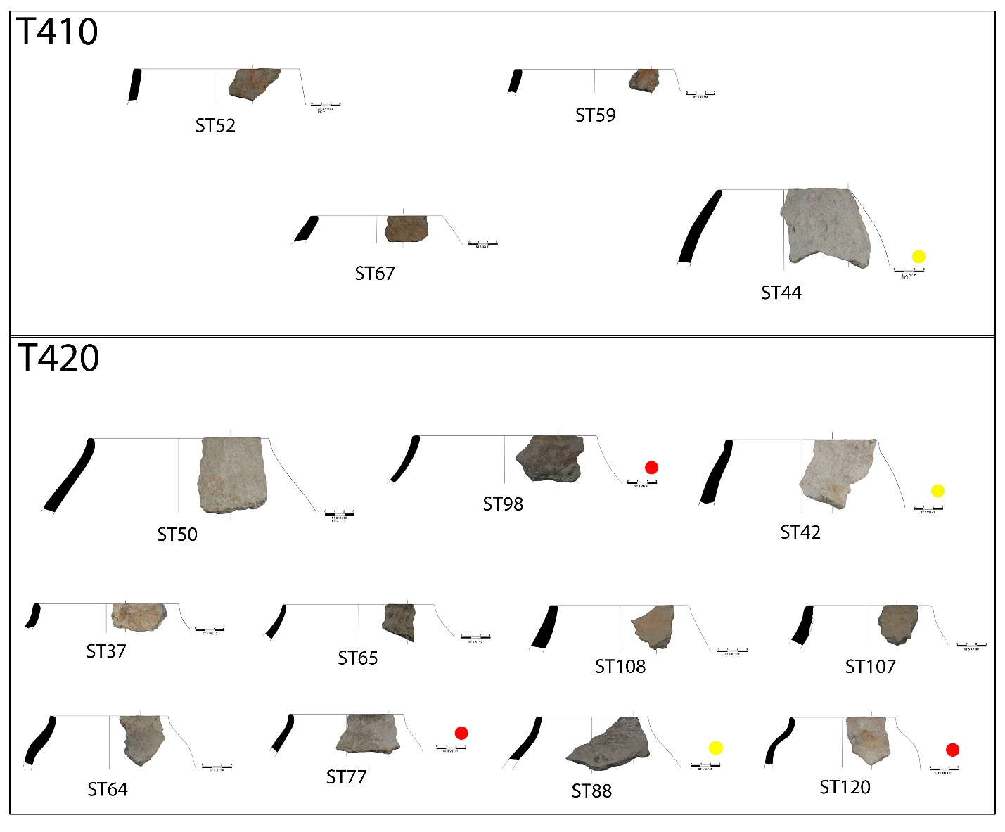
Fig. S2.9 Spherical and pear-shaped jar samples from Starčevo-Grad

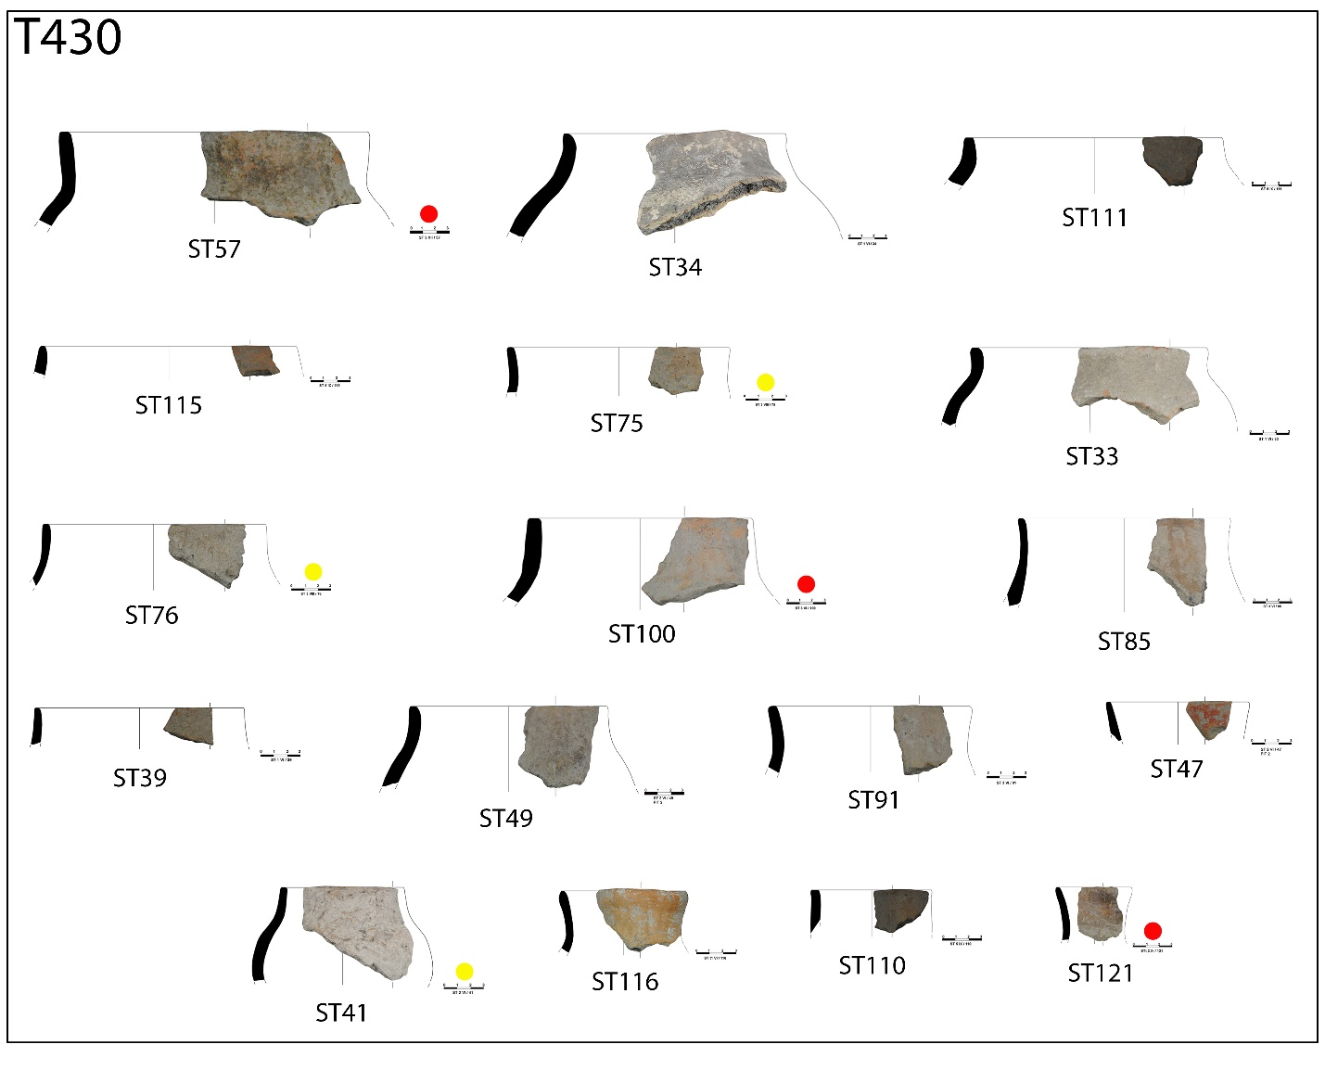
Fig. S2.10 Necked jar samples from Starčevo-Grad

Fig. S2.11 Sample from jar with everting rim (S-shaped) from Starčevo-Grad
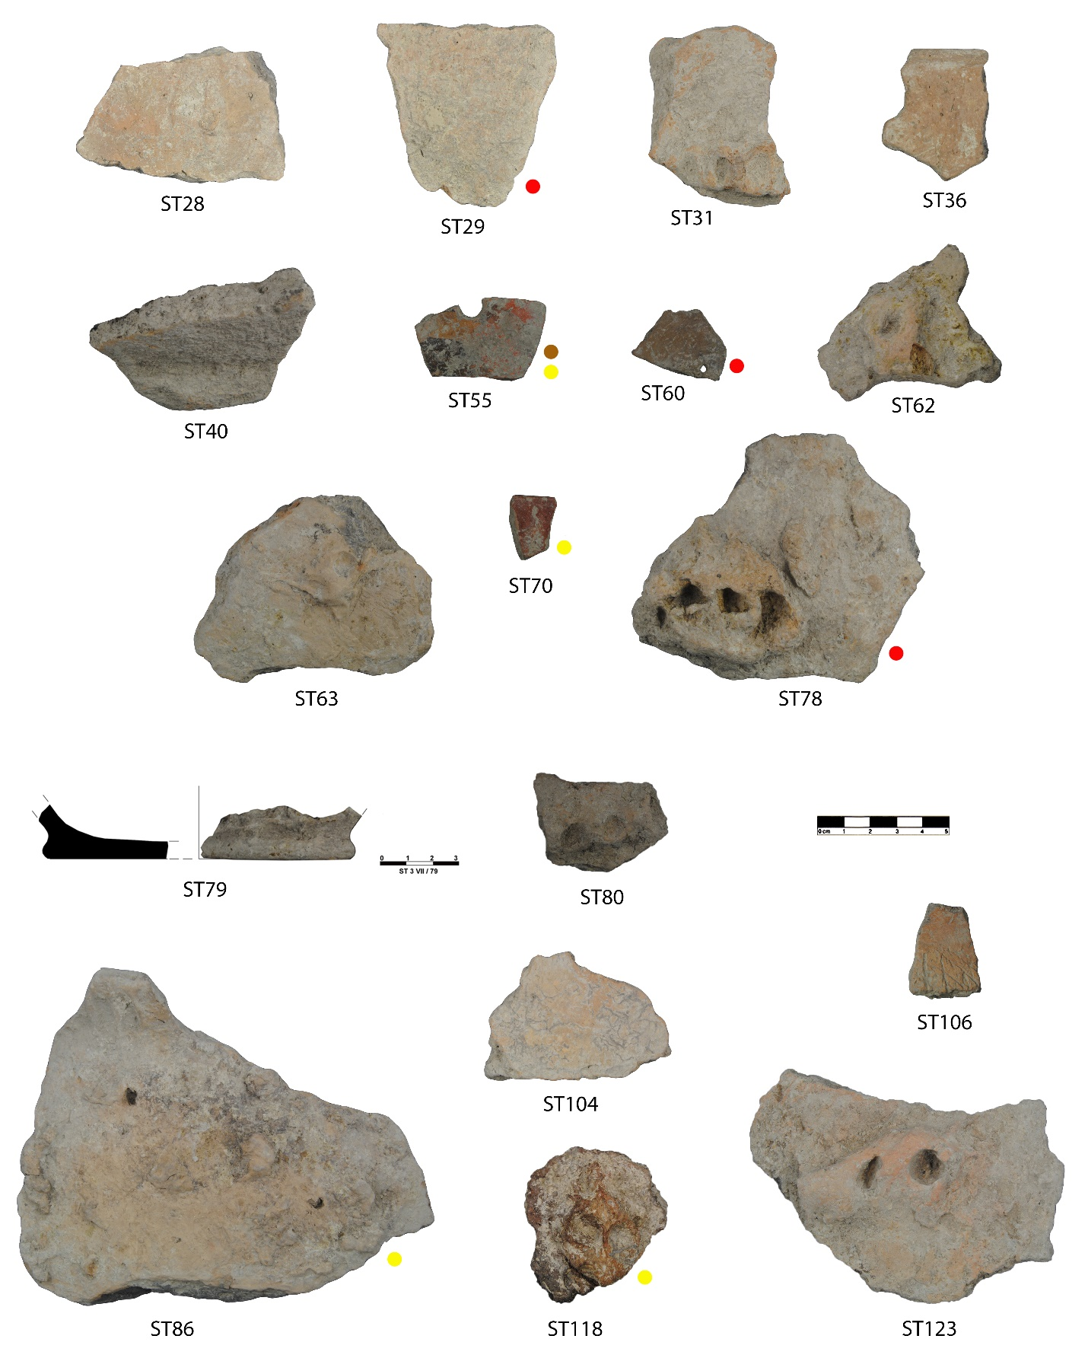
Fig. S2.12 Samples from Starčevo-Grad from vessels with uncertain morphology

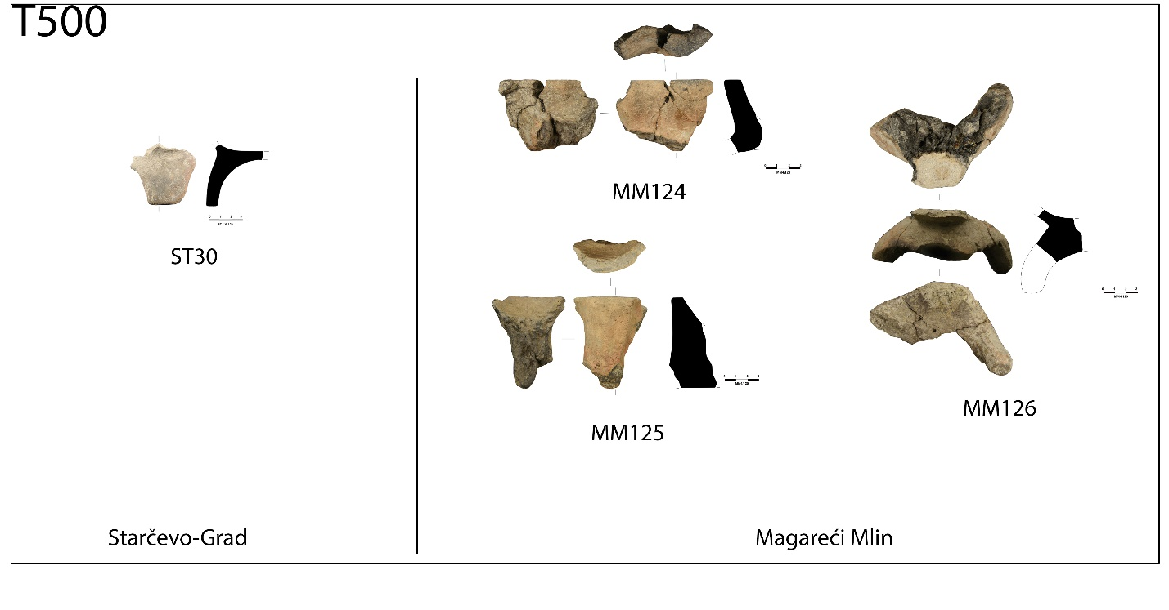
Fig. S2.13 Altar samples (legs and recipients) from Starčevo-Grad and Magareći Mlin

Magareći Mlin, western Vojvodina, Serbia, northern Balkan
Early 6th millennium calBC

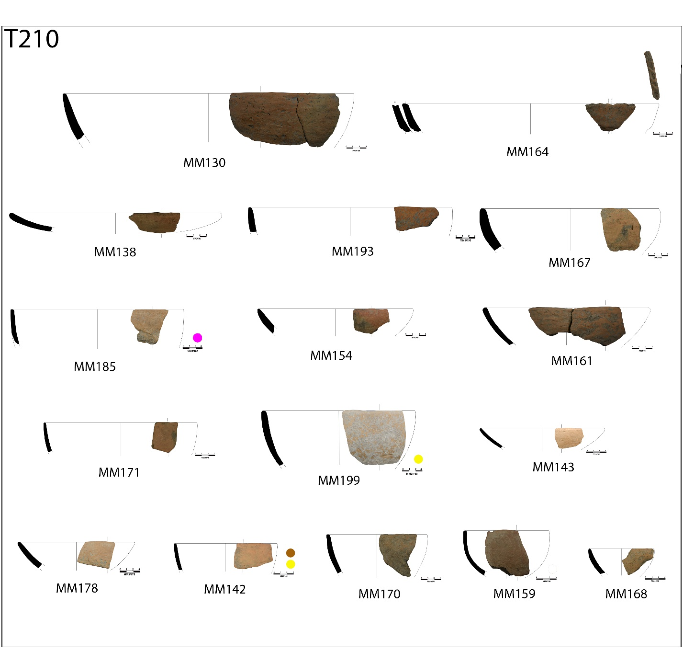
Fig. S2.14 Spherical dish samples from Magareći Mlin

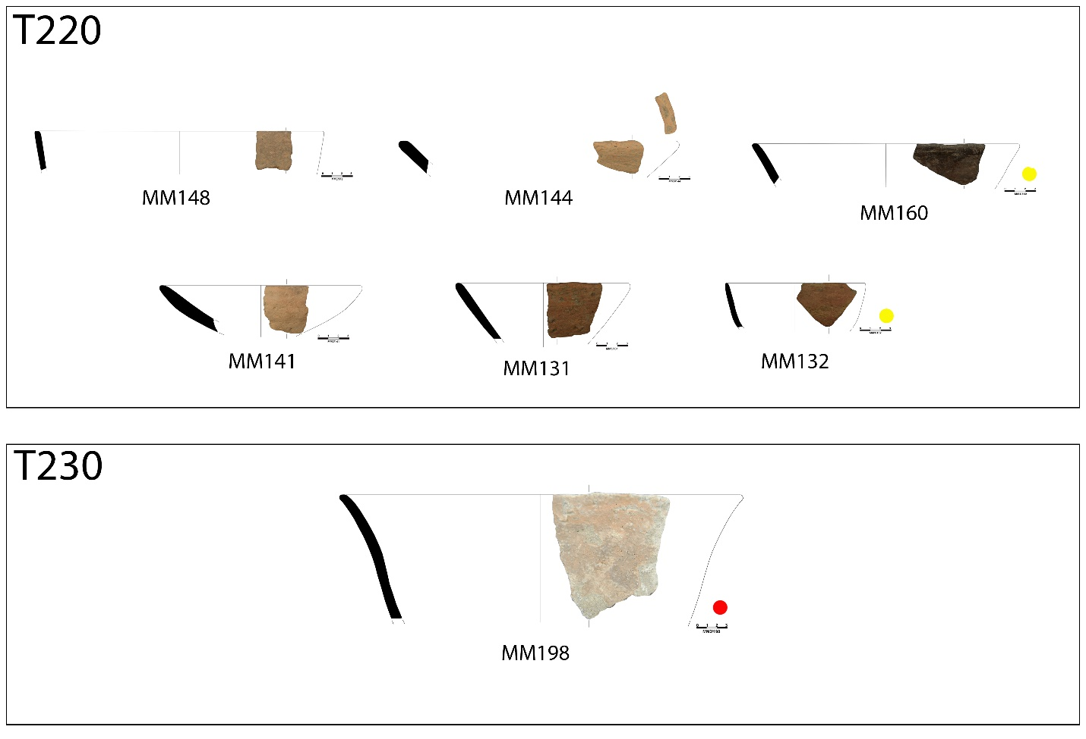
Fig. S2.15 Conical and everted-rim dish samples from Magareći Mlin

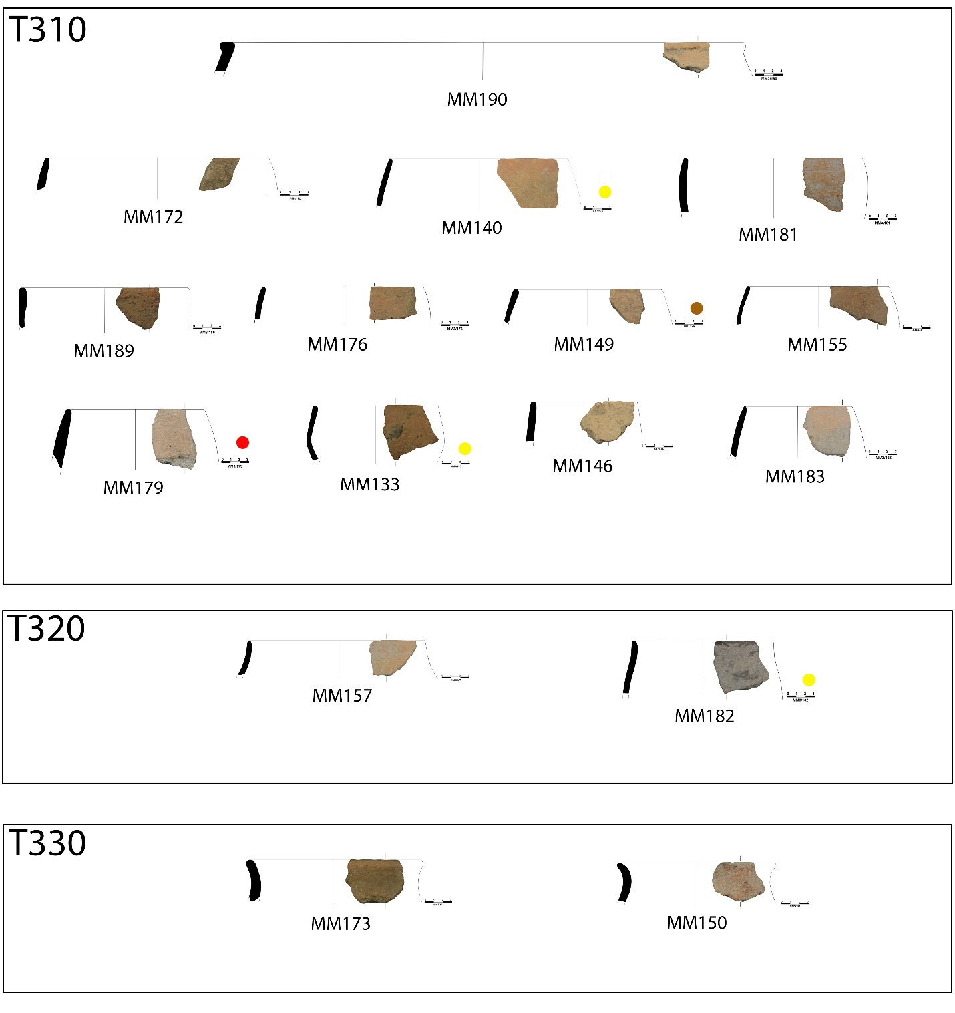
Fig. S2.16 Bowl samples from Magareći Mlin
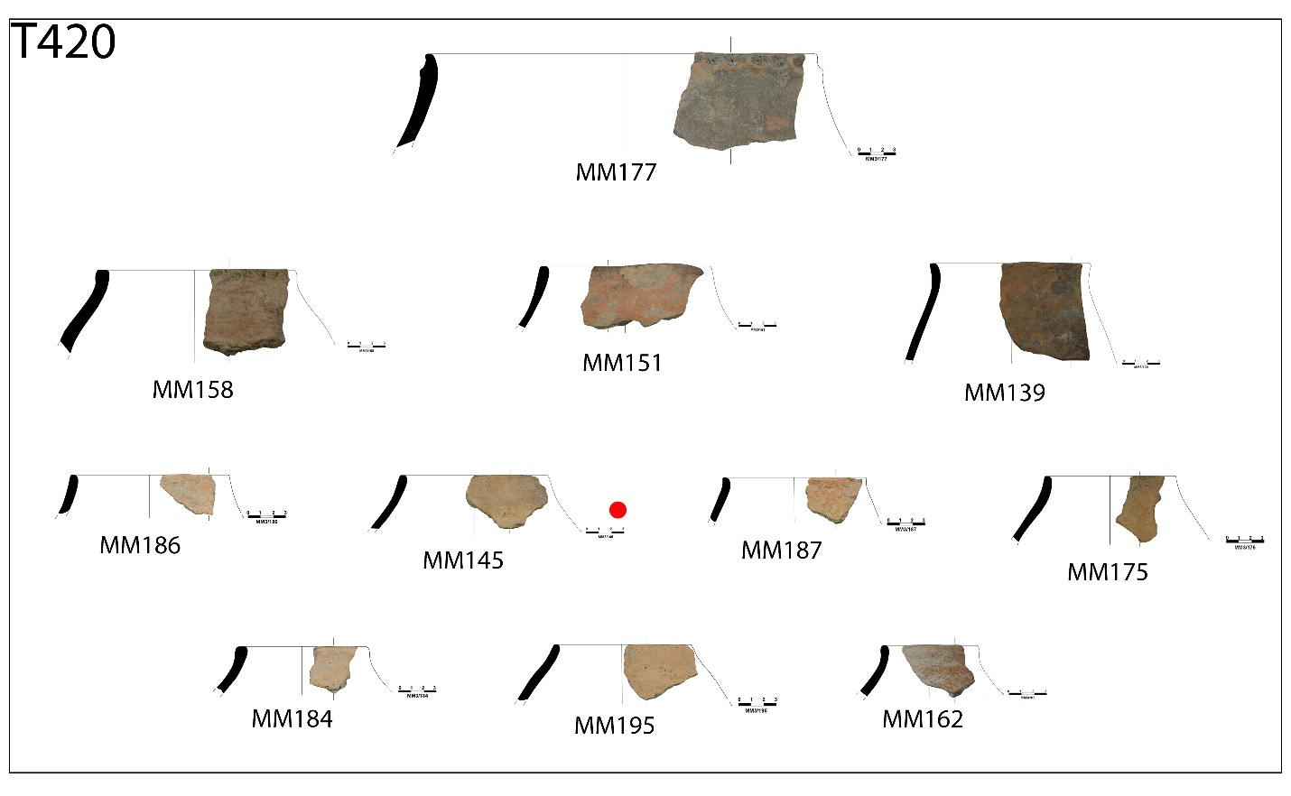
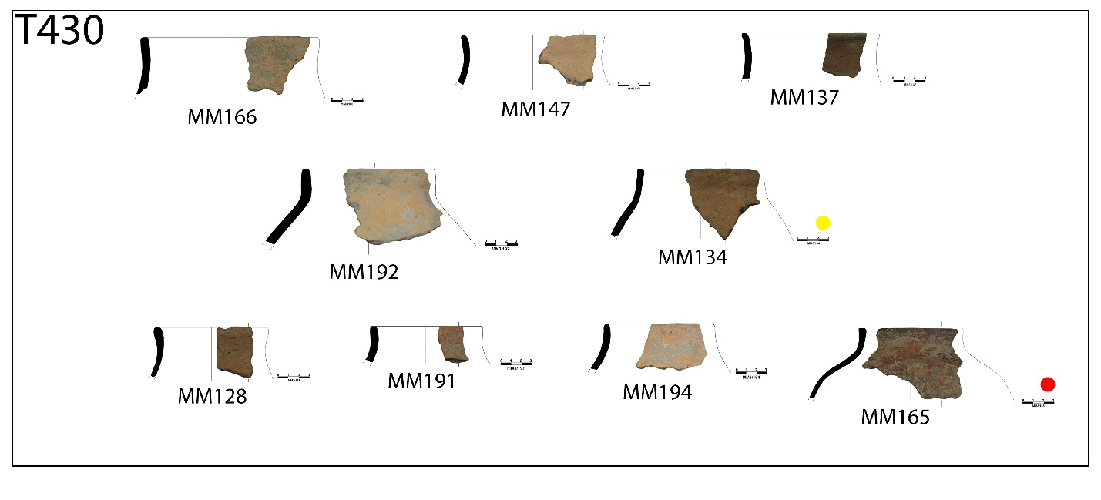
Fig. S2.17 Jar samples from Magareći Mlin

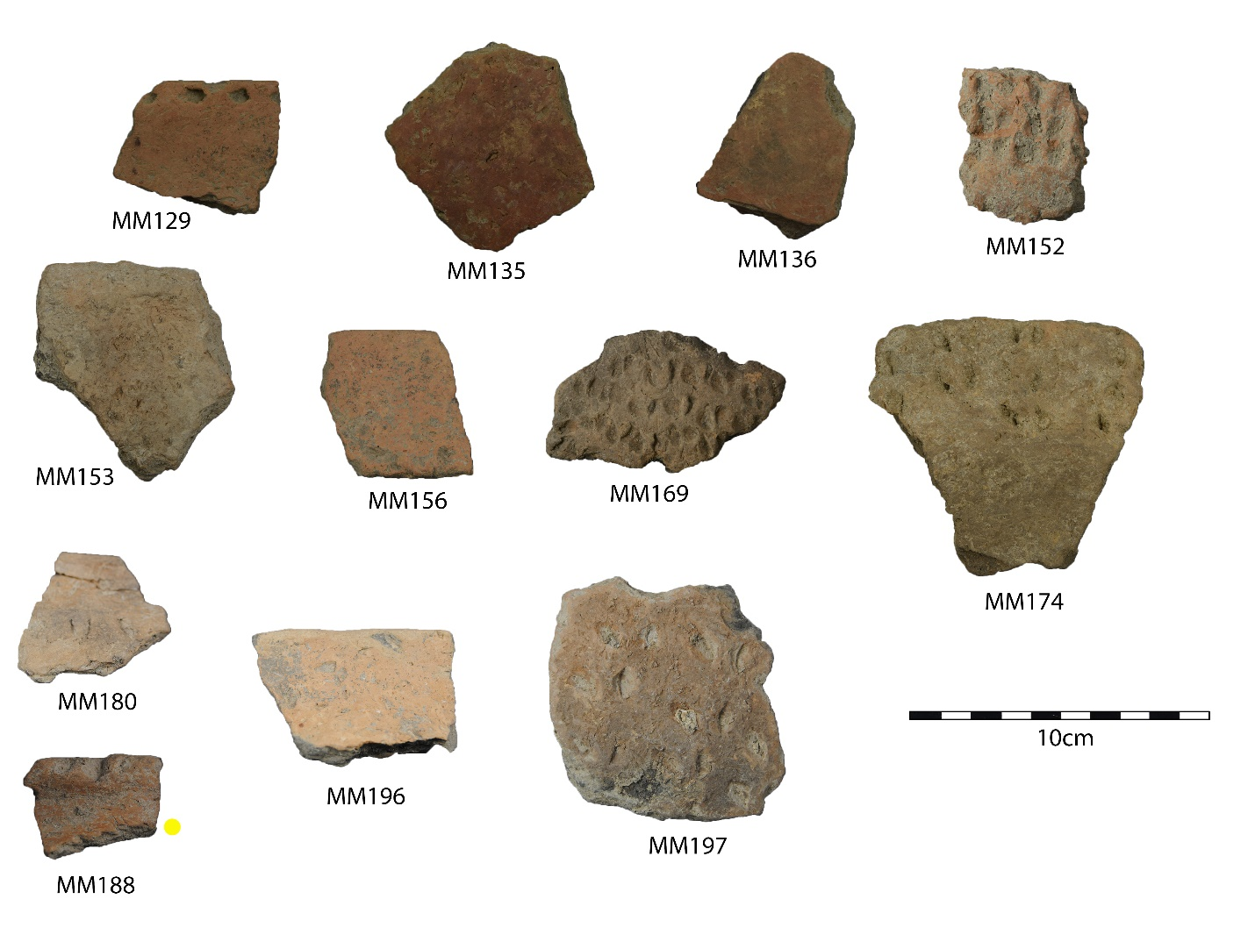
Fig. S2.18 Samples from Magareći Mlin from vessels with uncertain morphology

Rutonjina Greda, central Vojvodina, Serbia, northern Balkan
first half of the 6th millennium calBC

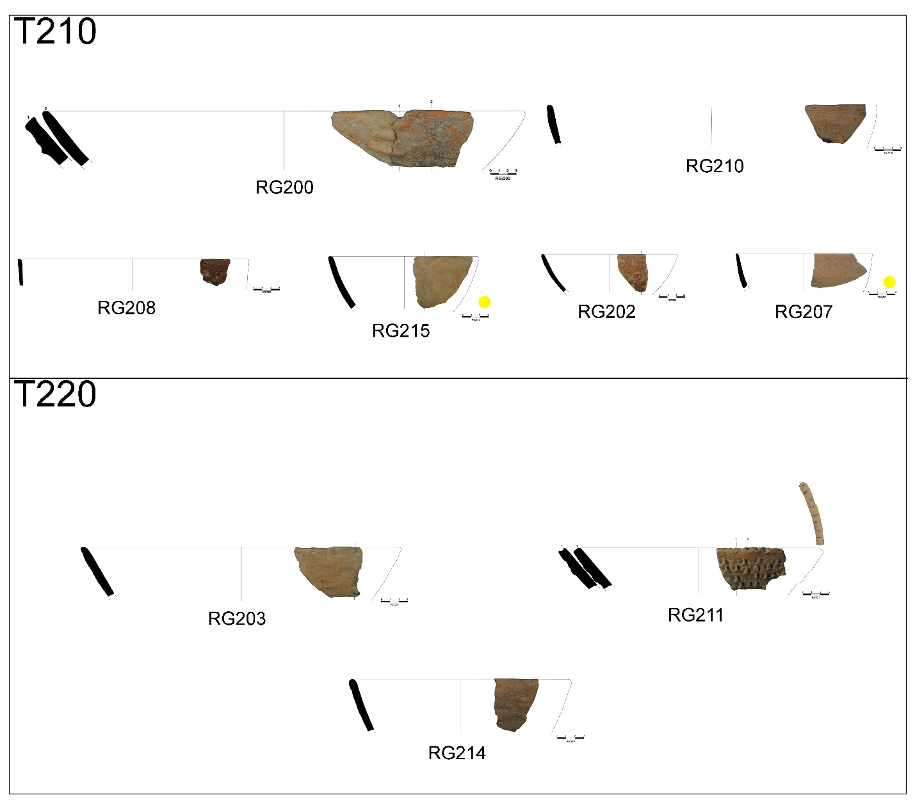
Fig. S2.19 Dish samples from Rutonjina Greda
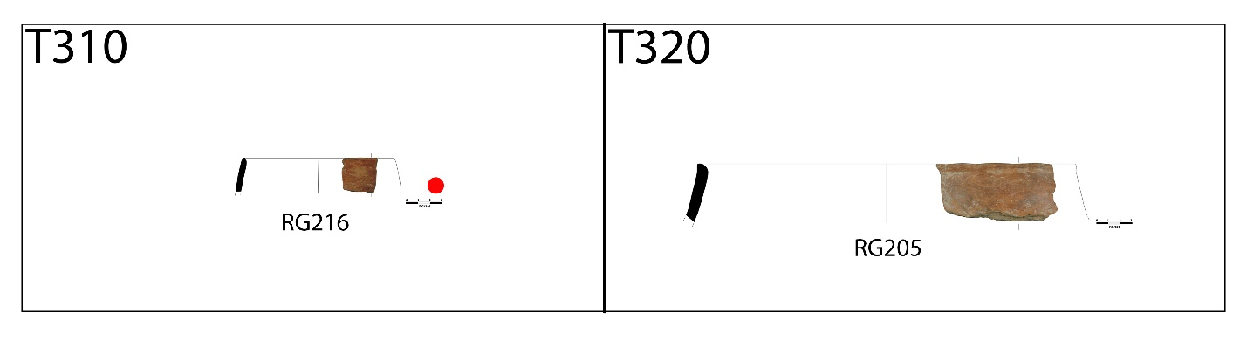
Fig. S2.20 Bowl samples from Rutonjina Greda

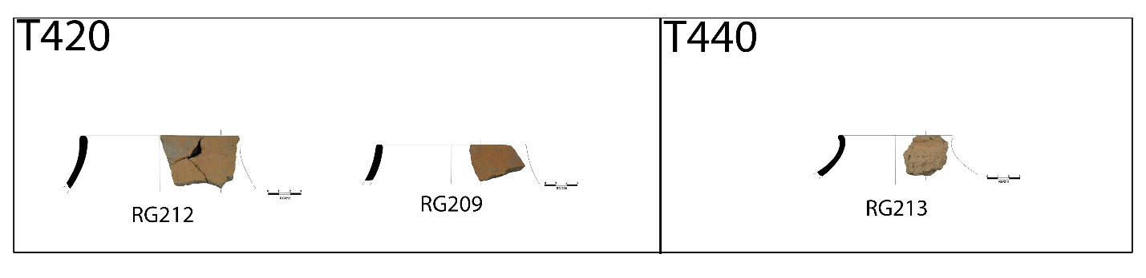
Fig. S2.21 Jar samples from Rutonjina Greda

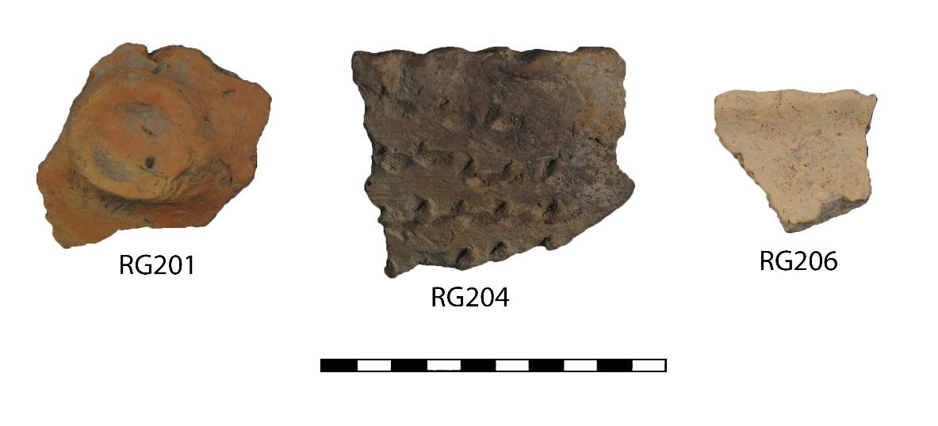
Fig. S2.22 Samples from Rutonjina Greda from vessels with uncertain morphology

