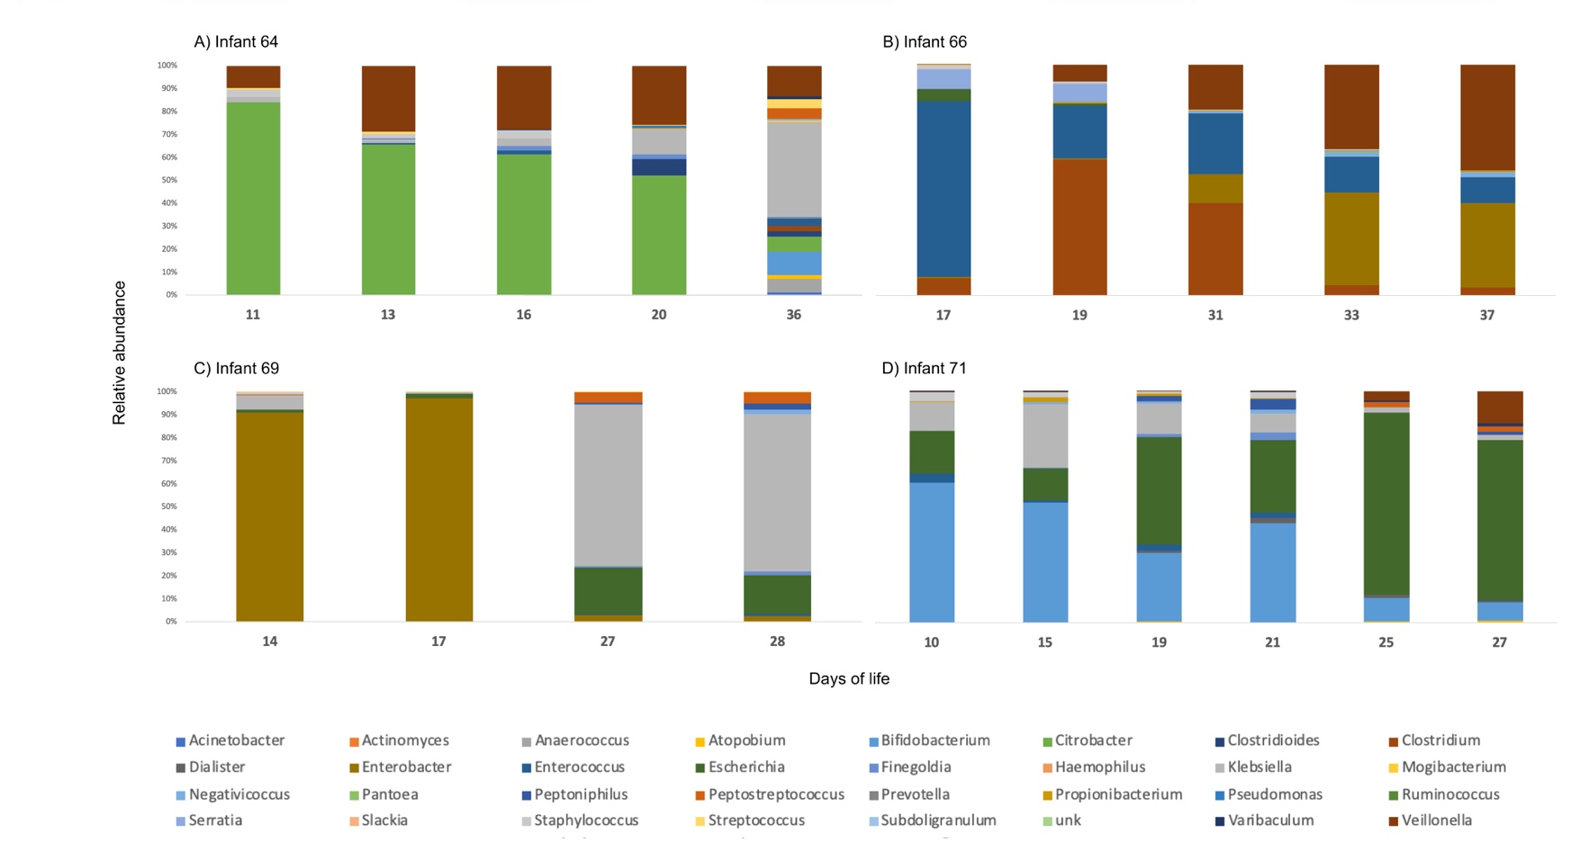
Fig A. Relative abundances of different Bacterial genera found in stool samples of premature infants on different days of life. Infants 64 and 66 are control infants, infants 69 and 71 were later on diagnosed with Necrotizing enterocolitis.

Table A. Accession phrases for Escherichia spp. genes in on ggkbase interface (https://ggkbase.berkeley.edu/) used in this study
Coupled genes for DR | Genes | Scaffolds used for the different infants
 |  | Infant 71 | Infant 69 | Infant 66 | Infant 64
1) | cydAB | 71_013_scaffold_12_143-144 | 69_008_scaffold_426_11-10 | 66_004_scaffold_7_85-84 | N2_064_000G1_scaffold_3505_6-5
1) | cyoABCD | 71_013_scaffold_3_97-100 | 69_008_scaffold_38_77-74 | 66_004_scaffold_23_112-115 | N2_064_000G1_scaffold_1959_5-8
2) | arcA | 71_013_scaffold_7_194 | 69_008_scaffold_6_24 | 66_004_scaffold_32_26 | N2_064_000G1_scaffold_499_1
2) | fnr | 71_013_scaffold_10_62 | 69_008_scaffold_39_24 | 66_004_scaffold_22_279 | N2_064_000G1_scaffold_1695_1
3) | nrdDG | 71_013_scaffold_7_318-19 | 69_008_scaffold_6_178-179 | 66_004_scaffold_8_200-199 | N2_064_000G1_scaffold_3_430-431
3) | nrdAB | 71_013_scaffold_13_152-151 | 69_008_scaffold_35_2-3 | 66_004_scaffold_6_87-86 | N2_064_000G1_scaffold_327_42-41
4) | norVW | 71_013_scaffold_6_83-84 | 69_008_scaffold_67_16-17 | 66_004_scaffold_66_52-53 | N2_064_000G1_scaffold_620_14-15
4) | norR | 71_013_scaffold_6_82 | 69_008_scaffold_67_15 | 66_004_scaffold_66_54 | N2_064_000G1_scaffold_620_13
5) | ompC | 71_013_scaffold_13_171 | 69_008_scaffold_1_16 | 66_004_scaffold_6_93 | N2_064_000G1_scaffold_844_3
5) | ompF | 71_013_scaffold_17_90 | 69_008_scaffold_116_19 | 66_004_scaffold_11_234 | N2_064_000G1_scaffold_923_6

Table B. Percent of shared affiliation of the predicted proteins on the same scaffold of each of Escherichia spp. genomes
 | Super-kingdom |  | Phylum |  | Class |  | Order |  | Family |  | Genus |  | Species
Infant | % | Winner | % | Winner | % | Winner | % | Winner | % | Winner | % | Winner | % | Winner
64 | 100 | Bacteria | 95 | Proteobacteria | 95 | Gammaproteobacteria | 95 | Enterobacterales | 94 | Enterobacteriaceae | 90 | Escherichia | 90 | E. coli
66 | 100 | Bacteria | 99 | Proteobacteria | 99 | Gammaproteobacteria | 99 | Enterobacterales | 97 | Enterobacteriaceae | 85 | Escherichia | 84 | E. vulneris
69 | 100 | Bacteria | 100 | Proteobacteria | 100 | Gammaproteobacteria | 100 | Enterobacterales | 99 | Enterobacteriaceae | 97 | Escherichia | 96 | E. coli
71 | 100 | Bacteria | 100 | Proteobacteria | 100 | Gammaproteobacteria | 100 | Enterobacterales | 100 | Enterobacteriaceae | 96 | Escherichia | 95 | E. coli

