SUPPORTING INFORMATION
Back to the future: the advantage of studying key events in human evolution using a new high resolution radiocarbon method.
Sahra Talamo, Bernd Kromer, Michael P. Richards, Lukas Wacker

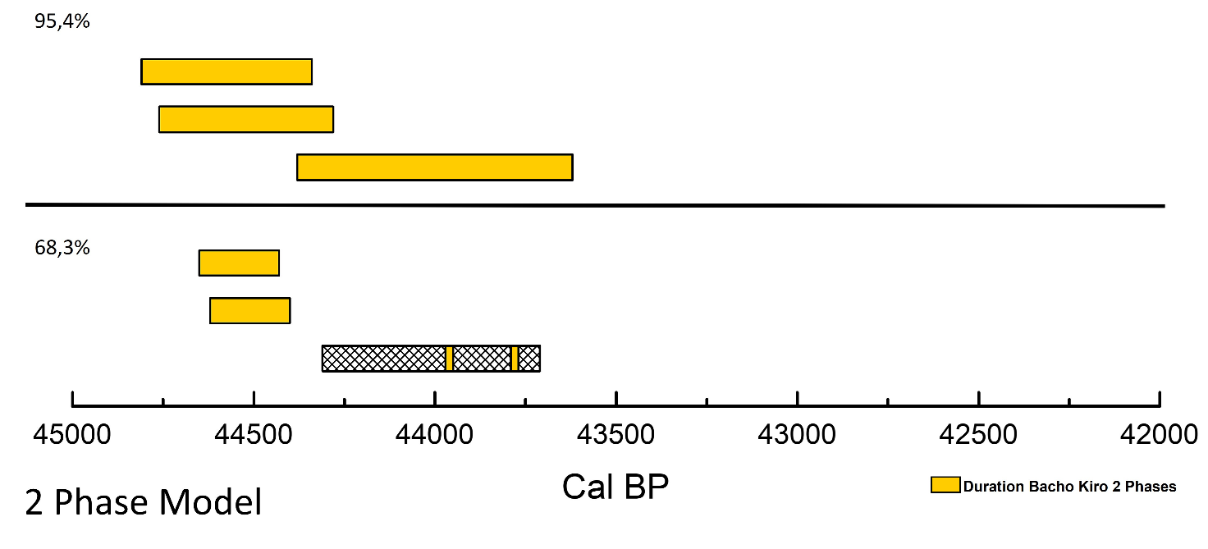
S2 Fig. The calibrated ranges of the 4 Bacho Kiro Homo sapiens in 2 phases model. The calibrated ranges both at 68.3% and at 95.4% of the 4 Bacho Kiro Homo sapiens directly dated obtained using the 2 phases model (dark yellow).

