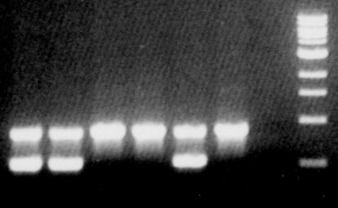

S1 Fig. An example of the tynA screening by PCR. The template DNAs were from E. coli strains isolated from fecal samples. The upper band is a 900 bp positive control (lacY) and the lower band is from the ECAO gene (tynA, 500bp). There are three tynA+ (lanes 1-2 and 5 from left) and three tynA- samples (lanes 3-4 and 6). Negative control (lane 7), size marker (lane 8).

