S11 Table. Power by effect size
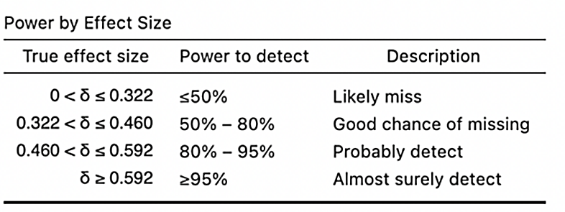
Reference: Bartlett J, Charles S. Power to the People: A Beginner’s Tutorial to Power Analysis using jamovi. 2021.

