S2 Table A: table of ANOVA results with the response variable initial weight
 | Df | Sum Sq | Mean Sq | F value | Pr(>F)
Initial Length | 1 | 20.1960 | 20.1960 | 3632.957 | < 2.2e-16
Clutch | 2 | 0.2187 | 0.1093 | 19.668 | 5.440e-08
Initial Length : Clutch | 2 | 0.3750 | 0.1875 | 33.727 | 4.617e-12
Residuals | 106 | 0.5893 | 0.0056

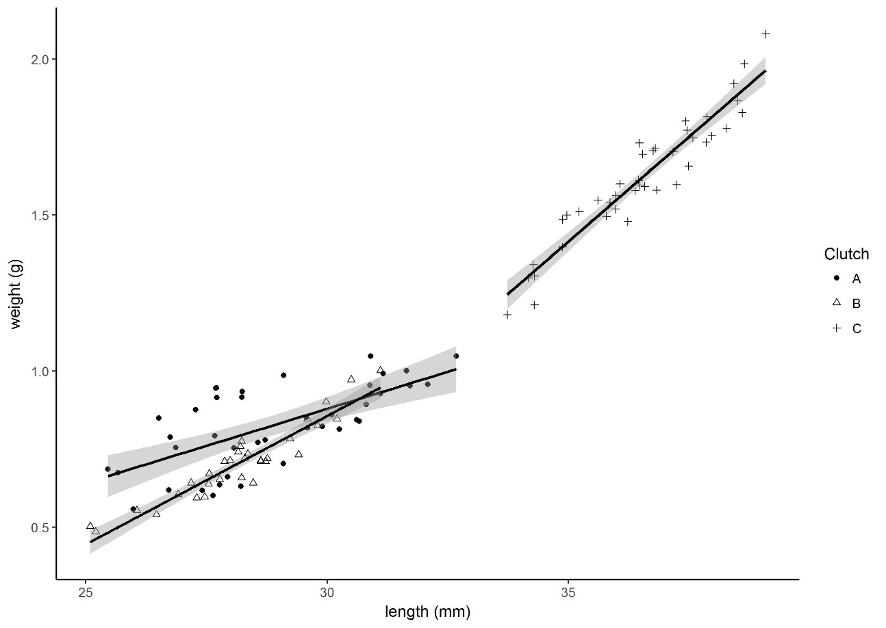
S2 Figure A: length weight relationships of the 3 clutches at the start of the experiment.

S2 Table B: coefficients of the three clutches
Clutch | Intercept | slope
A | -0.54460085 | 0.04746250
B | -1.06841405 | 0.03484301
C | -2.73881573 | 0.08678282

