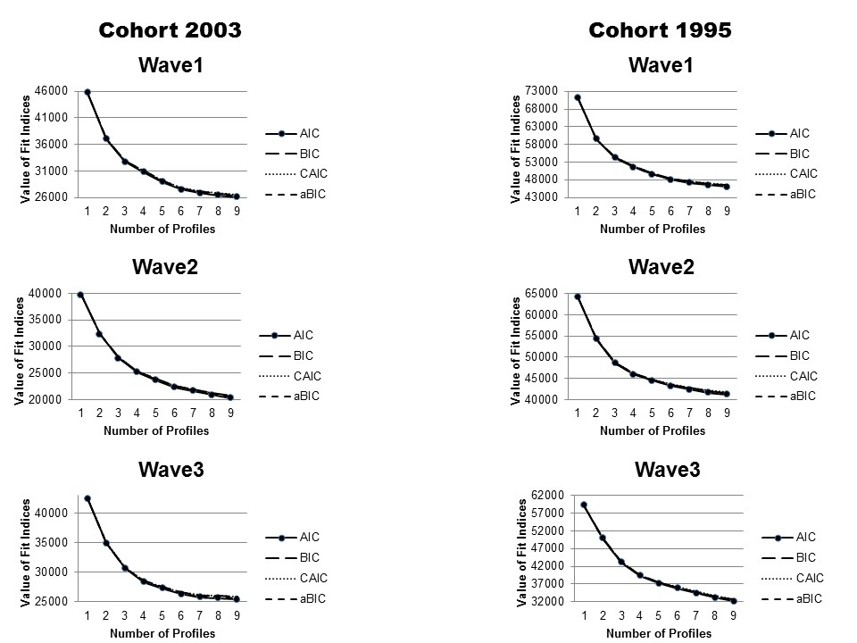
S3 Fig. Elbow plots for Cohort 2003 and Cohort 1995 across 3 waves.

