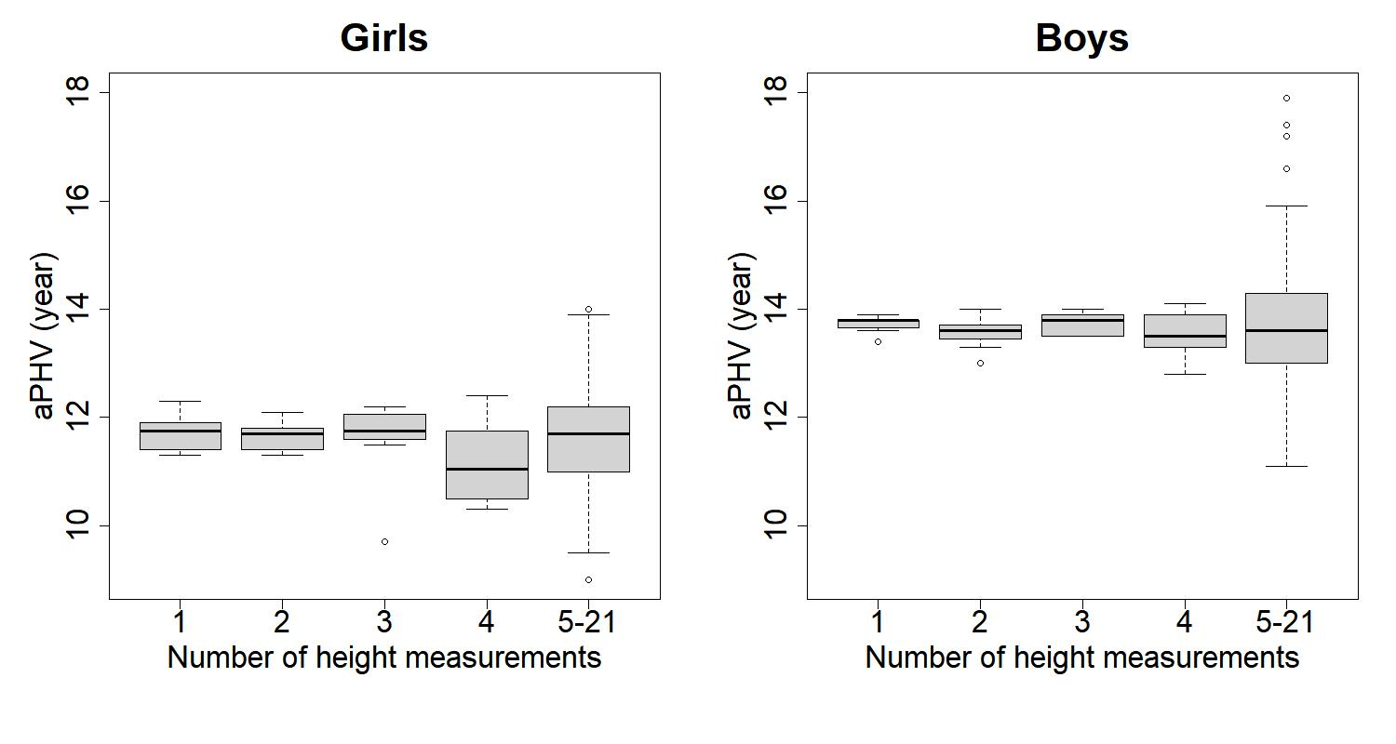S1 Fig. Distributions of the aPHV values by the number of the height measurements for girls and boys.

