Metabolomics Analysis Identifies Glutamic acid and Cystine imbalances in COVID-19 Patients Without Comorbid Conditions. Implications on Redox Homeostasis and COVID-19 Pathophysiology
José C. Páez-Franco, José L. Maravillas-Montero, Nancy R. Mejía-Domínguez, Jiram Torres-Ruiz, Karla M. Tamez-Torres, Alfredo Pérez-Fragoso³ Juan Manuel Germán-Acacio¹, Alfredo Ponce-de-León⁴, Diana Gómez-Martín³, and Alfredo Ulloa-Aguirre
Supplementary information, S1 Figure
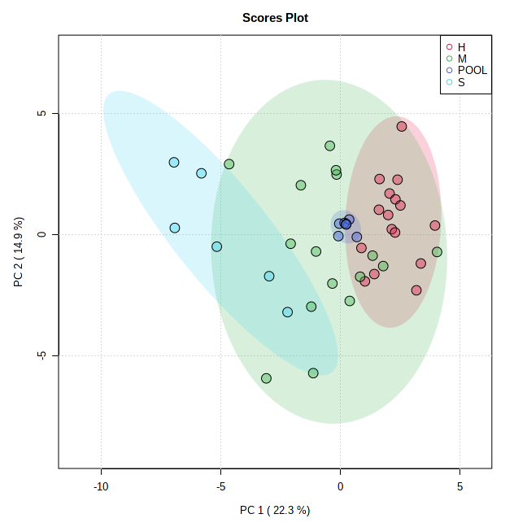
S1 Figure. Principal component analysis of all patients included in the analysis. Pooled samples (blue intense) were used as a QC and shows a compact well-defined cluster, ensuring a good reproducibility of our GC/MS analysis.

