Development and dematerialization: an international study: Supplementary Materials

Julia K. Steinberger (1,2), Fridolin Krausmann (1), Michael Getzner (3), Heinz Schandl (4), Jim West (4)
Affiliations
- Institute of Social Ecology, Vienna, Alpen Adria Universitaet Klagefurt-Wien-Graz, Schottenfeldgasse 29, 1070 Vienna, Austria. julias@alum.mit.edu, fridolin.krausmann@aau.at
- Sustainability Research Institute, School of Earth & Environment, University of Leeds, Leeds LS2 9JT, United Kingdom, julias@alum.mit.edu
- Center of Public Finance and Infrastructure Policy, Vienna University of Technology, Karlsplatz 13, 1040 Vienna, Austria, michael.getzner@tuwien.ac.at
- CSIRO Ecosystem Sciences, Clunies Ross St, Black Mountain, ACT 2601, Australia, Heinz.Schandl@csiro.au , Jim.West@csiro.au .

Data
Table S1: references for country material flow sources (details of references are listed at the end of the Supplementary Materials).
Country | Material Flow Analysis data source | Years covered
Algeria | SEC 2011 | 1970-2005
Argentinia | SEC 2011 | 1970-2004
Australia | Schandl and West 2010 | 1970-2005
Austria | Weisz 2006 | 1970-2004
Bangladesh | Schandl and West 2010 | 1970-2005
Belgium+Luxembourg | Weisz et al. 2006 | 1970-2004
Brazil | Mayer 2010 | 1970-2005
Canada | SEC 2011 | 1980-2003
China | Schandl and West 2010 | 1970-2005
Colombia | SEC 2011 | 1970-2005
Cuba | Eisenhut 2009 | 1970-2004
Denmark | Weisz et al. 2006 | 1970-2004
Finland | Weisz et al. 2006 | 1970-2004
France | Weisz et al. 2006 | 1970-2004
Germany | Weisz et al. 2006 | 1970-2004
Greece | Weisz et al. 2006 | 1970-2004
India | Singh et al. 2012 | 1970-2005
Indonesia | Schandl and West 2010 | 1970-2005
Iran | Schandl and West 2010 | 1970-2005
Ireland | Weisz et al. 2006 | 1970-2004
Italy | Weisz et al. 2006 | 1970-2004
Japan | Krausmann et al. 2011 | 1970-2005
Malaysia | Schandl and West 2010 | 1970-2005
Nepal | Schandl and West 2010 | 1970-2005
Netherlands | Weisz et al. 2006 | 1970-2004
New Zealand | Schandl and West 2010 | 1970-2005
Pakistan | Schandl and West 2010 | 1970-2005
Philippines | Schandl and West 2010 | 1970-2005
Portugal | Weisz et al. 2006 | 1970-2004
Rep. Korea | Schandl and West 2010 | 1970-2005
Singapore | Schandl and West 2010 | 1970-2005
Spain | Weisz et al. 2006 | 1970-2004
Sri Lanka | Schandl and West 2010 | 1970-2005
Sweden | Weisz et al. 2006 | 1970-2004
Thailand | Schandl and West 2010 | 1970-2005
Turkey | Schandl and West 2010 | 1970-2005
United Kingdom | Weisz et al. 2006 | 1970-2004
USA | Gierlinger and Krausmann 2012 | 1970-2005
Venezuela | SEC 2011 | 1970-2005
World | Krausmann et al. 2009 | 1970-2005

Methodological details
We present below some details regarding the quantitative methodologies summarized in the main article.

Cluster analysis
The cluster analysis is conducted using the Matlab software language “linkage” and “cluster” functions, based on the average linkage between all pairs of objects in any two clusters, and standardized Euclidean distances, which are inversely weighted by the sample variance in that coordinate, in order to make the dimensions unitless and cover the same range. The number of clusters is set to 8, to achieve a sufficient level of differentiation within the groups (otherwise, the clusters tend to be formed of 1 or 2 exceptional countries, like Finland and Australia, and all the others).

Results

Cluster analysis results
The cluster analysis is conducted at two points in time: at the beginning and end of the time span of our data, 1970 and 2004. The cluster analysis considers both economic (GDP/cap, logged to take into account the two orders of magnitude range) and physical variables (DMC/cap). Because we are interested in development trajectories as well as development status, these variables are considered in terms of their static and growth values (the growth values are averaged between 1970-1975 and 2000-2004 in order to smooth over exceptionally variable years). The country clusters are thus defined in terms of their dynamic growth rates, as well as their material and economic status.

Results of the 1970 clustering

The results of the 1970 levels, growth rates averaged between 1970-1975 are shown below (the number in parentheses is the number of countries in a given cluster). Clusters 4 & 5 comprise the most developed countries, next come intermediate clusters 1 & 2, with countries which have lower levels of development, but faster growth. Cuba, in cluster 3, is distinguished from this intermediate group by its material degrowth, while Algeria, in cluster 8, it characterised by extreme material growth. Then comes cluster 6, with the developing countries, from which Bangladesh in cluster 7 is separated because of its economic degrowth during that time period. Interestingly, contrary to our initial expectation, the highest growth rates are seen for the intermediate countries, while the developing countries have growth rates which are similar to those of the most mature countries.
Cluster 1 (4): Greece, Portugal, Spain, Turkey;
Cluster 2 (5): Brazil, Iran, Malaysia, Rep. Korea, Singapore;
Cluster 3 (1): Cuba;
Cluster 4 (16): Argentina, Austria, Australia, Belgium+Luxembourg, Germany, Denmark, France, Ireland, Italy, Japan, Netherlands, New Zealand, Sweden, Venezuela, United Kingdom, USA;
Cluster 5 (1): Finland;
Cluster 6 (9): China, Colombia, India, Indonesia, Nepal, Philippines, Pakistan, Sri Lanka, Thailand;
Cluster 7 (1): Bangladesh;
Cluster 8 (1): Algeria

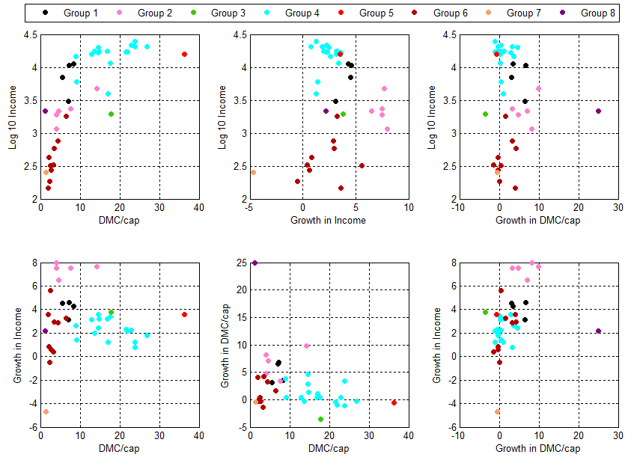

Results for 2004 clustering
The results of the 2004 levels, growth rates averaged between 2000-2004 are shown below (the number in parentheses is the number of countries in a given cluster). Clusters 2 & 5 comprise the most developed countries, which have been augmented by Greece, Portugal, Spain and Rep. Korea. Singapore, in cluster 8, belongs to this group, and is distinguished by its large material degrowth, due to the end of large construction phase in the city-state (see Schulz (Schulz, 2007) for the details on the history of Singapore’s material flows). The intermediate group, formed by clusters 1, 3, 6 & 7, has a significantly changed membership: it has been augmented by Argentina and Venezuela (moving down from their mature status in 1970) as well as China, Colombia, Indonesia and Thailand (moving up from the developing group). The developing group of cluster 4 has thus shrunk. Cuba is distinguished from the other intermediate countries by an exceptional combination of material degrowth and economic growth, whereas China is in a cluster of its own due to its material and economic growth.

Cluster 1 (5): Argentina, Brazil, Colombia, Turkey, Venezuela;
Cluster 2 (5): Algeria, Indonesia, Iran, Malaysia, Thailand;
Cluster 3 (6): Bangladesh, India, Nepal, Pakistan, Philippines, Sri Lanka;
Cluster 4 (2): Australia, Finland;
Cluster 5 (17): Austria, Belgium+Luxembourg, Germany, Denmark, France, Greece, Ireland, Italy, Japan, Rep. Korea, Netherlands, New Zealand, Portugal, Spain, Sweden, United Kingdom, USA;
Cluster 6 (1): Cuba;
Cluster 7 (1): China;
Cluster 8 (1): Singapore.

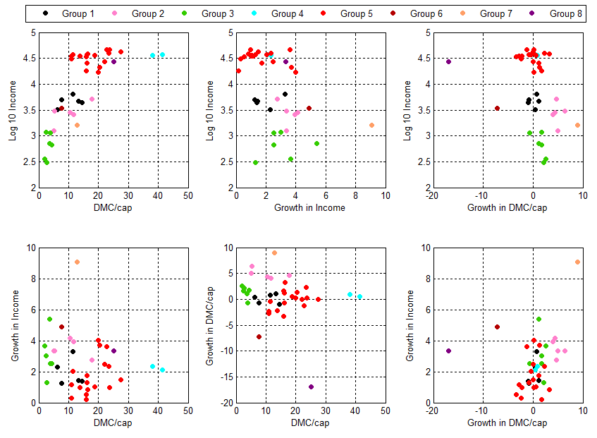
Note: material flow data for Canada is only available for 1980-2003, but Canada is straightforwardly classified as a mature industrialized country.

Individual country trajectories
Table S2:
 | Population | GDP/cap | Total DMC/cap | Mineral DMC/cap | Biomass DMC/cap | CO2/cap
Units | 1000 pers | USD | tons/cap | tons/cap | tons/cap | tons CO2/cap
Year | 2005 | 2005 | 2005 (*) | 2005 (*) | 2005 (*) | 2005
Algeria | 32,900 | 3,142 | 5.4 | 4.6 | 0.8 | 4.2
Argentina | 38,700 | 4,730 | 14.5 | 4.1 | 10.4 | 4.1
Bangladesh | 153,100 | 376 | 2.0 | 0.8 | 1.2 | 0.3
Brazil | 186,100 | 4,740 | 13.3 | 4.6 | 8.7 | 1.9
China | 1,303,700 | 1,766 | 12.8 | 10.3 | 2.4 | 4.3
Colombia | 43,000 | 3,358 | 6.3 | 2.2 | 4.1 | 1.4
Cuba | 11,200 | 3,810 | 7.6 | 2.3 | 5.3 | 2.2
Greece | 11,100 | 21,819 | 20.3 | 16.9 | 3.5 | 8.9
India | 1,094,600 | 768 | 3.7 | 2.1 | 1.7 | 1.3
Indonesia | 219,200 | 1,304 | 5.1 | 2.5 | 2.5 | 1.6
Iran | 69,100 | 2,976 | 10.5 | 7.1 | 3.5 | 6.2
Malaysia | 25,600 | 5,382 | 17.8 | 10.0 | 7.8 | 7.2
Nepal | 27,200 | 303 | 2.6 | 0.2 | 2.5 | 0.1
Pakistan | 155,800 | 701 | 4.4 | 1.4 | 2.9 | 0.9
Philippines | 85,500 | 1,156 | 3.8 | 1.5 | 2.3 | 0.9
Portugal | 10,500 | 18,122 | 16.0 | 12.0 | 4.0 | 6.2
Rep. Korea | 48,100 | 17,551 | 19.9 | 18.5 | 1.4 | 9.6
Singapore | 4,300 | 28,423 | 25.1 | 24.9 | 0.3 | 14.0
Spain | 43,400 | 26,042 | 16.2 | 12.6 | 3.7 | 8.1
Sri Lanka | 19,700 | 1,241 | 2.5 | 1.1 | 1.3 | 0.6
Thailand | 65,900 | 2,674 | 11.6 | 7.4 | 4.2 | 4.1
Turkey | 71,200 | 6,786 | 11.3 | 7.8 | 3.5 | 3.3
Venezuela | 26,600 | 5,428 | 8.6 | 5.0 | 3.6 | 6.0
Australia | 20,400 | 37,474 | 41.3 | 31.5 | 9.9 | 17.8
Austria | 8,200 | 36,792 | 18.6 | 14.4 | 4.2 | 8.8
Belgium+Luxembourg | 10,900 | 37,855 | 16.1 | 11.8 | 4.3 | 10.9
Canada | 32,300 | 35,088 | 32.3 | 24.2 | 8.1 | 17.3
Denmark | 5,400 | 47,577 | 23.8 | 17.0 | 6.8 | 8.6
Finland | 5,200 | 37,290 | 38.1 | 29.0 | 9.1 | 10.4
France | 60,900 | 35,262 | 13.9 | 8.7 | 5.1 | 6.4
Germany | 82,500 | 33,811 | 15.8 | 12.5 | 3.3 | 9.8
Ireland | 4,200 | 48,533 | 22.8 | 13.7 | 9.1 | 10.4
Italy | 58,600 | 30,332 | 10.9 | 8.1 | 2.8 | 8.0
Japan | 127,800 | 35,627 | 11.1 | 9.8 | 1.3 | 9.7
Netherlands | 16,300 | 39,122 | 16.3 | 13.3 | 3.0 | 10.6
New Zealand | 4,100 | 27,298 | 21.9 | 7.4 | 14.5 | 8.1
Sweden | 9,000 | 41,066 | 23.4 | 15.6 | 7.7 | 5.7
United Kingdom | 60,200 | 37,859 | 11.5 | 8.9 | 2.6 | 9.0
USA | 295,600 | 42,562 | 27.5 | 21.7 | 5.8 | 19.7
World | 6,466,800 | 7,070 | 8.9 | 6.0 | 2.9 | 4.5
(*) 2004 values for EU-15, Argentina, Cuba, 2003 for Canada.

Panel analysis

Table S3 shows that results are mixed for all country groups and variables, depending on the assumptions about common vs. individual unit root processes. GDP is non-stationary in levels throughout the sample, pointing to steady economic growth in the long run. Total DMC seems to be stationary for the total sample as well as for the mature countries while developing countries seem to follow a steady growth in their material consumption. Minerals consumption is also rather stationary with some inconclusive results for mature countries. For biomass and CO2, we also find mainly stationary or rather inconclusive results.
Table S4 presents the results for the cointegration tests exploring relations between GDP on the one hand, and CO2 and material consumption on the other hand. Again, results are shown for different assumptions and test statistics.

Table S3: Panel stationarity tests of explanatory and dependent variables (H₀: non-stationarity)
Variables -Stationarity Tests |  | H0: | Non-stationarity
 | Variables | Level |  |  |  | 1st difference |  | Conclusion
 | Assumption | Common unit root process | Individual unit root process |  | Common unit root process | Individual unit root process
 |  | Levin, Lin & Chu | ADF-Fisher | PP-Fisher | Levin, Lin & Chu | ADF-Fisher | PP-Fisher
YRPOP | World | -2.605*** | 71.321 | 73.935 | 14,956*** | 424,678*** | 476,662*** | I(1)
 | Industrialized | -3,43122*** | 25.5281 | 32.5771 | -10,2564*** | 151,098*** | 151,453*** | I(1)
 | Developing | -0.52838 | 45.7933 | 41.3581 | -10,9976*** | 273,580*** | 325,209*** | I(1)
DMC | World | -3,84168*** | 120,258*** | 130,082*** | -33,1085*** | 1162,61*** | 1472,72*** | I(0)
 | Industrialized | -2,51292*** | 70,5677*** | 74,8311*** | -22,0341*** | 455,429*** | 506,163*** | I(0)
 | Developing | -3,10088*** | 49.6906 | 55.251 | -24,8759*** | 707,182*** | 966,56*** | I(1)
DMC-minerals + fossils | World | -4,94123*** | 124,009*** | 111,433** | -29,8771*** | 1016,56*** | 1157,08*** | I(0)
 | Industrialized | -0.16712 | 51,2208** | 44,2533* | -18,8014*** | 362,514*** | 387,235*** | inconclusive, rather I(1)
 | Developing | -5,18715*** | 72,7883** | 67,1801** | -23,4241*** | 654,042*** | 769,84*** | I(0)
DMC-bio | World | -3,74098*** | 149,782*** | 153,987*** | -41,7207*** | 1771,17*** | 2999,17*** | I(0)
 | Industrialized | -3,81875*** | 86,2552*** | 91,8116*** | -28,6487*** | 803,717*** | 1708,64*** | I(0)
 | Developing | -2,46484*** | 63,527* | 62,1756* | -30,6565*** | 967,457*** | 1290,53*** | inconclusive, rather I(0)
CO2 | World | -4,64687*** | 101,581* | 112,41*** | -29,9823*** | 1102,27*** | 1398,06*** | inconclusive, rather I(0)
 | Industrialized | -2,83345*** | 44,6588* | 43,6644* | -24,2181*** | 552,647*** | 659,444*** | inconclusive, rather I(0)
 | Developing | -3,98519*** | 56,9224** | 68,7456** | -20,0663*** | 549,624*** | 738,618*** | I(0)

Table S4: Panel cointegration tests (H₀: no cointegration between GDP per capita and the dependent variables)
Cointegration tests of YRPOP and … |  | H0: | No cointegration
 | Assumption | Common AR coefficients |  |  | Individual Ar coefficients |  |  | Conclusion
 |  | Panel rho-Statistic | Panel PP-Statistic | Panel ADF-Statistic | Group rho-Statistic | Group PP-Statistic | Group ADF-Statistic
DMC | World | -6,202961*** | -5,969705*** | -6,212418*** | -4,593915*** | -5,805509*** | -5,873886*** | HA
 | Industrialized | -5,268056*** | -4,869351*** | -4,936479*** | -2,78316*** | -4,230388*** | -4,359523*** | HA
 | Developing | -4,49281*** | -4,355037*** | -4,530825*** | -3,658278*** | -4,040782*** | -4,023618*** | HA
DMC-minerals + fossils | World | -9,281431*** | -8,745356*** | -7,285038*** | -3,537668*** | -3,793903*** | -2,834667*** | HA
 | Industrialized | -5,715232*** | -0.474545 | -0.498886 | -2,550198*** | -1,701826** | -2,198584** | H0
 | Developing | -7,2049*** | -8,114665*** | -6,773899*** | -2,484881*** | -3,508373*** | -1,864403** | HA
DMC-bio | World | -4,645479*** | -4,53602*** | -4,39759*** | -6,053045*** | -8,251414*** | -8,516939*** | HA
 | Industrialized | -6,419447*** | -4,730584*** | -5,350099*** | -5,216475*** | -7,187071*** | -6,94893*** | HA
 | Developing | -2,644052*** | -2,982923*** | -2,682776*** | -3,555214*** | -4,78431*** | -5,321543*** | HA
CO2 | World | -4,624471*** | -5,850175*** | -6,328748*** | -2,862971*** | -4,610696*** | -4,66452*** | HA
 | Industrialized | -4,892013*** | -4,561008*** | -4,581873*** | -2,695245*** | -3,655819*** | -3,657491*** | HA
 | Developing | -3,107185*** | -4,330359*** | -4,767756*** | -1,495421* | -2,967419*** | -3,035541*** | HA

References
Eisenhut, S., 2009. Material Flow Analysis: Cuba. Masterthesis, Universität Wien.
Gierlinger, S., Krausmann, F., 2012. The physical economy of the United States of America: Extraction, trade and consumption of materials from 1870 to 2005. Journal of Industrial Ecology, 16 (3), 365-377.
Krausmann, F., Gingrich, S., Eisenmenger, N., Erb, K.-H., Haberl, H., Fischer-Kowalski, M., 2009. Growth in global materials use, GDP and population during the 20th century. Ecological Economics, 68 (10), 2696-2705.
Krausmann, F., Gingrich, S., Nourbakhch-Sabet, R., 2011. The metabolic transition in Japan: A material flow account for the period 1878 to 2005. Journal of Industrial Ecology, 15 (6), 877-892.
Mayer, A. Resource use and material flows in the Brazilian economy, 1960-2005. Social Ecology Working Paper 118, Vienna: Inst. of Social Ecology.
SEC 2011. Material Flow Database of the Institute of Social Ecology. Vienna: Institute of Social Ecology.
Schandl, H., West, J., 2010. Resource use and resource efficiency in the Asia-Pacific region. Global Environmental Change, 20 (4), 636-647.
Singh, S.J., Krausmann, F., Gingrich, S., Haberl, H., Erb, K.-H., Lanz, P., Martinez-Alier, J., Temper, L., 2012. India's biophysical economy, 1961 – 2008. Sustainability in a national and global context. Ecolgical Economics, 76, 60-69.
Weisz, H., Krausmann, F., Amann, C., Eisenmenger, N., Erb, K.-H., Hubacek, K., Fischer-Kowalski, M., 2006. The physical economy of the European Union: Cross-country comparison and determinants of material consumption. Ecological Economics, 58 (4), 676-698.

