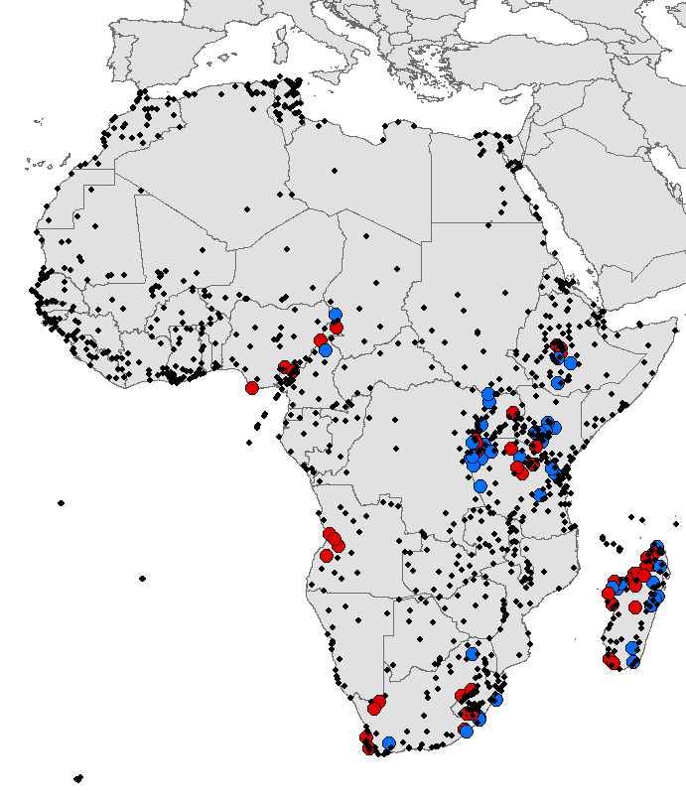

Figure S1. Distribution of all African IBAs (stars), showing the 93 IBAs covered in the assessment of land-cover change (circles). Blue: protected IBAs, red: unprotected IBAs.

