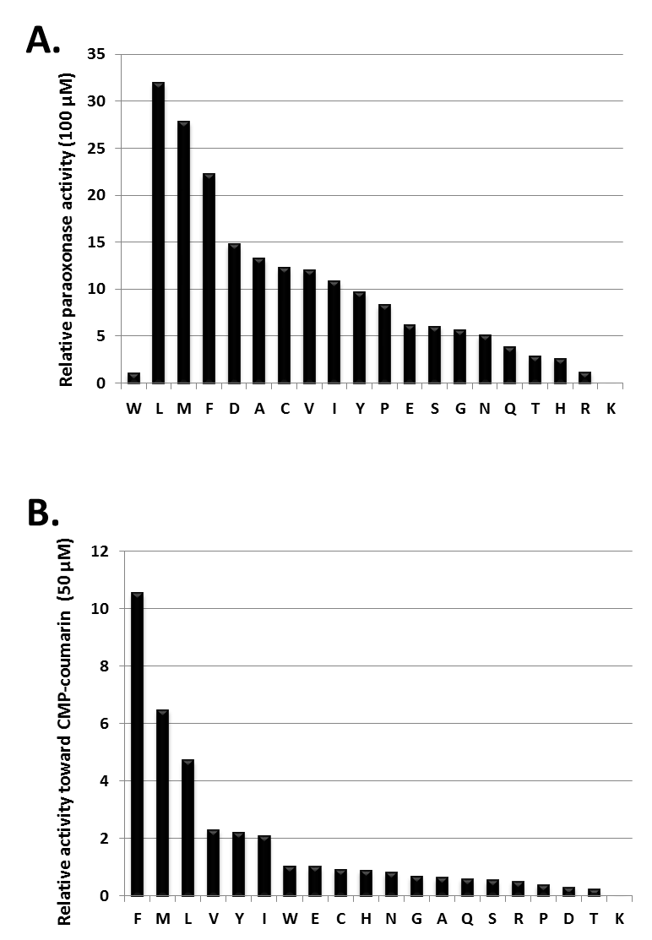
Figure S3: Supplemental SsoPox-W263 saturation site OP hydrolase activity screening
Relative activities of W263 saturation site variants have been screened with 100 µM (A.) of paraoxon substrate and 50 µM (C.) of CMP-coumarin substrate.

