Supporting Information

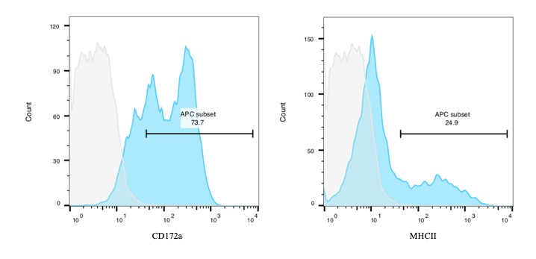
S1 Fig. Adherent cells developing in bone marrow GM-CSF culture. In bone marrow culture induced by GM-CSF, adhrent cells were obtained and confirmed MHCII expression by flow cytometry. Allophycocyanin (APC)-conjugated goat anti-mouse IgG was used as secondary antibody.

