Colonization of a deglaciated moraine: contrasting patterns of carbon uptake and release from C3 and CAM plants
Elisa Varolo, Damiano Zanotelli, Leonardo Montagnani, Massimo Tagliavini, Stefan Zerbe

Supplemental material S3

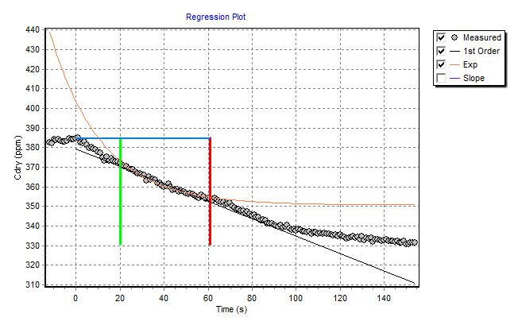

S3 Fig. Example of raw CO₂ data (1 Hz) collected during one measurement with a clear chamber over a Festuca plot. X axis represents time after chamber closure (s). Fluxes were recomputed considering only the data measured between 20 and 60 seconds after chamber closure (limits represented in the plot by the green and red vertical lines). In such a short time the exponential fitting produced an uncommon high value of CO₂ uptake (-9.33 µmol CO₂ m²s⁻¹) compared with the linear fitting (-2.90 µmol CO₂ m²s⁻¹) or compared with the exponential fitting if the regression time was enlarged to a 20-100 s time window (- 2.63 µmol CO₂ m²s⁻¹).

