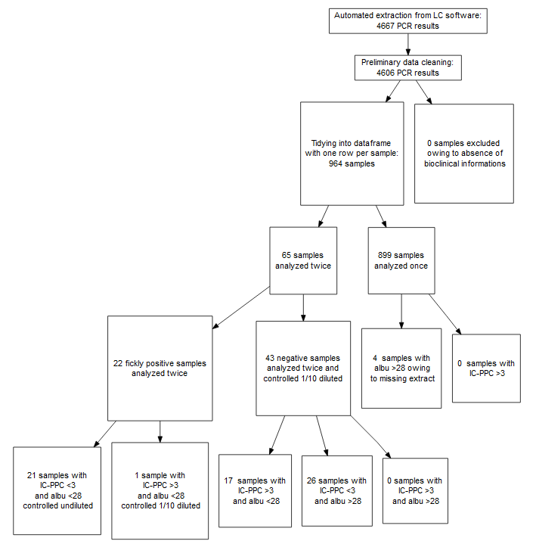

Figure S2: Flow chart of data cleaning and tidying of Pneumocystis PCR results

