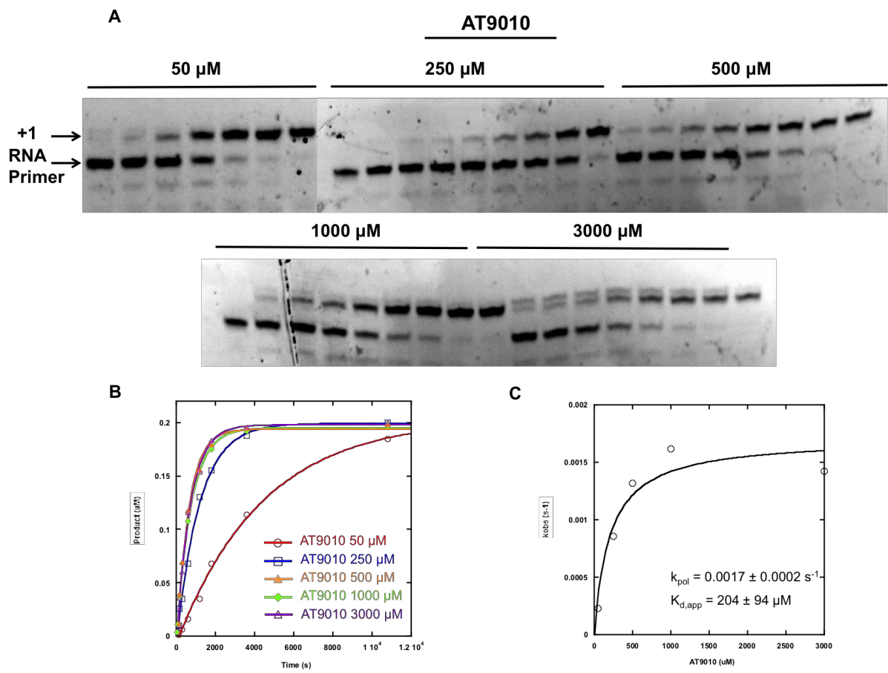
S2 Fig. AT9010 incorporation catalyzed by POLRMT. (A) POLRMT (0.5 µM) was incubated with fluorescein-labeled-RNA/DNA scaffold (0.2 µM) for 1 min and then rapidly mixed with SOF TP (50-3000 µM). Reactions were quenched at various times with EDTA (50 µM). (B) Quantitated RNA product was plotted as a function of time and fit to a single exponential equation. (C) Values for k_{obs} were plotted as a function of AT-9010 concentration and fit to as hyperbola, yielding a k_{pol} value of 0.0017 ± 0.0002 s⁻¹ and a K_{d,app} value of 204 ± 94 µM).

