Supplementary File 4: Occurrences of tobacco and alcohol subtypes per film, by year
a. Mean number of occurrences per film for tobacco sub-types
b. Mean number of occurrences per film for alcohol sub-types
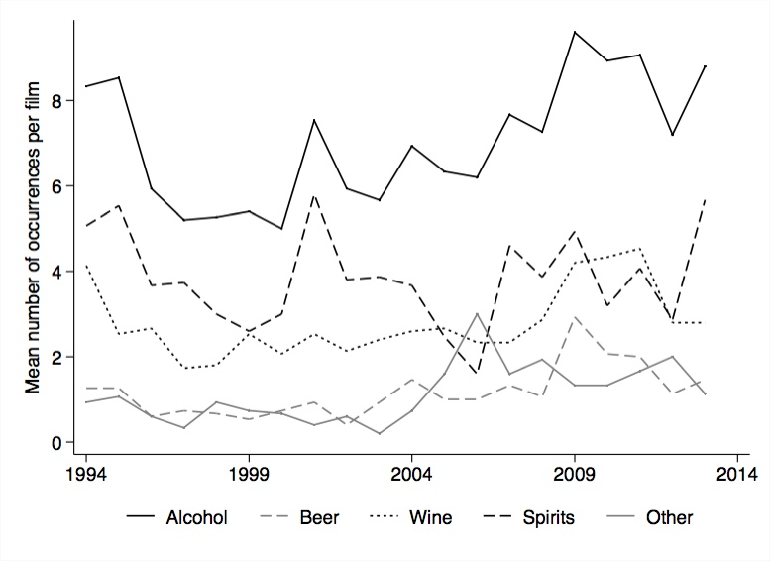
a
b

