S1 Appendix

Kinetics parameters of the hydrolysis of ortho-nitrophenyl-β-D-galactopyranoside (ONPG) catalysed by β-galactosidase from Kluyveromyces lactis in native form

Conditions of the kinetics studies: range of ONPG concentration 0.5 – 20 mM; β-galactosidase concentration 5.059 mg/L (determined using Lowry’s method); Thermostated batch reactor, 37°C)
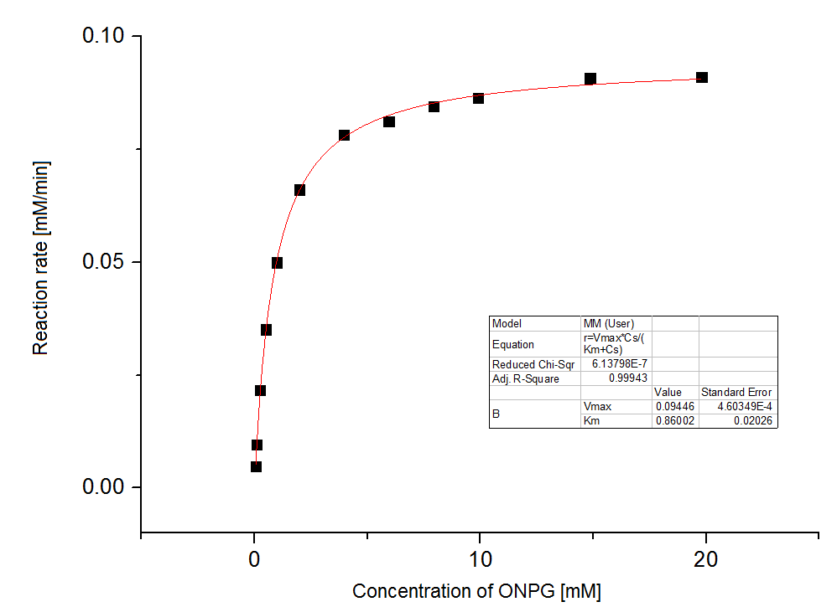
Fig. S1. Michaelis-Menten plot and the kinetics parameters (V_{max}= 0.0945 ± 0.0005 mM/min; K_{m} = 0.8600 ± 0.0203 mM) determined using nonlinear regression (OriginPro).

