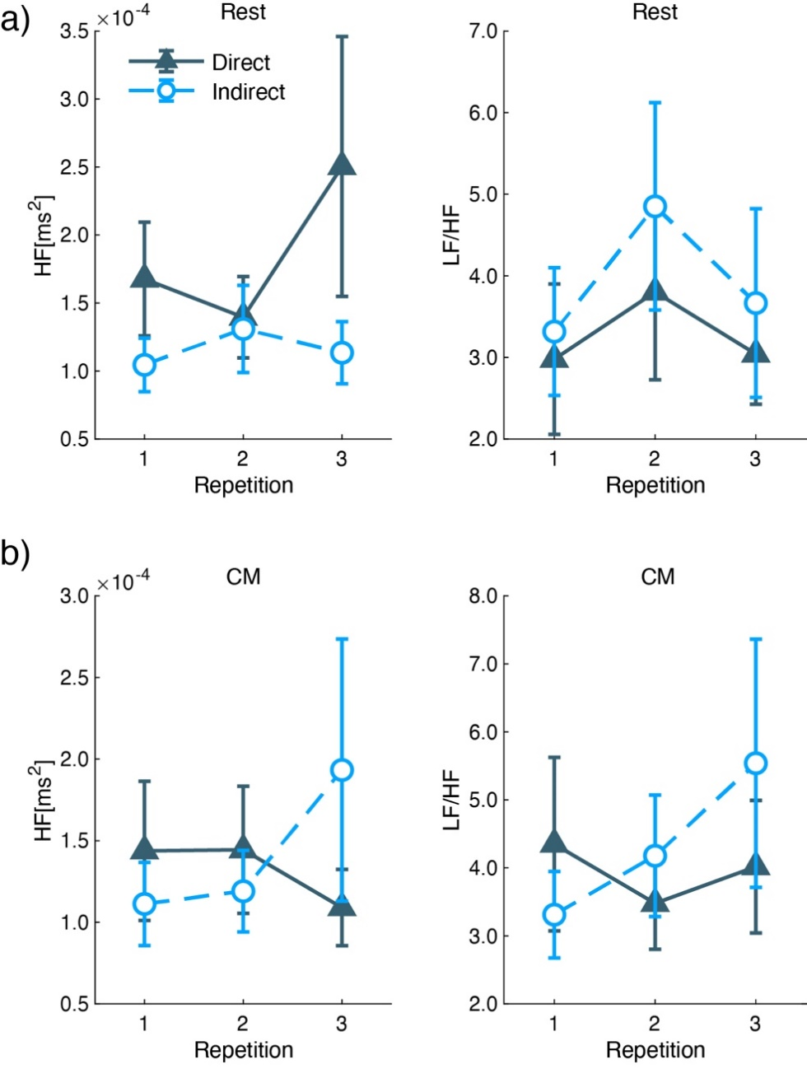
Supplementary Figure 3. ECG parameters of HF and LF/HF during a) Rest and b) CM. The right row shows the mean and standard error of HF, and the left row shows that of LF/HF. The X-axis shows the repetition.

