<Supporting Information>
Figure S1. Overall process of genome assembly and gene prediction.
Table S1. List of GeneBank ID, Location and Type of 75 individuals used in phylogenomic analysis.
GenBank ID | Location | Type
AB086102 | Japan: Hiroshima | domestic chicken
GU261684 | China: Yunnan | domestic chicken
GU261695 | China: Yunnan | wild fowl
GU261700 | Myanmar | wild fowl
NC_007235 | Laos: Vientiane | wild fowl
GU261704 | China: Yunnan | wild fowl
GU261705 | China: Yunnan | domestic chicken
GU261714 | China: Yunnan | domestic chicken
GU261699 | China: Yunnan | domestic chicken
GU261674 | China: Hainan | wild fowl
GU261696 | China: Hainan | wild fowl
GU261693 | China: Yunnan | wild fowl
GU261701 | China: Henan | domestic chicken
GU261675 | China: Hunan | domestic chicken
GU261681 | China: Hunan | domestic chicken
GU261718 | China: Yunnan | domestic chicken
GU261679 | China: Henan | domestic chicken
GU261680 | Southern India | domestic chicken
GU261716 | Myanmar | wild fowl
GU261707 | India | wild fowl
NC_007236 | Philippine: Manila | wild fowl
NC_007237 | Indonesia: Bali | wild fowl
GU261687 | Laos | domestic chicken
GU261682 | Laos | domestic chicken
GU261683 | China: Xinjiang | domestic chicken
GU261677 | China: Zhejiang | domestic chicken
GU261697 | Southern India | domestic chicken
GU261685 | Northeast India | domestic chicken
GU261686 | China: Henan | domestic chicken
GU261713 | China: Yunnan | domestic chicken
AP003317 | Commercial Line | domestic chicken
AY235571 | Commercial Lines | domestic chicken
AP003318 | Commercial Line | domestic chicken
GU261712 | China: Yunnan | domestic chicken
GU261709 | India | domestic chicken
AY235570 | Commercial Line | domestic chicken
AP003580 | Commercial Line | domestic chicken
GU261694 | China: Hebei | domestic chicken
AP003319 | Laos: Vientiane | domestic chicken
HQ857210 | Northeast India | domestic chicken
HQ857209 | Northeast India | domestic chicken
GU261708 | India | wild fowl
HQ857212 | Northeast India | domestic chicken
HQ857211 | Northeast India | domestic chicken
GU261691 | Myanmar | wild fowl
GU261702 | China: Yunnan | wild fowl
GU261688 | China: Yunnan | domestic chicken
GU261711 | China: Yunnan | domestic chicken
GU261689 | China: Yunnan | domestic chicken
GU261703 | Myanmar | wild fowl
GU261717 | China: Yunnan | domestic chicken
DQ648776 | China: Yunnan | domestic chicken
GU261678 | China: Henan | domestic chicken
GU261710 | China: Yunnan | domestic chicken
GU261676 | China: Yunnan | domestic chicken
GU261719 | China: Yunnan | domestic chicken
GU261690 | China: Yunnan | wild fowl
GU261715 | China: Yunnan | domestic chicken
GU261706 | China: Yunnan | wild fowl
GU261692 | China: Yunnan | wild fowl
GU261698 | Northeast India | domestic chicken
NC_001323 |  | Commercial Line
AP006746 | Japan : Tokyo, Tama Zoological Park | Grey Junglefowl
AP003320 | Lao Zoological Park,Vientiane, Lao | Grey Junglefowl
AP003321 | Vientiane, Las | Red Jungle Fowl : Spadiceus
AP003323 | Indonesia | Red Jungle Fowl : bankiva
AP003322 | Philippine | Red Jungle Fowl : gallus
AP003325 | Tama Zoological Park, Tokyo, Japan | Ceylon junglefowl(Gallus lafayettei)
AP006741 | Delhi National Park, Delhi, India | Grey junglefowl (Gallus sonnerati)
AP003324 | Bali, Indonesia | Green junglefowl (Gallus varius)

Table S2. The result summary of Modeltest using 56 models from PAUP.
a) Details of selected model
Model selected | GTR+I+G
-lnL | 34137.36
K | 10
AIC | 68294.71
Base frequencies:
freqA = | 0.3043
freqC = | 0.3243
freqG = | 0.1338
freqT = | 0.2377
Substitution model:
Rate matrix
R(a) [A-C] = | 3.1105
R(b) [A-G] = | 69.8681
R(c) [A-T] = | 3.0613
R(d) [C-G] = | 1.2357
R(e) [C-T] = | 55.6961
R(f) [G-T] = | 1
Among-site rate variation
Proportion of invariable sites (I) = | 0.7559
Variable sites (G)
Gamma distribution shape parameter | 1.0295

b) The result of tested 56 models.
Model | -lnL | K | AIC | delta | weight | cumWeight
GTR+I+G | 34137.36 | 10 | 68294.71 | 0 | 0.9751 | 0.9751
TVM+I+G | 34142.09 | 9 | 68302.17 | 7.4609 | 0.0234 | 0.9984
TrN+I+G | 34147.21 | 7 | 68308.43 | 13.7188 | 0.001 | 0.9995
TIM+I+G | 34146.9 | 8 | 68309.8 | 15.0938 | 0.0005 | 1
HKY+I+G | 34152.57 | 6 | 68317.15 | 22.4375 | 1.31E-05 | 1
K81uf+I+G | 34152.25 | 7 | 68318.49 | 23.7812 | 6.68E-06 | 1
GTR+I | 34165.21 | 9 | 68348.41 | 53.7031 | 2.13E-12 | 1
TVM+I | 34171.78 | 8 | 68359.56 | 64.8516 | 8.07E-15 | 1
TrN+I | 34175.44 | 6 | 68362.88 | 68.1719 | 1.53E-15 | 1
TIM+I | 34175.06 | 7 | 68364.12 | 69.4062 | 8.27E-16 | 1
HKY+I | 34182.67 | 5 | 68375.34 | 80.625 | 3.03E-18 | 1
K81uf+I | 34182.28 | 6 | 68376.55 | 81.8438 | 1.65E-18 | 1
GTR+G | 34214.7 | 9 | 68447.39 | 152.6797 | 6.84E-34 | 1
TVM+G | 34218.82 | 8 | 68453.63 | 158.9219 | 3.02E-35 | 1
TrN+G | 34225.78 | 6 | 68463.56 | 168.8516 | 2.11E-37 | 1
TIM+G | 34225.34 | 7 | 68464.69 | 169.9766 | 1.20E-37 | 1
HKY+G | 34230.37 | 5 | 68470.74 | 176.0312 | 5.81E-39 | 1
K81uf+G | 34229.93 | 6 | 68471.86 | 177.1484 | 3.32E-39 | 1
GTR | 34673.59 | 8 | 69363.19 | 1068.477 | 0.00E+00 | 1
TVM | 34676.43 | 7 | 69366.87 | 1072.156 | 0.00E+00 | 1
TrN | 34687.99 | 5 | 69385.98 | 1091.266 | 0.00E+00 | 1
TIM | 34687.3 | 6 | 69386.6 | 1091.891 | 0.00E+00 | 1
HKY | 34690.91 | 4 | 69389.83 | 1095.117 | 0.00E+00 | 1
K81uf | 34690.22 | 5 | 69390.45 | 1095.734 | 0.00E+00 | 1
SYM+I+G | 34994.83 | 7 | 70003.66 | 1708.945 | 0.00E+00 | 1
TVMef+I+G | 35001.57 | 6 | 70015.14 | 1720.43 | 0.00E+00 | 1
SYM+I | 35024.02 | 6 | 70060.04 | 1765.328 | 0.00E+00 | 1
TIMef+I+G | 35029.37 | 5 | 70068.74 | 1774.031 | 0.00E+00 | 1
TVMef+I | 35029.71 | 5 | 70069.42 | 1774.711 | 0.00E+00 | 1
TrNef+I+G | 35031.09 | 4 | 70070.19 | 1775.477 | 0.00E+00 | 1
K81+I+G | 35036.53 | 4 | 70081.06 | 1786.352 | 0.00E+00 | 1
K80+I+G | 35038.25 | 3 | 70082.51 | 1787.797 | 0.00E+00 | 1
TIMef+I | 35058.55 | 4 | 70125.11 | 1830.398 | 0.00E+00 | 1
TrNef+I | 35060.38 | 3 | 70126.76 | 1832.047 | 0.00E+00 | 1
K81+I | 35064.57 | 3 | 70135.13 | 1840.422 | 0.00E+00 | 1
K80+I | 35066.41 | 2 | 70136.82 | 1842.109 | 0.00E+00 | 1
SYM+G | 35064.74 | 6 | 70141.48 | 1846.773 | 0.00E+00 | 1
TVMef+G | 35074.1 | 5 | 70158.2 | 1863.492 | 0.00E+00 | 1
TIMef+G | 35098.94 | 4 | 70205.88 | 1911.164 | 0.00E+00 | 1
TrNef+G | 35100.85 | 3 | 70207.7 | 1912.992 | 0.00E+00 | 1
K81+G | 35108.72 | 3 | 70223.44 | 1928.727 | 0.00E+00 | 1
K80+G | 35110.64 | 2 | 70225.29 | 1930.578 | 0.00E+00 | 1
SYM | 35504.9 | 5 | 71019.8 | 2725.086 | 0.00E+00 | 1
TVMef | 35518.96 | 4 | 71045.92 | 2751.211 | 0.00E+00 | 1
TIMef | 35538.52 | 3 | 71083.05 | 2788.336 | 0.00E+00 | 1
TrNef | 35540.54 | 2 | 71085.07 | 2790.359 | 0.00E+00 | 1
K81 | 35552.56 | 2 | 71109.13 | 2814.414 | 0.00E+00 | 1
K80 | 35554.58 | 1 | 71111.16 | 2816.445 | 0.00E+00 | 1
F81+I+G | 35659.85 | 5 | 71329.7 | 3034.992 | 0.00E+00 | 1
F81+I | 35682.82 | 4 | 71373.64 | 3078.93 | 0.00E+00 | 1
F81+G | 35705.14 | 4 | 71418.27 | 3123.563 | 0.00E+00 | 1
F81 | 36112.66 | 3 | 72231.31 | 3936.602 | 0.00E+00 | 1
JC+I+G | 36487.18 | 2 | 72978.36 | 4683.648 | 0.00E+00 | 1
JC+I | 36510.67 | 1 | 73023.34 | 4728.633 | 0.00E+00 | 1
JC+G | 36530.41 | 1 | 73062.82 | 4768.109 | 0.00E+00 | 1
JC | 36931.09 | 0 | 73862.19 | 5567.477 | 0.00E+00 | 1
-lnL : Negative log likelihood; K : Number of estimated parameters; AIC : Akaike Information Criterion; delta : Information difference; weight : Information weight; cumWeight : Cumulative information weight

Figure S2. An overview of the phylogenetic analysis process.

Table S3. The result summary of read mapping using Bowtie2
Categories | Samples
 | KNC_R(16) | KNC_Y(24) | KNC_W(3) | KNC_L(40) | KNC_G(53)
Total number of reads (pairs) | 174,786,737 (100%) | 184,357,557 (100%) | 183,203,458 (100%) | 176,744,880 (100%) | 187,177,967 (100%)
Concordantly 1 time (pair) | 153,196,154 (87.65%) | 162,391,840 (88.09%) | 159,423,218 (87.02%) | 152,887,235 (86.50%) | 164,537,465 (87.90%)
Concordantly > 1 time (pair) | 10,219,837 (5.85%) | 11,528,236 (6.25%) | 11,388,706 (6.22%) | 11,064,103 (6.26%) | 11,580,493 (6.19%)
Discordantly 1 time (pair) | 3,836,219 (33.74%) | 2,977,379 (28.53%) | 4,699,222 (37.92%) | 4,914,884 (38.42%) | 2,173,681 (19.65%)
aligned exactly 1 time (singleton) | 4,704,925 (31.22%) | 4,368,759 (29.28%) | 4,677,955 (30.41%) | 4,955,881 (31.45%) | 5,337,267 (30.03%)
aligned > 1 time (singleton) | 1,887,982 (12.53%) | 1,797,388 (12.05%) | 2,202,578 (14.32%) | 2,172,806 (13.79%) | 1,831,168 (10.30%)
Overall alignment rate | 97.58% | 97.63% | 97.68% | 97.56% | 97.17%

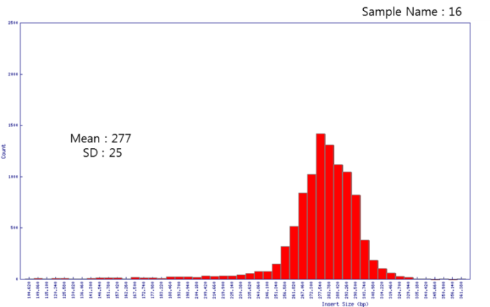
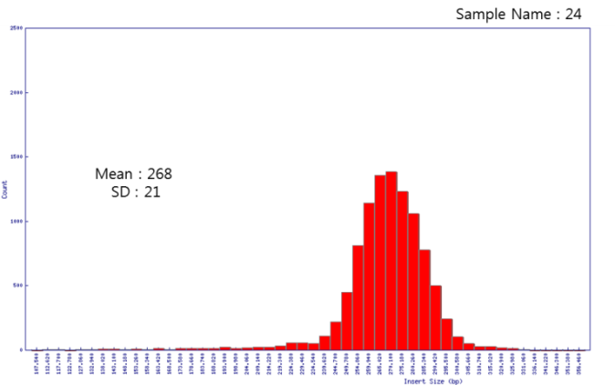
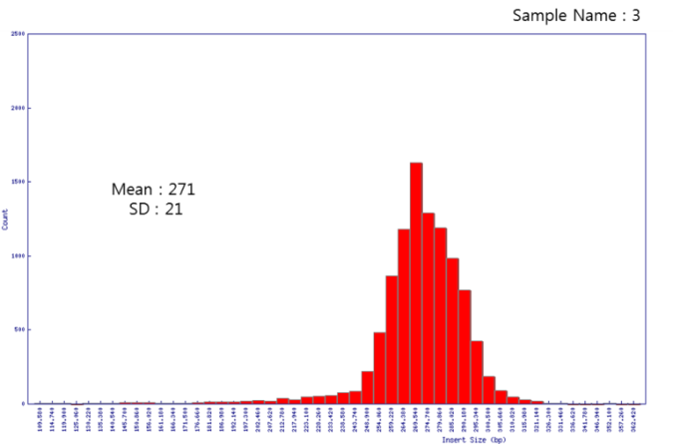
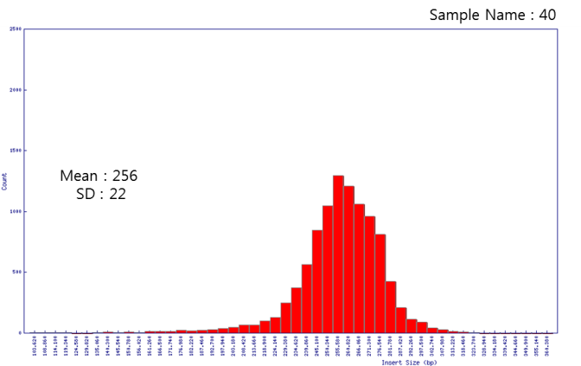
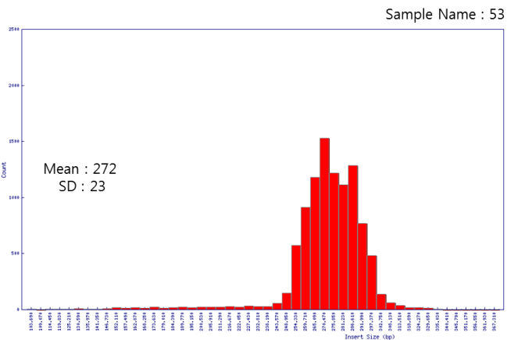
Figure S3. Insert size distributions of 5 KNC samples.

Figure S4. Distribution of known and novel SNVs in each chromosome.
Table S4. The result summary of variant calling using GATK.
Categories |  | Samples
 |  | KNC_R(16) | KNC_Y(24) | KNC_W(3) | KNC_L(40) | KNC_G(53)
INDEL | Raw (1,531,995) | 53,172 | 59,314 | 58,898 | 71,510 | 53,302
 | Pass INDEL (1,345,019) | 47,822 | 53,098 | 52,599 | 63,503 | 48,954
 | Missing filter (1,339,266) | 47,471 | 52,723 | 52,262 | 63,035 | 48,481
SNV | Raw (12,507,596) | 612,571 | 699,118 | 687,205 | 833,459 | 635,840
 | Pass SNP (11,063,897) | 550,343 | 631,217 | 619,550 | 755,175 | 571,380
 | Missing filter (10,962,086) | 545,252 | 626,348 | 615,689 | 749,082 | 565,418

* The number in sample column of INDEL & SNP : the number of sample specific variants

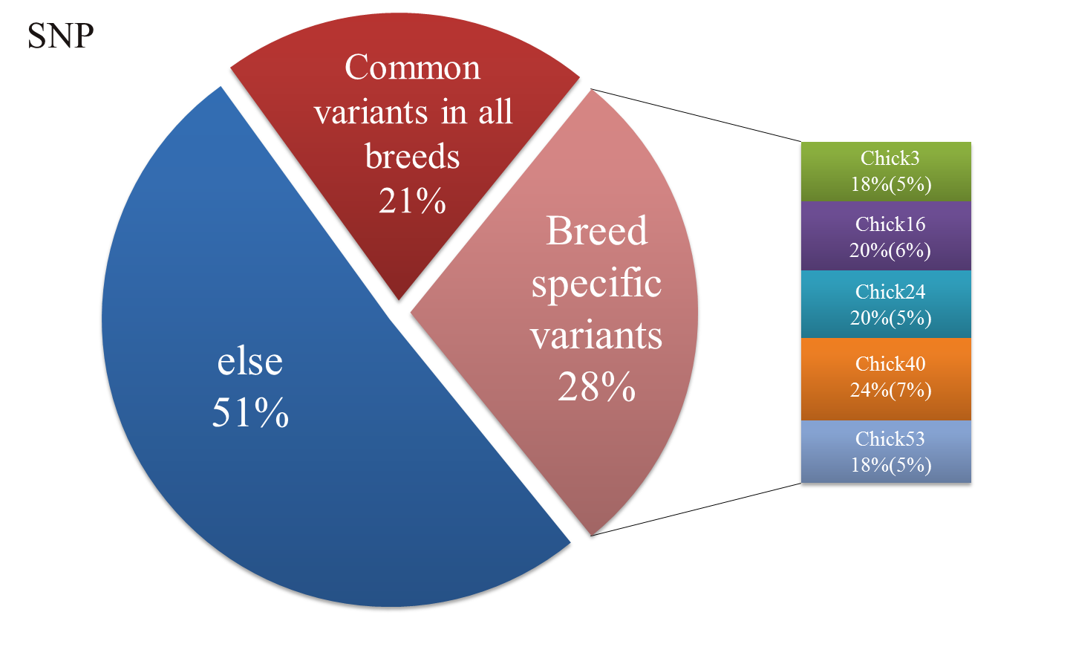
Figure S5. Ratio of breed specific SNV and the proportion of each breed in breed specific SNVs.
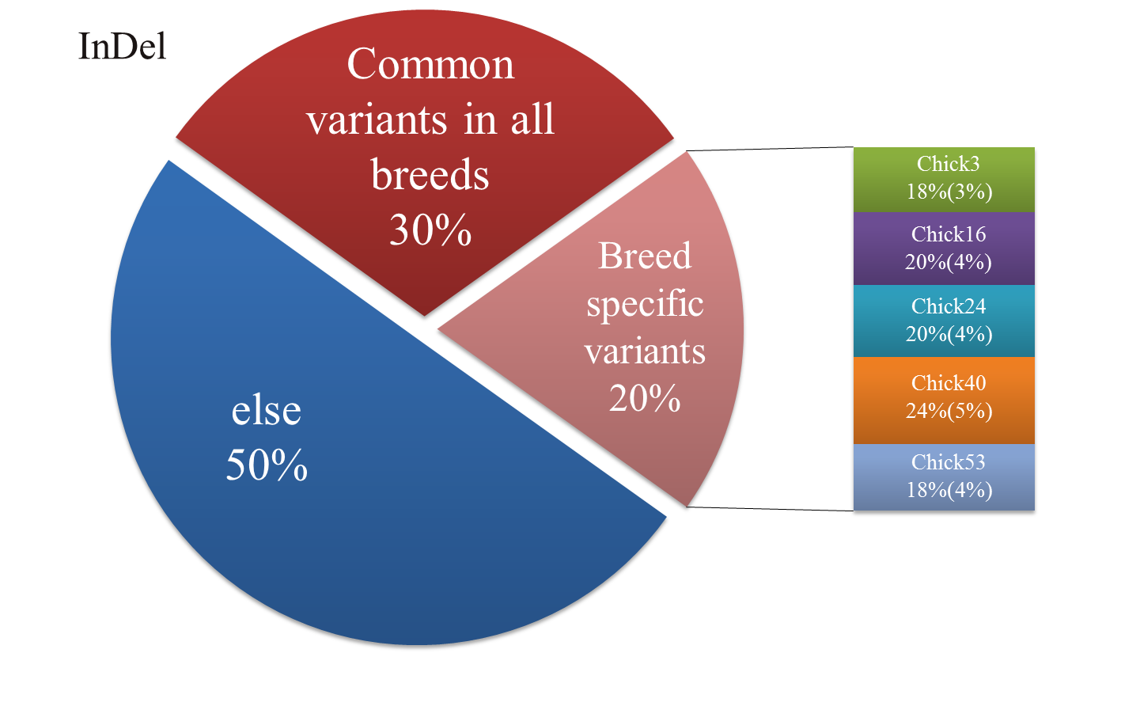
Figure S6. Ratio of breed specific InDel and the proportion of each breed in breed specific InDels.

Figure S7. Ratio of the number of chromosomal variants to the total number of variant.

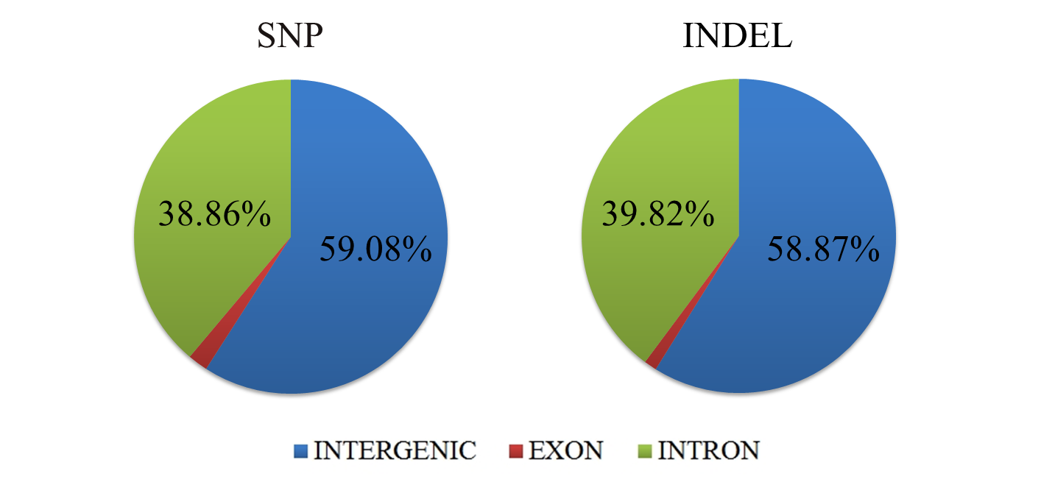
Figure S8. Ratio of each variant location in three variant types (SNP, InDel and CNV).
Table S5. The list of synonymous and non-synonymous variants in common genes of highly variable regions.
Chr | Position | rs ID | Gene Name | Ref | Alt | Variant Type
6 | 4224056 | . | PCDH15 | C | T | Synonymous
6 | 4229110 | rs313675060 | PCDH15 | G | A | Non-synonymous
6 | 4229173 | rs13564223 | PCDH15 | T | C | Synonymous
6 | 4229224 | rs312847192 | PCDH15 | C | T | Synonymous
6 | 4232521 | rs313099267 | PCDH15 | T | C | Synonymous
6 | 4232554 | rs14568172 | PCDH15 | A | G | Synonymous
6 | 4234475 | . | PCDH15 | G | A | Synonymous
6 | 4236298 | rs314575975 | PCDH15 | G | A | Synonymous
6 | 4236376 | rs313725350 | PCDH15 | A | G | Non-synonymous
6 | 4241555 | rs313104422 | ENSGALG00000006716 | C | T | Non-synonymous
6 | 4241620 | . | ENSGALG00000002638 | G | A | Non-synonymous
6 | 4241659 | . | ENSGALG00000002638 | G | A | Non-synonymous
6 | 4241660 | rs316029067 | ENSGALG00000002638 | T | C | Synonymous
6 | 4253773 | rs312946121 | CCDC61 | C | T | Synonymous
6 | 4255187 | . | CCDC61 | C | T | Synonymous
6 | 4261940 | rs316995093 | CCDC61 | C | T | Synonymous
6 | 4261985 | . | CCDC61 | C | A | Synonymous
6 | 4262012 | rs314660677 | CCDC61 | T | A | Synonymous
6 | 4262051 | . | CCDC61 | G | A | Synonymous
6 | 4285266 | rs15767865 | PCDH15 | A | G | Synonymous
6 | 4287469 | rs16535684 | PCDH15 | C | T | Synonymous
6 | 4290453 | rs315541806 | PCDH15 | A | G | Synonymous
6 | 4290504 | rs317404631 | PCDH15 | T | C | Synonymous
6 | 4296263 | rs317485464 | PCDH15 | C | T | Synonymous
6 | 4301893 | rs317750367 | PCDH15 | A | G | Synonymous
6 | 4303282 | rs318016312 | PCDH15 | G | T | Synonymous
6 | 4303357 | rs317241809 | PCDH15 | G | A | Synonymous
6 | 4305072 | rs317951418 | PCDH15 | C | T | Synonymous
6 | 4308645 | rs312273510 | PCDH15 | G | A | Synonymous
6 | 4308665 | rs312744667 | PCDH15 | G | A | Synonymous
6 | 4310205 | . | PCDH15 | C | T | Non-synonymous
6 | 4310346 | . | PCDH15 | T | A | Synonymous
6 | 4310349 | rs313345140 | PCDH15 | A | C | Non-synonymous
6 | 4310424 | rs313539303 | PCDH15 | T | A | Synonymous
6 | 4315980 | rs14568074 | PCDH15 | G | A | Synonymous
6 | 4321280 | rs13564171 | PCDH15 | C | T | Synonymous
6 | 4550555 | rs313275476 | BMS1 | T | G | Non-synonymous
6 | 4550736 | rs16532257 | BMS1 | G | T | Synonymous
6 | 4551519 | rs317329335 | BMS1 | T | C | Synonymous
6 | 4551558 | rs316986733 | BMS1 | C | G | Synonymous
6 | 4552075 | rs315693216 | BMS1 | T | C | Synonymous
6 | 4552111 | rs16532261 | BMS1 | C | T | Synonymous
6 | 4556162 | rs15762384 | BMS1 | C | T | Non-synonymous
6 | 4556163 | rs15762386 | BMS1 | T | C | Synonymous
6 | 4556190 | rs15762388 | BMS1 | G | T | Non-synonymous
6 | 4556202 | rs315518222 | BMS1 | T | C | Synonymous
6 | 4556939 | . | BMS1 | A | G | Synonymous
6 | 4558644 | rs315416387 | BMS1 | A | C | Non-synonymous
6 | 4560802 | rs316213482 | BMS1 | A | G | Synonymous
6 | 4560847 | rs317188690 | BMS1 | T | C | Synonymous
6 | 4561476 | rs316786682 | BMS1 | G | A | Synonymous
6 | 4562567 | rs314849160 | BMS1 | T | C | Synonymous
6 | 4562990 | rs317079533 | BMS1 | T | C | Non-synonymous
6 | 4562996 | . | BMS1 | G | T | Non-synonymous
6 | 4563001 | rs317476030 | BMS1 | A | G | Non-synonymous
6 | 4563039 | rs316639983 | BMS1 | C | T | Synonymous
6 | 4563082 | . | BMS1 | T | C | Non-synonymous
6 | 4563132 | rs315205899 | BMS1 | C | T | Synonymous
6 | 4563260 | rs14564917 | BMS1 | G | C | Non-synonymous
6 | 4563263 | rs14564918 | BMS1 | T | G | Non-synonymous
6 | 4563327 | rs313735300 | BMS1 | A | G | Synonymous
6 | 4563534 | rs315188932 | BMS1 | A | G | Synonymous
6 | 4563684 | rs314859638 | BMS1 | T | G | Non-synonymous
6 | 4563694 | . | BMS1 | A | G | Non-synonymous
6 | 4565768 | . | BMS1 | T | A | Synonymous
6 | 4567342 | . | BMS1 | C | T | Synonymous
6 | 4568712 | . | BMS1 | A | G | Synonymous
6 | 4568747 | . | BMS1 | C | T | Non-synonymous
6 | 4569862 | rs16532272 | BMS1 | T | A | Synonymous
6 | 4569868 | rs313312360 | BMS1 | G | A | Synonymous
6 | 4569931 | rs313756588 | BMS1 | G | C | Synonymous
6 | 4569934 | rs314668522 | BMS1 | G | A | Synonymous
6 | 4594840 | rs15762493 | ENSGALG00000002638 | C | T | Synonymous
6 | 4594846 | rs15762495 | ENSGALG00000002638 | C | T | Synonymous
6 | 4602082 | rs314875596 | ENSGALG00000002638 | G | C | Synonymous
6 | 4602427 | rs13563020 | ENSGALG00000002638 | T | C | Synonymous
6 | 4602482 | rs13563021 | ENSGALG00000002638 | G | A | Synonymous
6 | 4602554 | rs15762565 | ENSGALG00000002638 | G | A | Synonymous
6 | 4603807 | rs313870152 | ENSGALG00000002638 | A | G | Synonymous
6 | 4603839 | rs317650965 | ECD | G | A | Synonymous
6 | 4604756 | rs313075079 | ECD | T | C | Synonymous
6 | 4605603 | . | ECD | A | G | Non-synonymous
6 | 4606787 | rs14565165 | ECD | T | C | Non-synonymous
6 | 4606821 | . | ECD | G | A | Synonymous
6 | 4606875 | . | ECD | C | G | Non-synonymous
6 | 4611381 | rs14565175 | ECD | A | C | Synonymous
6 | 4612274 | . | ECD | C | A | Non-synonymous
6 | 4612298 | . | DNAJC9 | C | T | Synonymous
6 | 4614558 | rs316313079 | DNAJC9 | C | T | Synonymous
6 | 4614605 | rs315862237 | DNAJC9 | G | C | Synonymous
6 | 4640356 | . | ENSGALG00000002638 | A | G | Synonymous
6 | 4640682 | . | ENSGALG00000002638 | T | G | Non-synonymous
6 | 4640763 | rs317776059 | ENSGALG00000002638 | G | A | Synonymous
6 | 4640778 | rs13563007 | ENSGALG00000002638 | A | G | Synonymous
6 | 4644587 | rs315130613 | ANXA11 | C | T | Synonymous
6 | 4647572 | . | ANXA11 | G | T | Non-synonymous
6 | 4649167 | rs29008631 | ANXA11 | T | C | Non-synonymous
6 | 4650390 | . | ANXA11 | G | A | Synonymous
6 | 4650414 | . | ANXA11 | T | G | Synonymous
6 | 4650423 | rs10728385 | ANXA11 | C | T | Synonymous
6 | 4654557 | . | ANXA11 | G | A | Non-synonymous
6 | 4670889 | rs314713975 | DNAJC9 | T | C | Synonymous
6 | 4671092 | rs315236461 | DNAJC9 | A | G | Synonymous
6 | 4671139 | rs314907519 | DNAJC9 | T | C | Synonymous
6 | 4671496 | rs15762794 | DNAJC9 | A | C | Synonymous
6 | 4672430 | rs315606443 | CSGALNACT2 | A | T | Synonymous
6 | 4672439 | . | CSGALNACT2 | A | G | Non-synonymous
6 | 4674376 | rs16531676 | CSGALNACT2 | C | G | Synonymous
6 | 4675902 | rs16531677 | CSGALNACT2 | A | G | Synonymous
6 | 4678603 | rs312355735 | ENSGALG00000027731 | A | G | Synonymous
6 | 4678621 | . | ENSGALG00000024441 | G | A | Synonymous
6 | 4678690 | rs314294621 | ENSGALG00000024441 | A | G | Synonymous
6 | 4678696 | rs14565098 | ENSGALG00000024441 | G | A | Synonymous
6 | 4678729 | rs14565099 | ENSGALG00000024441 | T | C | Synonymous
6 | 4679275 | . | ENSGALG00000024315 | T | C | Non-synonymous
6 | 4680578 | . | ENSGALG00000024315 | C | A | Synonymous
6 | 4680640 | . | ENSGALG00000024315 | G | C | Non-synonymous
6 | 4680644 | . | ENSGALG00000024315 | G | A | Non-synonymous
6 | 4681212 | rs13767528 | ENSGALG00000006724 | C | T | Non-synonymous
6 | 4682906 | rs314902080 | ENSGALG00000006724 | G | A | Synonymous
6 | 4682967 | . | ENSGALG00000006724 | C | T | Non-synonymous
6 | 4682973 | . | ENSGALG00000006724 | T | C | Synonymous
6 | 4683006 | . | ENSGALG00000006724 | C | T | Non-synonymous
6 | 4683355 | rs314474478 | ENSGALG00000006724 | C | T | Synonymous
6 | 4684560 | rs316894803 | ENSGALG00000006724 | T | C | Synonymous
6 | 4685253 | rs312620330 | ENSGALG00000006724 | T | C | Synonymous
6 | 4685265 | . | ENSGALG00000006724 | C | T | Synonymous
6 | 4685319 | rs312967217 | ENSGALG00000006716 | G | A | Non-synonymous
6 | 4685414 | . | ENSGALG00000006716 | C | T | Non-synonymous
6 | 4687735 | rs312329987 | ENSGALG00000006716 | G | A | Non-synonymous
6 | 4687756 | . | ENSGALG00000006716 | T | G | Non-synonymous
6 | 4688261 | . | ENSGALG00000006716 | T | C | Non-synonymous
6 | 4689061 | rs317498266 | ENSGALG00000006716 | A | G | Synonymous
6 | 4689096 | rs313950362 | ENSGALG00000006716 | G | A | Non-synonymous
6 | 4692890 | . | CSGALNACT2 | C | T | Synonymous
6 | 4693714 | rs16531678 | CSGALNACT2 | T | C | Synonymous
6 | 4693723 | rs314727659 | CCDC61 | A | G | Synonymous
6 | 4693765 | rs317164084 | CCDC61 | C | T | Synonymous
6 | 4693882 | rs315310730 | CCDC61 | C | T | Synonymous
6 | 4693900 | rs315798135 | CCDC61 | G | A | Non-synonymous
6 | 4694398 | rs15966534 | CCDC61 | T | C | Synonymous
6 | 4698453 | rs317462158 | PCDH15 | C | T | Synonymous
6 | 4698457 | rs314707952 | PCDH15 | A | G | Synonymous
6 | 4698553 | rs315247411 | PCDH15 | G | A | Non-synonymous
6 | 4699774 | rs312740292 | PCDH15 | T | C | Synonymous
6 | 4705668 | rs318156073 | PCDH15 | T | C | Synonymous
6 | 4706005 | rs313790177 | PCDH15 | G | A | Synonymous
6 | 4751043 | . | FAM149B1 | C | G | Non-synonymous
6 | 4751071 | . | FAM149B1 | C | T | Non-synonymous
6 | 4756618 | . | FAM149B1 | C | G | Non-synonymous
6 | 4756646 | rs14565206 | FAM149B1 | C | T | Synonymous
6 | 4756676 | rs13563100 | FAM149B1 | C | T | Synonymous
6 | 4756712 | rs312913804 | FAM149B1 | C | A | Synonymous
6 | 4760333 | . | FAM149B1 | T | G | Non-synonymous
6 | 4761416 | . | FAM149B1 | G | A | Non-synonymous
6 | 4761476 | . | FAM149B1 | G | A | Synonymous
6 | 4761605 | . | ENSGALG00000027731 | C | T | Synonymous
6 | 4761686 | . | ENSGALG00000027731 | C | T | Non-synonymous
6 | 4761866 | . | ENSGALG00000027731 | C | T | Non-synonymous
6 | 5484685 | rs314355527 | ENSGALG00000002638 | C | T | Non-synonymous
6 | 5484747 | rs312307453 | ENSGALG00000002638 | G | A | Synonymous
6 | 5484773 | rs315183890 | ENSGALG00000002638 | G | A | Synonymous
6 | 5484778 | rs15762491 | ENSGALG00000002638 | G | A | Synonymous
6 | 5764889 | rs15768437 | PCDH15 | G | A | Synonymous
6 | 5841405 | rs317478407 | PCDH15 | T | C | Synonymous
6 | 5849337 | rs314167769 | PCDH15 | C | G | Non-synonymous
6 | 5854828 | rs314658012 | PCDH15 | T | C | Synonymous
6 | 5854885 | . | IPMK | C | T | Synonymous
6 | 5855954 | rs14565379 | IPMK | A | C | Synonymous
6 | 5896370 | rs15763074 | IPMK | C | T | Non-synonymous
6 | 5896405 | . | IPMK | T | C | Synonymous
6 | 5907970 | rs316024078 | IPMK | A | T | Synonymous
6 | 5908054 | . | IPMK | A | T | Synonymous
6 | 5927714 | rs313732930 | IPMK | T | C | Non-synonymous
6 | 5931579 | rs314831555 | IPMK | C | T | Synonymous
6 | 5955268 | rs315540873 | IPMK | A | C | Synonymous
6 | 5955331 | rs315478119 | IPMK | C | T | Synonymous
6 | 5955427 | rs316390358 | IPMK | A | G | Synonymous
6 | 5955538 | . | IPMK | T | G | Non-synonymous
6 | 5955840 | rs317769899 | IMP4 | C | T | Synonymous
6 | 5955960 | . | IMP4 | G | A | Synonymous
6 | 5969998 | . | IMP4 | T | A | Synonymous
6 | 5970001 | . | IMP4 | A | G | Synonymous
6 | 5970015 | . | IMP4 | A | G | Synonymous
6 | 5970058 | rs10729093 | IMP4 | T | G | Synonymous
6 | 5980813 | . | IMP4 | G | A | Non-synonymous
6 | 5980832 | rs316895297 | FAM149B1 | C | T | Synonymous
6 | 5983013 | rs316146231 | FAM149B1 | A | G | Synonymous
6 | 5994263 | rs14565179 | FAM149B1 | C | A | Synonymous
6 | 6003140 | rs317678981 | FAM149B1 | C | T | Synonymous
6 | 6018558 | rs14565180 | FAM149B1 | T | C | Synonymous
6 | 6034967 | . | FAM149B1 | C | T | Synonymous
6 | 6035039 | rs314702035 | FAM149B1 | C | T | Synonymous
6 | 6035096 | rs313751671 | FAM149B1 | C | T | Non-synonymous
6 | 6039802 | rs13563079 | FAM149B1 | A | G | Synonymous
6 | 6039844 | rs15762736 | FAM149B1 | G | A | Synonymous
6 | 6039904 | rs313587760 | FAM149B1 | T | C | Non-synonymous
6 | 6042928 | rs13563088 | FAM149B1 | C | T | Synonymous
6 | 6057204 | rs316567292 | FAM149B1 | C | T | Synonymous
6 | 6062644 | . | FAM149B1 | A | G | Synonymous
6 | 6062739 | rs312370989 | FAM149B1 | C | T | Non-synonymous
6 | 6062887 | . | FAM149B1 | C | T | Synonymous
9 | 2487445 | . | RET | G | C | Synonymous
9 | 2577715 | rs314421041 | RET | G | A | Synonymous
9 | 2730278 | . | RET | T | C | Synonymous
9 | 2730327 | rs16531716 | RET | T | C | Synonymous
9 | 2778003 | . | RET | G | T | Synonymous
9 | 2778133 | rs316945363 | RET | G | T | Synonymous
9 | 2778262 | rs315231537 | RET | G | A | Synonymous
9 | 2891405 | rs16531737 | RET | A | G | Synonymous
9 | 2891411 | . | RET | T | C | Synonymous
9 | 2934998 | rs13563116 | UBE2D1 | G | A | Synonymous
9 | 2936265 | rs313427622 | UBE2D1 | T | A | Synonymous
9 | 2937083 | rs314014023 | TFAM | T | G | Synonymous
9 | 2937143 | rs316175688 | TFAM | T | A | Synonymous
9 | 2939530 | . | TFAM | G | A | Synonymous
9 | 2939539 | . | TFAM | C | T | Non-synonymous
9 | 2939611 | rs16531695 | RET | G | A | Synonymous
9 | 2941477 | . | RASGEF1A | C | T | Synonymous
9 | 2941660 | rs312271878 | RASGEF1A | T | C | Synonymous
9 | 2941967 | rs313102556 | RASGEF1A | C | T | Synonymous
9 | 2942207 | rs313063862 | RASGEF1A | T | C | Synonymous
9 | 2942702 | . | RASGEF1A | C | T | Synonymous
9 | 2942723 | . | RASGEF1A | G | A | Synonymous
9 | 2942762 | . | RASGEF1A | G | A | Synonymous
9 | 2942941 | rs313421108 | RASGEF1A | C | T | Synonymous
9 | 2942944 | rs14567666 | PCDH15 | C | T | Synonymous
9 | 2943447 | rs318080911 | PCDH15 | A | G | Synonymous
9 | 2943905 | . | PCDH15 | A | G | Non-synonymous
9 | 2947606 | rs16531739 | RET | T | C | Non-synonymous
9 | 2947653 | rs316593153 | RET | G | A | Synonymous
9 | 2947752 | rs316965365 | RET | G | A | Synonymous
9 | 2947764 | rs315633520 | RET | G | A | Synonymous
9 | 2947771 | rs16531742 | RET | G | A | Synonymous
9 | 2947896 | . | RET | C | A | Synonymous
9 | 2947925 | rs317667870 | RET | A | T | Non-synonymous
9 | 2948312 | rs316508568 | RASGEF1A | C | T | Synonymous
9 | 2964587 | rs315474274 | VPS8 | C | T | Synonymous
9 | 2964659 | . | VPS8 | G | A | Synonymous
9 | 2964661 | rs313638194 | VPS8 | T | G | Non-synonymous
9 | 2964689 | . | VPS8 | G | A | Synonymous
9 | 2964703 | . | VPS8 | C | G | Non-synonymous
9 | 2966730 | . | VPS8 | G | A | Synonymous
9 | 2968065 | rs317770278 | VPS8 | C | T | Synonymous
9 | 2978724 | rs313718066 | VPS8 | T | C | Synonymous
9 | 2978784 | rs312489261 | VPS8 | G | A | Synonymous
9 | 2978802 | rs312612149 | VPS8 | C | T | Synonymous
9 | 2986533 | rs316723108 | VPS8 | T | A | Synonymous
9 | 2987211 | rs317044479 | VPS8 | C | T | Synonymous
9 | 2987229 | rs15966449 | VPS8 | C | T | Synonymous
9 | 2987885 | rs318002862 | VPS8 | T | C | Synonymous
9 | 2988225 | . | VPS8 | C | T | Synonymous
9 | 2992770 | . | VPS8 | G | A | Synonymous
9 | 2998087 | rs313002505 | VPS8 | G | A | Synonymous
9 | 2998117 | rs316667358 | VPS8 | A | G | Synonymous
9 | 2999688 | . | VPS8 | C | T | Synonymous
9 | 3000738 | rs13767093 | VPS8 | A | G | Synonymous
9 | 3008682 | . | VPS8 | C | T | Synonymous
9 | 3008742 | rs15966354 | VPS8 | G | A | Synonymous
9 | 3010720 | rs313634050 | VPS8 | G | A | Non-synonymous
9 | 3011787 | . | VPS8 | C | T | Synonymous
9 | 3019944 | rs15966298 | VPS8 | G | A | Synonymous
9 | 3019954 | . | VPS8 | A | G | Non-synonymous
9 | 3020953 | rs14670233 | VPS8 | T | C | Synonymous
9 | 3029811 | . | VPS8 | T | A | Non-synonymous
9 | 3029824 | rs314031788 | VPS8 | T | C | Synonymous
9 | 3029833 | rs317753651 | VPS8 | C | T | Synonymous

Table S6. The result summary of Korean Native Chicken genome assembly using IDBA_UD.
Sample name | KNC_R(16) | KNC_Y(24) | KNC_W(3) | KNC_L(40) | KNC_G(53)
Number of contig | 60,290 | 62,213 | 58,616 | 61,911 | 57,044
Sequence length
Minimum length | 2,000 | 2,000 | 2,000 | 2,000 | 2,000
Maximum length | 283,645 | 314,996 | 491,386 | 389,965 | 350,576
Average length | 15,800 | 15,308 | 16,385 | 15,453 | 16,882
N50 length | 26,987 | 25,437 | 27,910 | 25,694 | 29,018
Residue information
Total residue count(bp) | 952,589,481 | 952,359,183 | 960,479,414 | 956,749,716 | 963,026,148
N contents | 58,428 | 35,411 | 43,377 | 30,066 | 43,123
Closed N by Gapcloser | 99,173 | 71,852 | 82,573 | 40,460 | 80,508
GC content (%) | 40.91% | 40.90% | 41.08% | 41.01% | 41.14%

Table S7. The result summary of remapping unaligned reads to assembled genome using bowtie2.
Categories | Samples
 | KNC_R(16) | KNC_Y(24) | KNC_W(3) | KNC_L(40) | KNC_G(53)
Total number of reads | 11,370,743 | 10,437,470 | 12,391,507 | 12,793,558 | 11,060,004
Concordantly 1 time | 1,932,064 (16.99%) | 2,117,448 (20.29%) | 2,066,499 (16.68%) | 1,942,966 (15.19%) | 2,286,405 (20.67%)
Concordantly > 1 time | 749,669 (6.59%) | 933,047 (8.94%) | 877,468 (7.08%) | 826,398 (6.46%) | 1,017,384 (9.20%)
Discordantly 1 time | 64,955 (0.75%) | 55,537 (0.75%) | 57,547 (0.61%) | 62,611 (0.62%) | 79,465 (1.02%)
Overall alignment rate | 24.16% | 29.76% | 24.22% | 22.14% | 30.59%

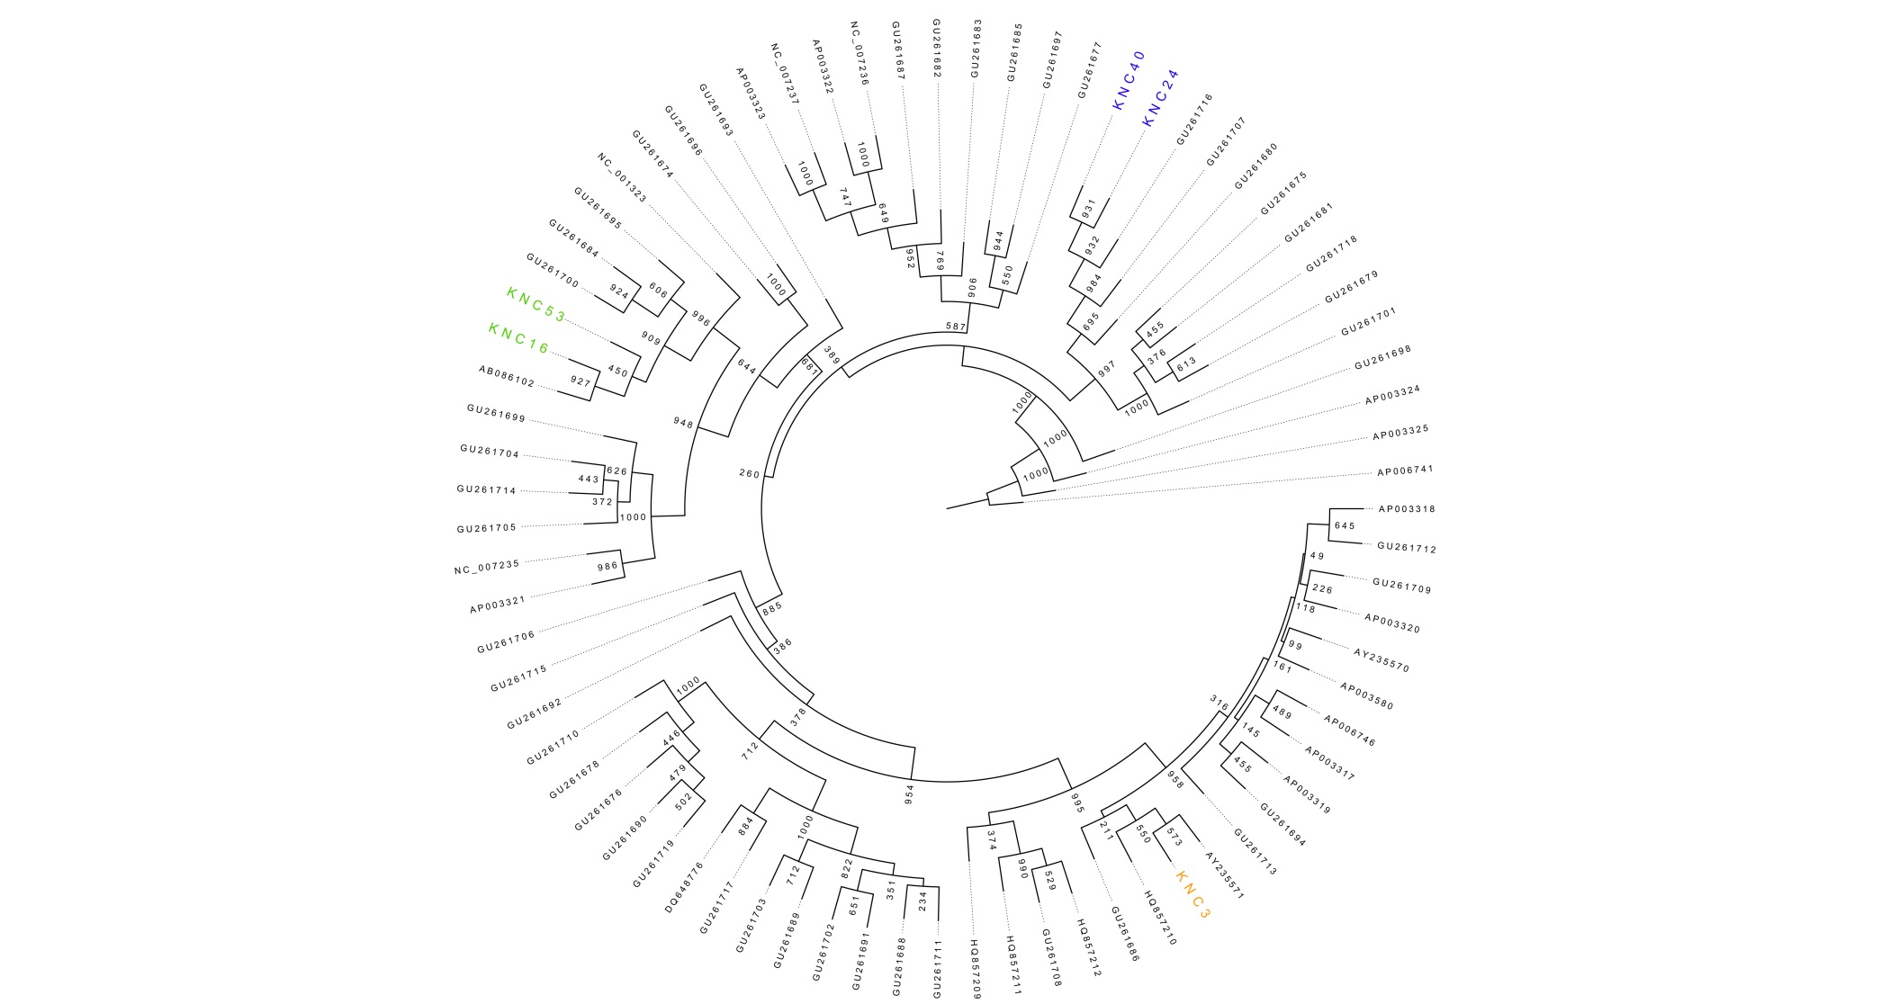
Figure S9. Neighbor joining tree of 75 samples used in this analysis.

