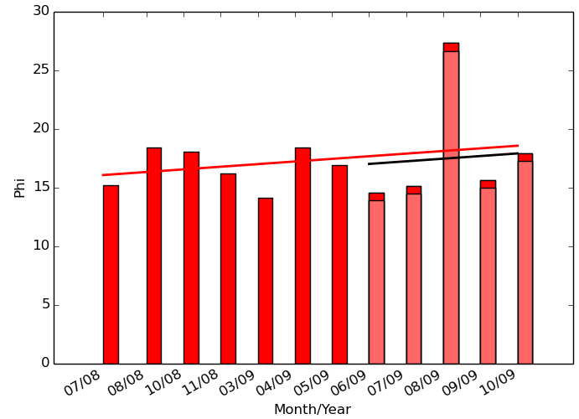 | 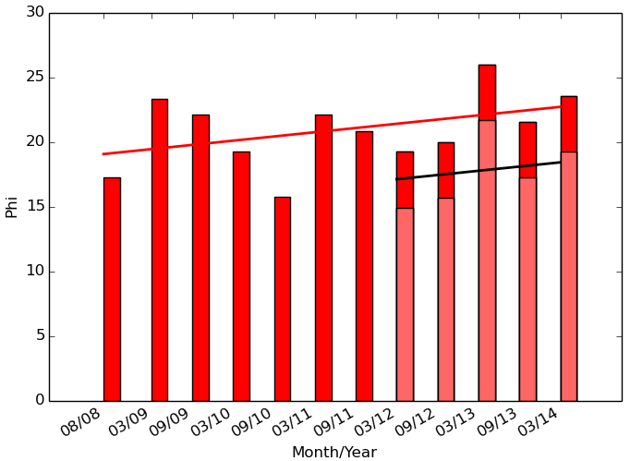
S4 Fig: Average phi plotted over time (node sampling = random walk, node sample size = 150 (left) and 200 (right), time step size δ = 100 ms). For 150 nodes, β = 0.4477, p = 0.018; for 200 nodes, β = 0.6535, p=0.00026.

