Supplemental information
S3 Fig. Dynamic Prediction of the Probability of Deceased Donor Transplant at Year-3 in Pre-KAS Cohort
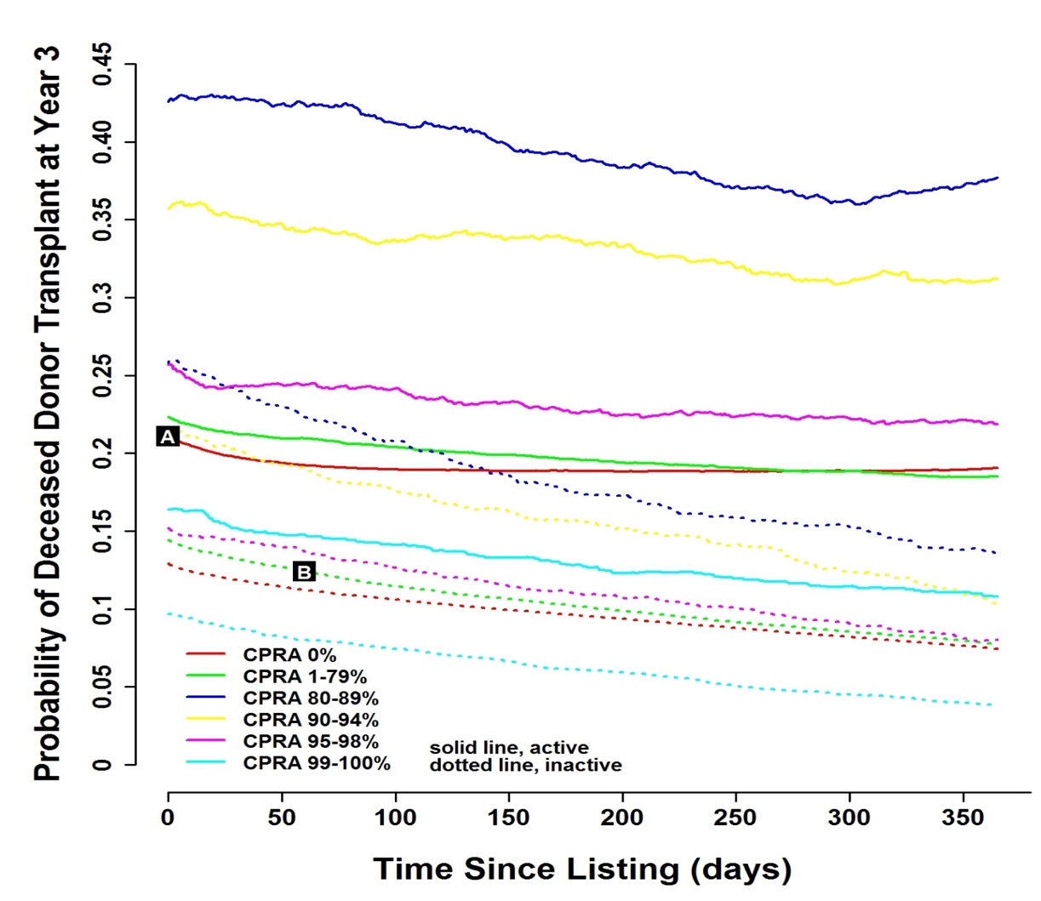

This figure shows the probability of deceased donor transplant at year 3 of listing given the CPRA/activity status at any time of the first year of listing (or disease history within first year of listing). For example, given the patient was listed as active with CPRA 0% at day 0, the predicted probability of transplant at year 3 was around 0.211 (point A), and if this patient transition to inactive with CPRA 1-79% at day 60, the predicted probability of transplant at year 3 deceased to 0.124 (point B). Probability estimate was included in S3 Table.

