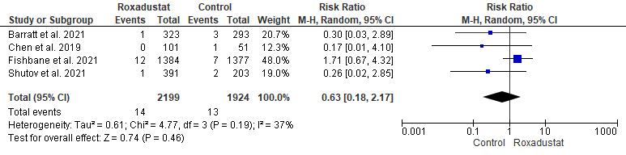
Figure S7 Forest plot of comparison: 4 Cardiovascular side effects, outcome: 4.5 Coronary artery disease.
CI: confidence interval; M-H: Mantel-Haenszel; df: degrees of freedom; I², I-squared.

