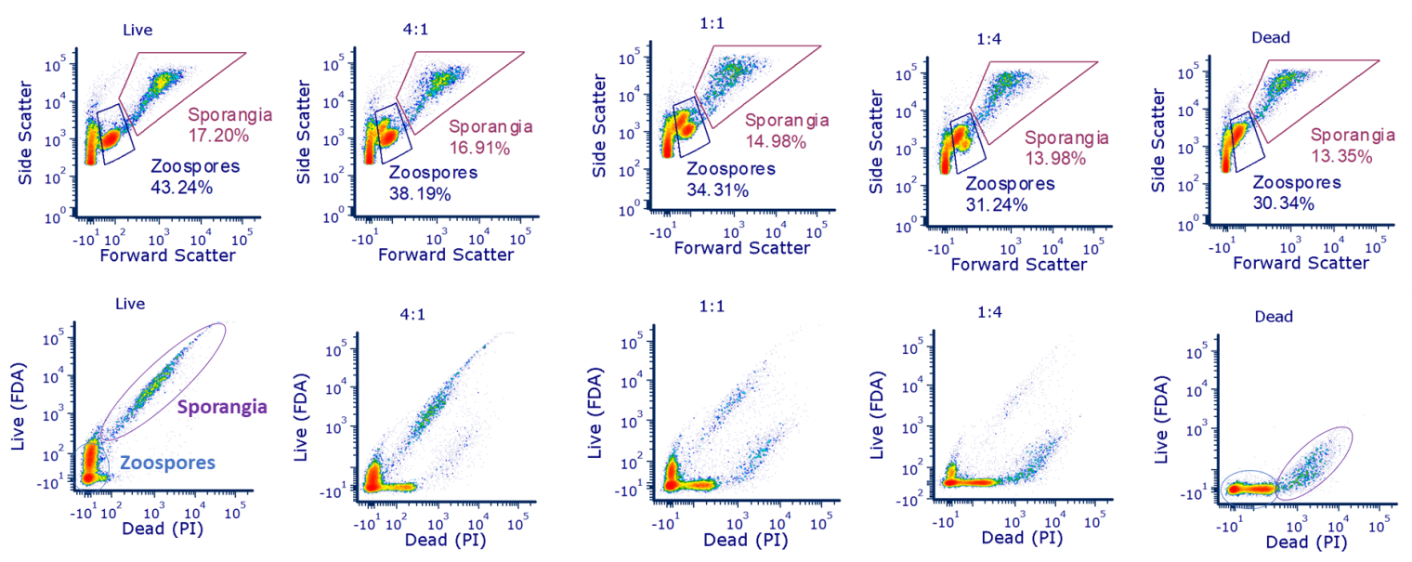

Figure S1. Live:dead staining of Bd populations. To test the staining protocol, samples of live and dead (heat-killed) Bd cultures were used to create a series of blended samples. Numbers represent portion live:dead in a sample. (Top panels) Forward vs. side scatter plots qualitatively showed loss of cell viability. (Bottom panels) Staining with FDA and PI showed distinct populations for both zoospores and sporangia.

