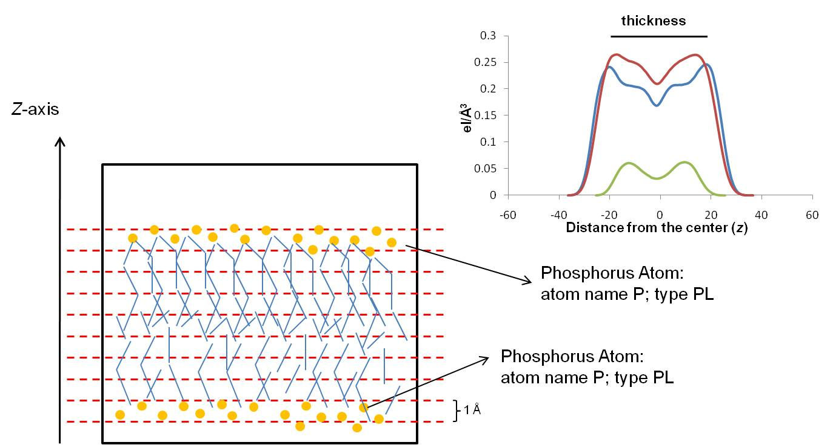

Figure S13. EDP scheme. At each simulation frame, the EDP is computed by summing the atomic number (Z) and the partial charges of the atoms falling into 1 A-thick slabs parallel to the z axis. The sum, normalized by volume, provides the local 1-D density value around z.

