Supplemental Information
Table A. Immunodulation Therapy in the COMET Cohort.
 | All | Progressor | Non-progressor | P-value
Drug | 8 (13.3) | 2 (5.7)  2 prednisone | 6 (24.0)  2 prednisone  3 azathioprine, prednisone  1 mycophenolate, prednisone | 0.06*
*P value based on Fisher’s exact test.

Fig A. Kaplan-Meier curves showing progression free survival for IPF patients with baseline biomarker levels above or below the identified thresholds (A) Carbonic Anhydrase XIII, (B) Granulin(GRN) and (C) Nascent polypeptide-associated complex subunit alpha (NACA). RMST indicates the comparison of restricted mean survival time (i.e. area under the K-M curves) between the two groups.
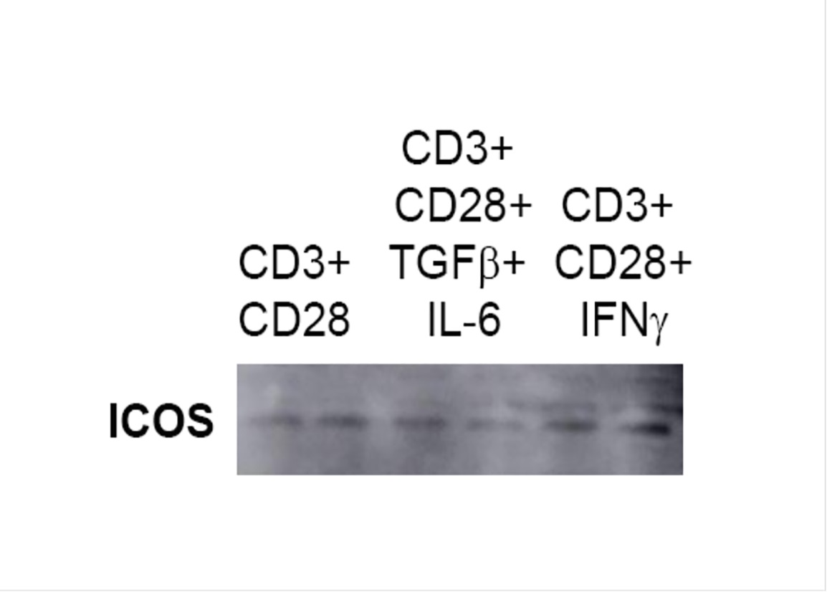
Fig B. ICOS is shed by activated T cells: A million CD4 positive splenocytes were stimulated with CD3 + CD28 then (TGFβ, 2ng/mL+ IL-6, 20ng/mL) or TH1 (IFNγ, 10ng/mL) for 24 hr. Cell free supernatants were collected and concentrated using Amicon Ultra Centrifugal filters (Millipore, Billerica, MA). Equal amounts of protein from each sample were separated on a 4-20% gradient SDS-polyacrylamide gel and transferred to a PVDF membrane (Amersham/GE Healthcare, Pittsburgh, PA). PVDF membrane was probed with rabbit monoclonal ICOS (Abcam).

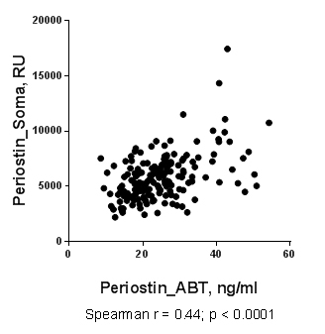
Fig C. Periostin levels correlate on SOMAscan and ELISA: The same plasma samples were run on a periostin ELISA developed by Abbot Pharmaceuticals and were compared to measures of periostin made by SOMAmer. The correlation was significant, Spearman r=0.44; p<0.0001.

