ROC curves
Alzheimer’s Disease Classifier Performances
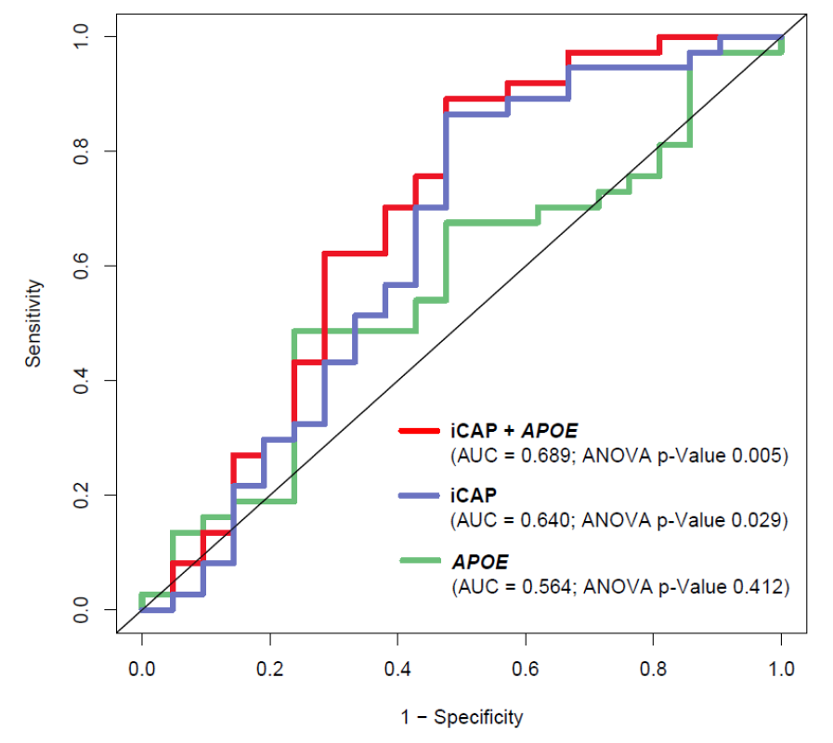

Supplementary Figure S1. ROC curves for iCAP-APOE4 AD classifier (iCAP classifier with APOE4 count included as a feature), the iCAP AD classifier, and the APOE4 classifier.

