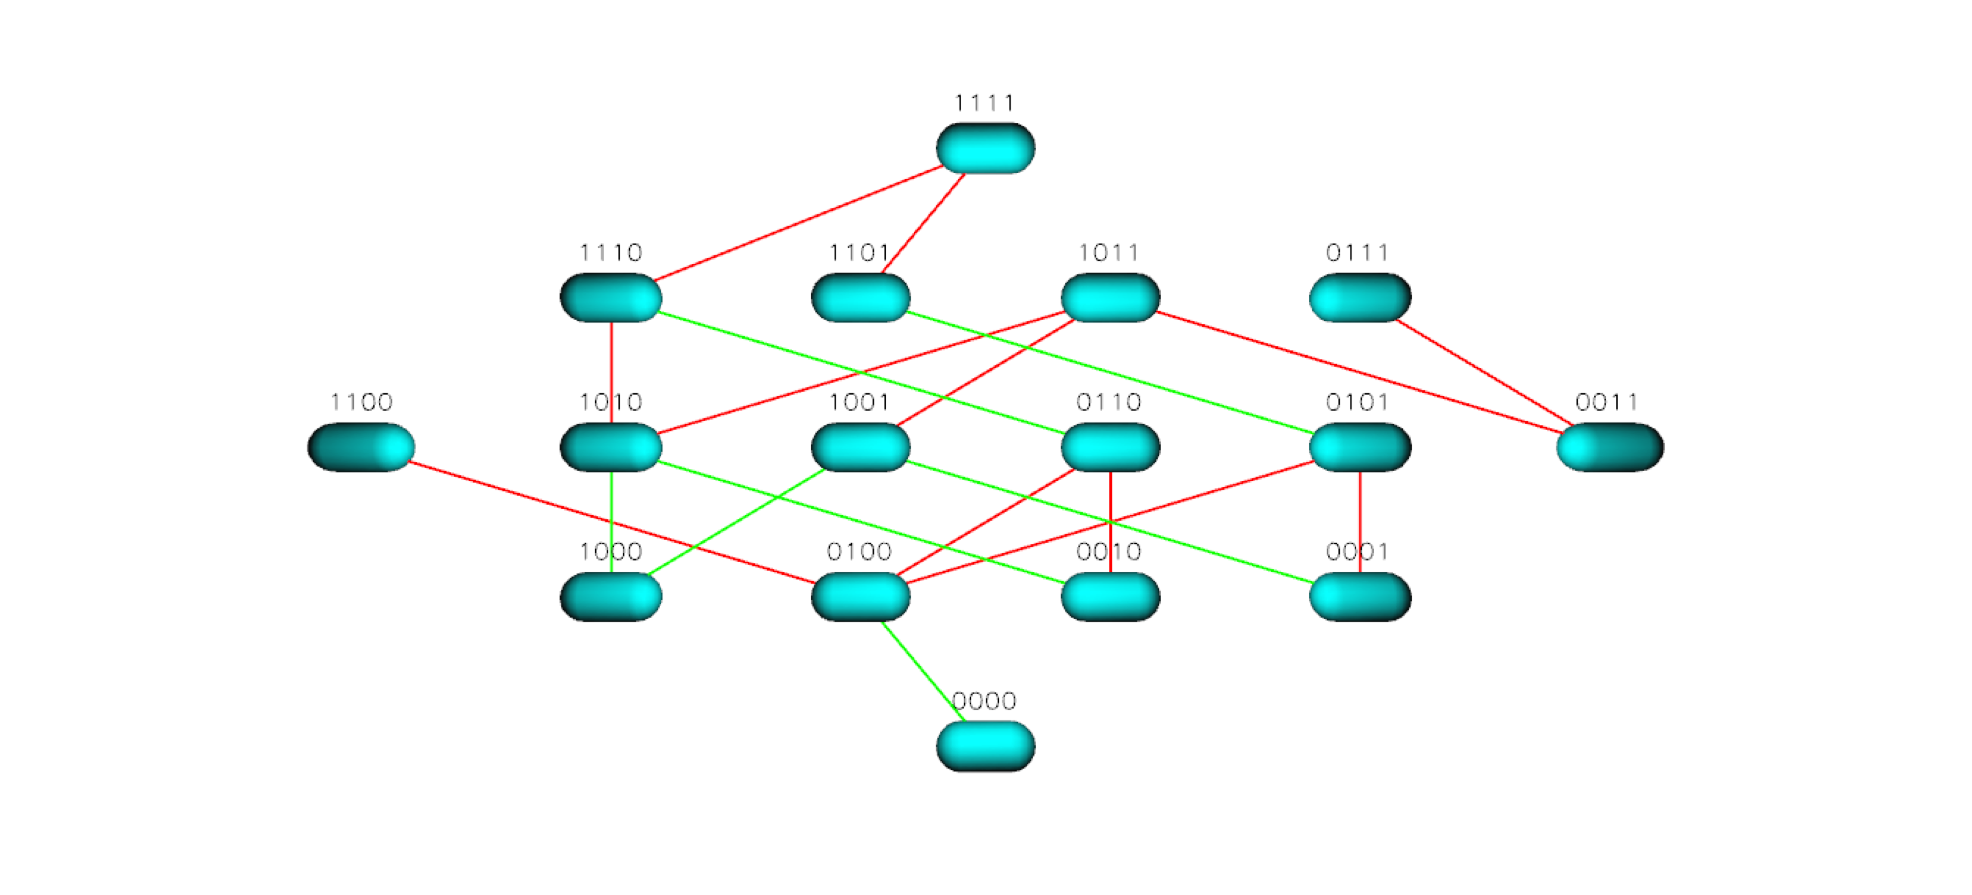
Figure S2 TEM 50 Landscape for Ceftazidime

