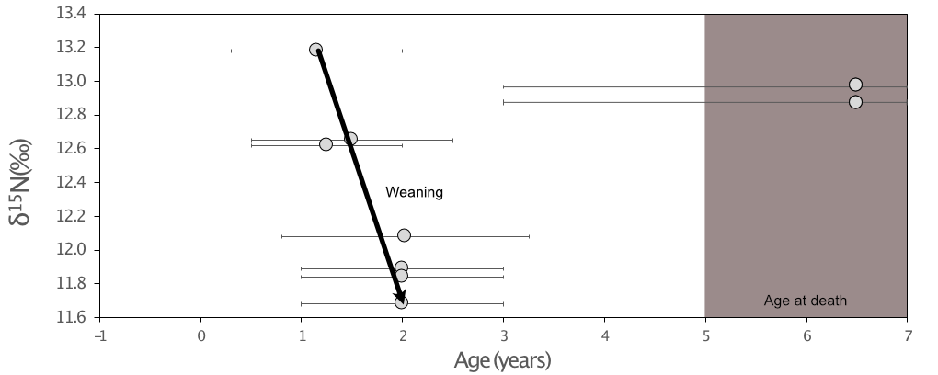
Figure S3. N isotopes obtained from the M1 dentine sampled from the tooth roots of the child 63949 (Jacobins convent, Rennes, France).

