S1 Fig. Beta-diversity for gut bacteria in NZ honey bees fed different carbohydrate diets for six days.
Beta diversity
S1 figures A–C display the beta-diversity of OTUs within the gut of NZ honey bees sourced from a single hive that were fed different carbohydrate diets for 6 days. The relative abundance of OTUs were displayed as PCoA plots using different distance matrices.
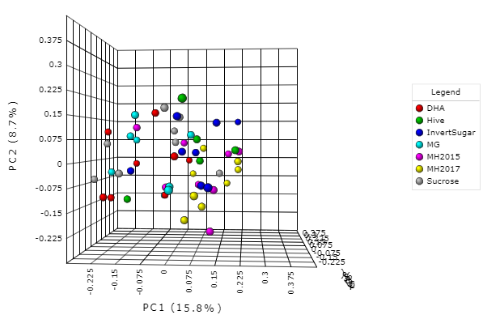
Figure A. Bray-Curtis PCoA 3-D visualisation of OTUs.
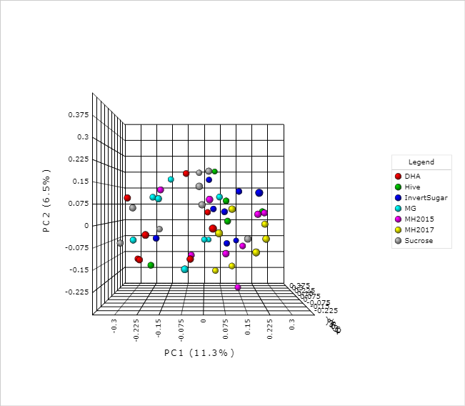
Figure B. Jaccard PCoA 3-D visualisation.
Figure C. Jensen-Shannon PCoA 3-D visualisation.

