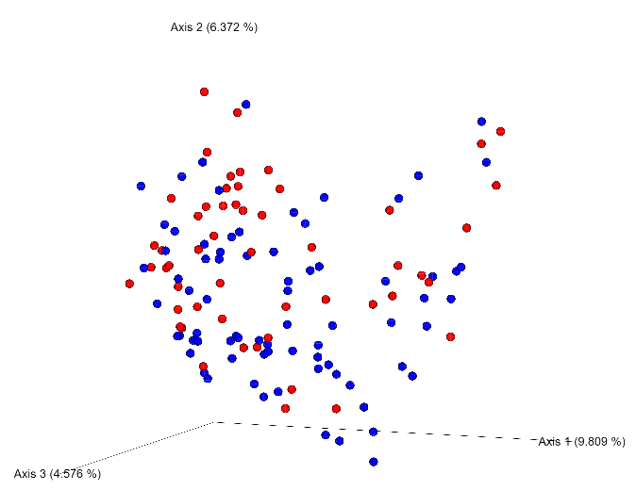
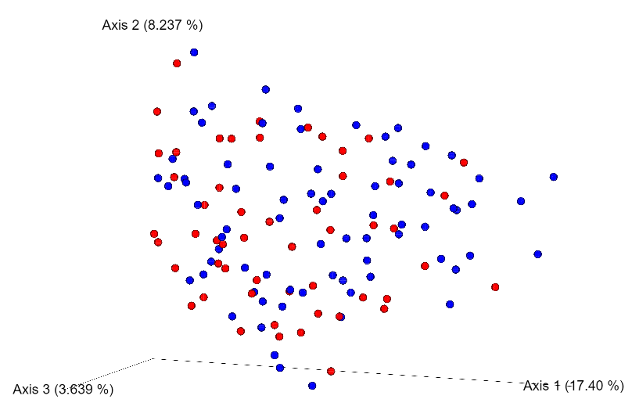
A B

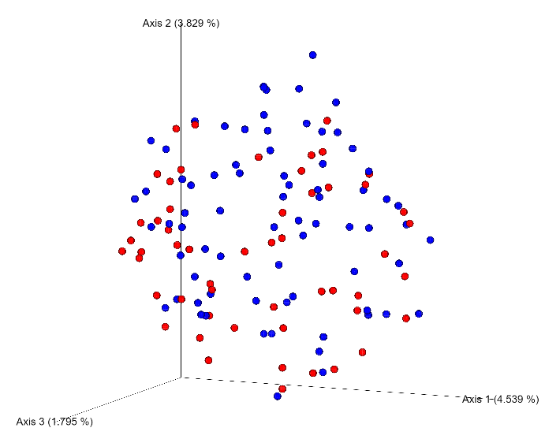
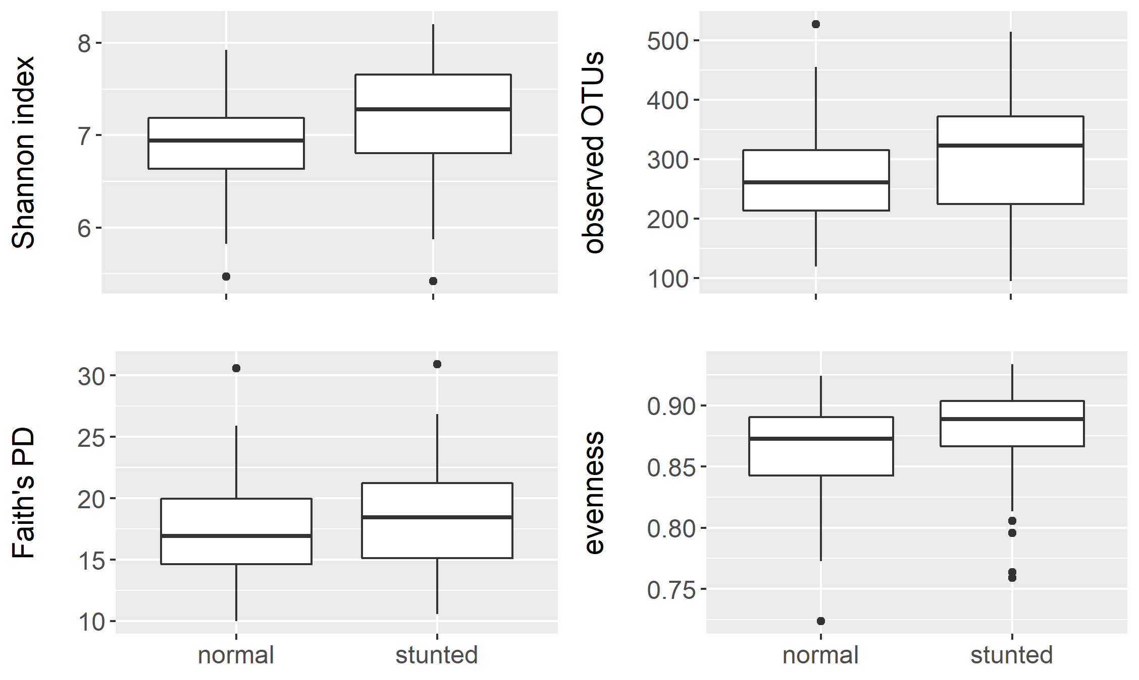
C D

S1 Fig. A. Unweighted UniFrac; B. Bray-Curtis, and C. Jaccard PCoA plots for the normal nutritional status (red) and stunted (blue) children. D: alpha-diversity indices Shannon index, observed OTUs, Faith’s phylogenetic diversity (PD), and evenness. All metrics q < 0.06.

