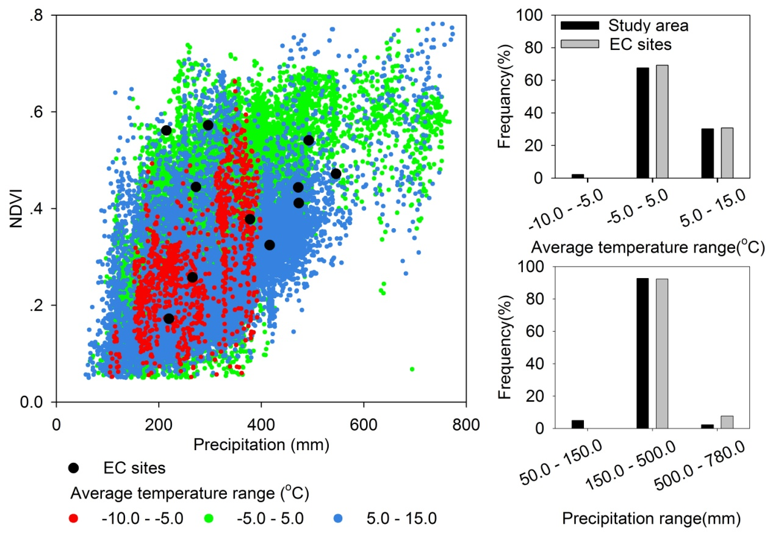
Figure S1. Distribution of eddy covariance (EC) tower sites over the climate and vegetation (NDVI) zones.

