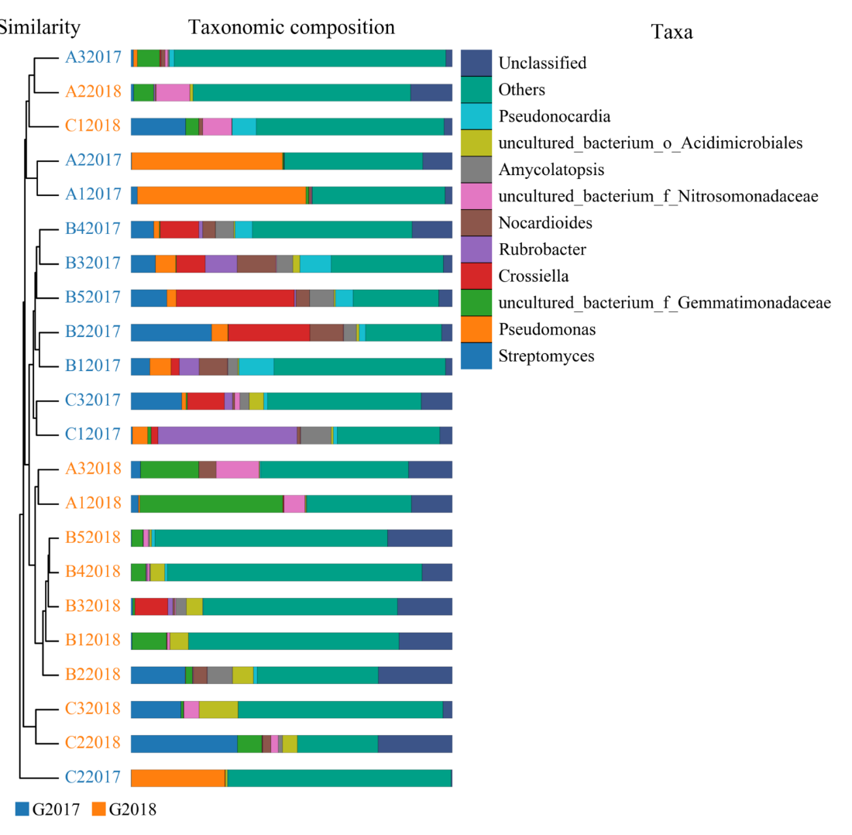
S4 Fig. Principal component analyses of the bacterial (A) communities in the 22 samples in 2017 and 2018.Weighted UniFrac UPGMA tree based on bacteria V3+V4 gene sequences.

