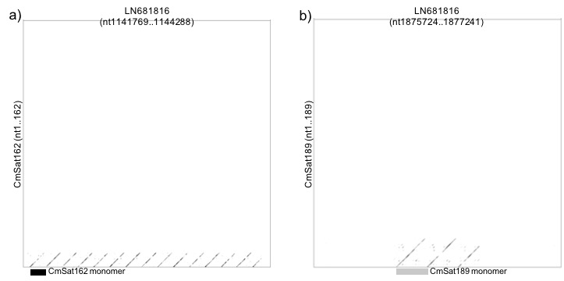

S3 Fig. CmSat162 (A) and CmSat189 (B) repeat organization in Cucumis melo genomic scaffold sequence (accession number: LN681816). For Cmsat162, sequence from nt1141769 to nt1144288 of LN681816 was used for dot plot analysis whereas sequence from nt1875724 to nt1877241 was used for CmSat189. The consensus sequences of both CmSat162 and CmSat189 are listed in Table S2.

