Supplementary Table S2. Docking results of compounds in NCI Diversity Set II to lanthionine synthetase C-like 2, ranked by the lowest binding energy (N=1,364 compounds).

ZINC Number | Name | Chemical Structure | Lowest  Binding  Energy  (kcal/mol)
ZINC01690699  (NSC61610) | 1-N,4-N-bis[3-(1H-benzimidazol-2-yl)phenyl]benzene-1,4-dicarboxamide | 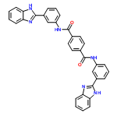 | -11.1
ZINC29589888 | 2-[2-[(6-oxo-5H-phenanthridin-3-yl)carbamoyl]phenyl]benzoic acid |  | -10.5
ZINC13130018 | 6-(1,3-dihydrophenanthro[9,10-d]imidazol-2-ylidene)cyclohexa-2,  4-dien-1-one | 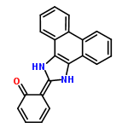 | -10.3
ZINC01726776 | 3-(4-chloro-6-phenoxy-1,3,5-triazin-2-yl)-1-phenylindole | 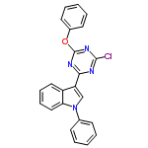 | -10.2
ZINC01736228 | (2R)-5-phenyl-2-[(2R)-5-phenyl-2,3-dihydro-1,3-benzoxazol-2-yl]-2,  3-dihydro-1,3-benzoxazole |  | -10.2
ZINC04783229 | 1-N,4-N-bis(3-phenylphenyl)piperazine-1,4-dicarboxamide | 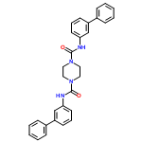 | -10.1
ZINC00990239 | 3-(4,5-dimethylbenzo[h][1,  6]naphthyridin-1-ium-2-yl)-2-methylquinolin-4-amine | 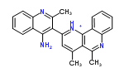 | -10
ZINC18057104 | 4-[(1-methyl-6-nitroquinolin-1-ium-4-yl)amino]-N-[4-[(1-methylpyridin-1-  ium-4-yl)amino]phenyl]benzamide | 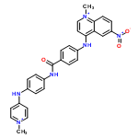 | -10
ZINC04214344 | Genostrychnine | 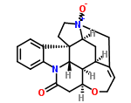 | -9.7
ZINC04720972 | 2-hydroxy-N-(4-methoxyphenyl)-11H-benzo[a]carbazole-3-carboxamide |  | -9.6

