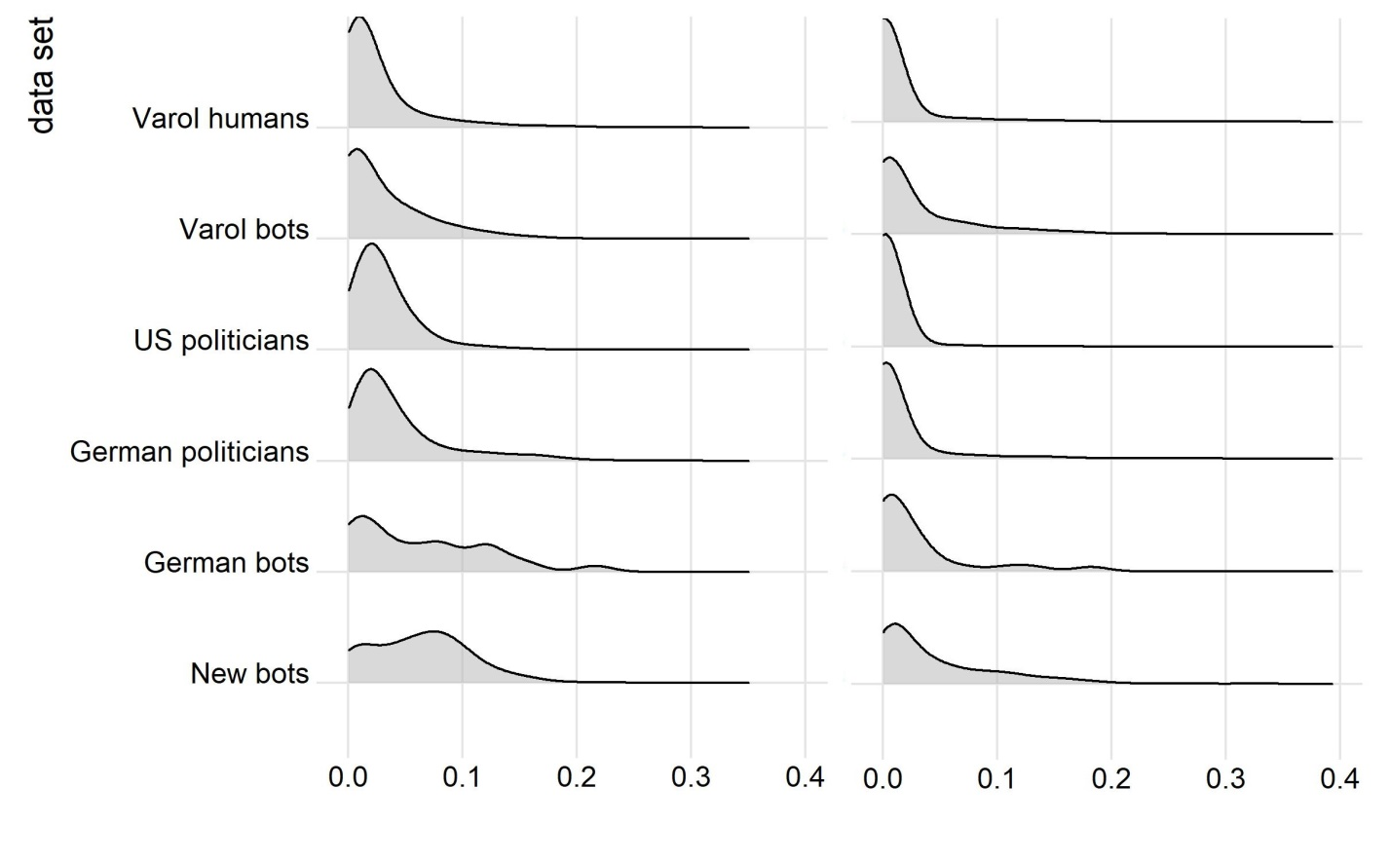
S2 Fig. Distribution of the SD for single accounts plotted as groups. Left for the Botometer English score, right for the Botometer English CAP. Bandwith of 0.015 was used for the both.

