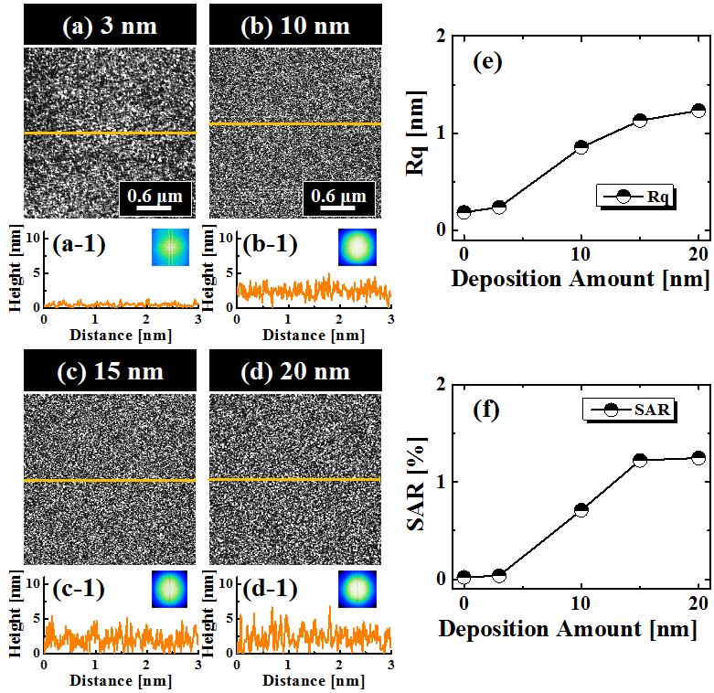
S2 Fig. (a) - (d) AFM top-views of 3 × 3 µm², showing the surface morphologies with the various deposition amount between 3 and 20 nm before annealing. (a-1) - (d-1) Line-profiles obtained from the yellow lines in (a) - (d). (Insets) 2-D FFT power spectra. (e) Root mean squared roughness (Rq). (f) Surface area ratio (SAR). The line profiles, Rq and SAR show the gradual enhancement of surface height, roughness and area increment with the deposition amount.

