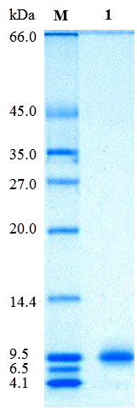
S3 Fig. SDS-PAGE electrophoresis of 5'- PDE

