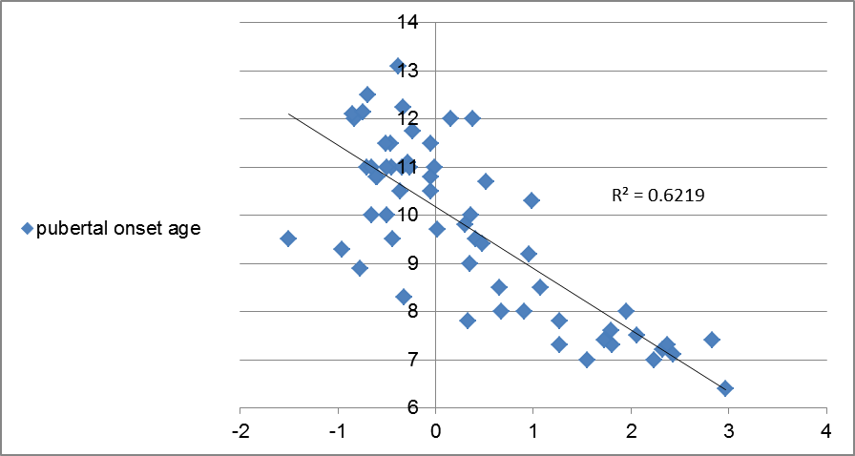

Fig 1. Israeli girls: Pubertal onset age vs height gap.

Fig 2. Israeli girls: Pubertal onset age vs BMI percentile.

Fig 3. Israeli girls: Height gap residual plot. This is the residual plot of the parameter height gap from the multivariable regression analysis of this parameter and the BMI percentile as independent parameters vs onset age of puberty as the dependent parameter.

Fig 4. Israeli girls: BMI-percentile residual plot. This is the residual plot of the parameter BMI-percentile from the multivariable regression analysis of this parameter and the height gap as independent parameters vs onset age of puberty as the dependent parameter.

