S4 Figure
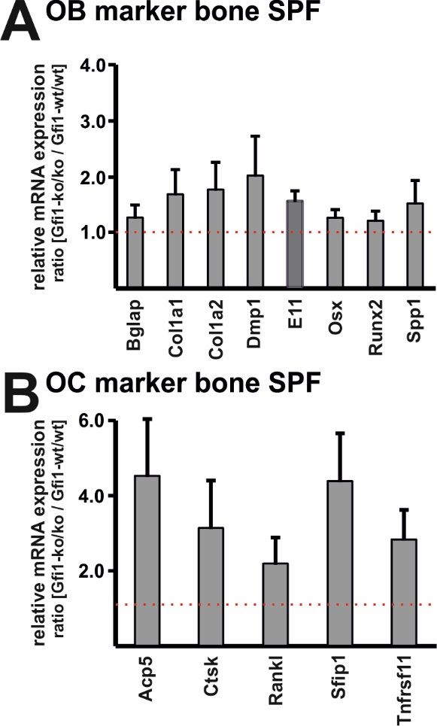
S4 Figure. Expression of osteoblast and osteoclast marker in bone tissue of SPF Gfi1-wt/wt and Gfi1-ko/ko mice.
(A) Relative expression of bone marker mRNA was analyzed with qPCR and results are presented as ratio Gfi1-ko/ko vs. Gfi1-wt/wt (n=3 with 3 technical replicates/sample; error bar indicates SD). Normal expression is indicated with the dotted line at 1. Gapdh expression was used as endogenous control. (B) Mature Oc. markers such as Acp5 and Ctsk are approx. 4-fold increased. The marker for Oc. progenitor cells Sfip1 (Pu.1) is also 4-fold elevated. Gapdh expression was used as endogenous control.

