a)
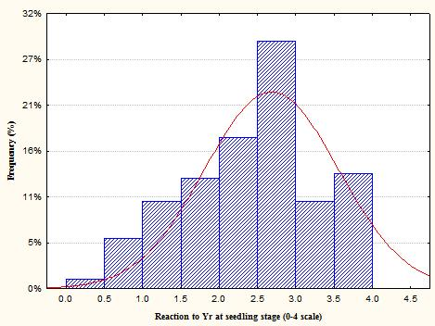
b)
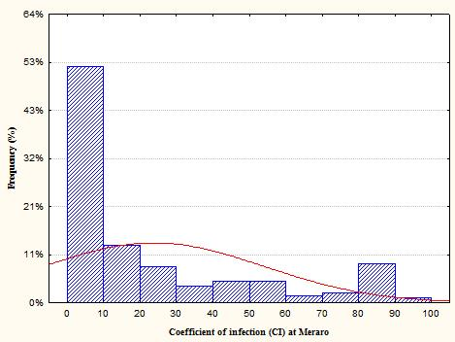
c)
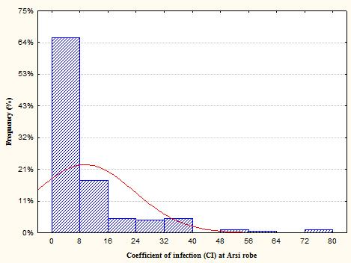
Figure S1: Frequency distribution of synthetic hexaploids evaluated to stripe rust at seedling stage (a) and adult plant stage at Meraro (b) and Arsi Robe (c)

