Questionnaire MuZIEKonderZOEK Study number
General information
1. I am a woman/man (delete what is not appropriate)
2. My date of birth is ……………………………
3. I am……… cm long en my weight is ……… kg
4. I am a smoker yes/no (delete what is not appropriate)
5. I am left/righthanded (delete what is not appropriate)
6. I sport on average ……… hours a week
7. I drink on average ……… glasses of alcohol a week
Music-specific information
8. The orchestra I am in is………………………..…………………………………………………………………
9. In this orchestra I play the following musical instrument: ……………………………………..
10. I have been playing this musical instrument for ………… years
11. I am taking lessons on this instrument yes/no (delete what is not appropriate)
12. I study …………. hours a week on this instrument (including repetitions)
13. Do you do a “warming-up” before playing?
- yes, namely ……… minutes
- no

14. I am a conservatory student yes/no (delete what is not appropriate)
Please pay attention:
The following question is about playing-related complaints. Please read the question, the explanation and the example on the next page carefully.

15. Have you ever had playing-related complaints?
Playing-related complaints are pain and other symptoms that are chronic, beyond your control and that interfere with your ability to play your instrument at the usual level

- Yes, namely a. In the past week
      - Yes fill in body chart 1 in and go to question b.
      - No go to question b.
b. In the past four weeks
- Yes fill in body chart 2 in and go to question c.
- No go to question c.
c. In the past three months
- Yes fill in body chart 3 in and go to question d.
- No go to question d.
d. In the past year
- Yes fill in body chart 4
- No go to question 16 (on the last page)
- No, never go to question 16 (on the last page)
Example: Joe had shoulder complaints (left) a year ago, but that is gone now. Furthermore, he had from 6 till 3 months ago complaints of his right hand. Last week he had complaints of his left elbow.
Joe fills in:
a) Yes and ticks the box next to left elbow
b) No
c) Yes and ticks the box next to right hand
d) Yes and ticks the boxes next to right hand and left shoulder

NB: So if you only had complaints in the past week, you don’t need to fill out all four body charts, but just the first one

Body chart 1: Playing-related complaints past week
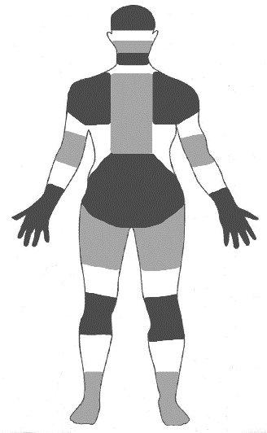
I had complaints of my:
Left
Right
Head

Mouth/jaw
Neck

Shoulder
Upper back

Elbow
Lower back

Hand/wrist

Hip/
upper leg

Knee

Foot/ankle
- Head
- Mouth/jaw
- Neck
- Shoulder left
- Shoulder right
- Upper back
- Elbow left
- Elbow right
- Lower back
- Hand/wrist left
- Hand/wrist right
- Hip/upper leg left
- Hip/upper leg right
- Knee left
- Knee right
- Foot/ankle left
- Foot/ankle right
Body chart 2: Playing-related complaints past four weeks

I had complaints of my:
Links
Rechts
Head

Mouth/jaw
Neck

Shoulder
Upper back

Elbow
Lower back

Hand/wrist

Hip/
upper leg

Knee

Foot/ankle
- Head
- Mouth/jaw
- Neck
- Shoulder left
- Shoulder right
- Upper back
- Elbow left
- Elbow right
- Lower back
- Hand/wrist left
- Hand/wrist right
- Hip/upper leg left
- Hip/upper leg right
- Knee left
- Knee right
- Foot/ankle left
- Foot/ankle right

Body chart 3: Playing-related complaints past three months

I had complaints of my:
- Head
Links
Rechts
Head

Mouth/jaw
Neck

Shoulder
Upper back

Elbow
Lower back

Hand/wrist

Hip/
upper leg

Knee

Foot/ankle
- Mouth/jaw
- Neck
- Shoulder left
- Shoulder right
- Upper back
- Elbow left
- Elbow right
- Lower back
- Hand/wrist left
- Hand/wrist right
- Hip/upper leg left
- Hip/upper leg right
- Knee left
- Knee right
- Foot/ankle left
- Foot/ankle right

Body chart 4: Playing-related complaints past year

I had complaints of my:
Links
Rechts
Head

Mouth/jaw
Neck

Shoulder
Upper back

Elbow
Lower back

Hand/wrist

Hip/
upper leg

Knee

Foot/ankle
- Head
- Mouth/jaw
- Neck
- Shoulder left
- Shoulder right
- Upper back
- Elbow left
- Elbow right
- Lower back
- Hand/wrist left
- Hand/wrist right
- Hip/upper leg left
- Hip/upper leg right
- Knee left
- Knee right
- Foot/ankle left
- Foot/ankle right

16. Please circle the number that best describe your physical ability
during the past week.
Did you have any difficulty:

 | No  difficulty | Mild  difficulty | Moderate  difficulty | Severe  difficulty | Unable
Using your usual technique for playing your instrument? | 1 | 2 | 3 | 4 | 5
Playing your musical instrument because of arm, shoulder or hand pain? | 1 | 2 | 3 | 4 | 5
Playing your musical instrument as well as you would like? | 1 | 2 | 3 | 4 | 5
Spending your usual amount of time practising or playing your instrument? | 1 | 2 | 3 | 4 | 5

That was the last question. Thank you for your cooperation!

