S2 Appendix. Experimental materials.
Experiment 1 (children): Child questionnaire (translated to English)

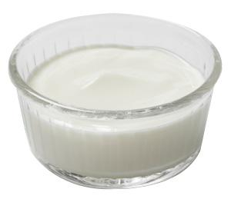
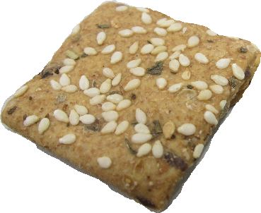
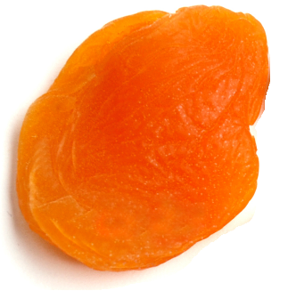
Which food would you would like to receive as a snack?

QUESTION 1
Dried apple | French fry  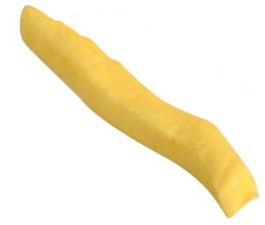
What would you prefer to eat?

QUESTION 2
Dried apricot  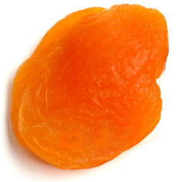 | Dried apple
What would you prefer to eat?

QUESTION 3
Natural yoghurt | Wholegrain cracker  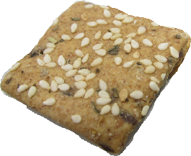
What would you prefer to eat?

QUESTION 4
Dried apricot | Natural yoghurt
What would you prefer to eat?

QUESTION 5
Dried Apple | Natural yoghurt
What would you prefer to eat?

QUESTION 6
Wholegrain cracker | Dried apple
What would you prefer to eat?

QUESTION 7
Gummy bear  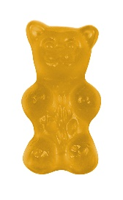 | Dried Apple
What would you prefer to eat?

QUESTION 8
Dried Apricot | Wholegrain cracker
What would you prefer to eat?

