Supplementary Figure 4
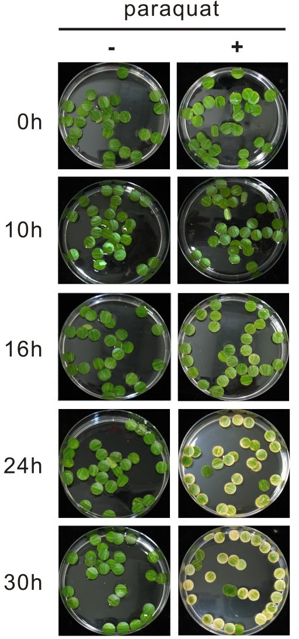

Phenotypic changes (bleaching) in 0.5 µM paraquat-treated leaf discs from mature leaves of C. roseus
Control discs did not show visible bleaching over 30 hrs, whereas bleaching starts in paraquat-treated discs after 16 hrs.

